**MAGNETISM**

Magnets attract certain materials known as magnetic materials e.g. iron, cobalt and their alloys. Magnets are made of these magnetic materials.

**PROPERTIES OF MAGNETS**

The ends of a magnet where attraction is strongest are known as **magnetic poles.**

A straight line drawn passing through ends is called **magnetic axis.**

**Directional property of a magnet**

A magnetic compass or a plotting compass always rests in North-South direction of the earth. The pole that points towards the North is called **North Pole (N)** or **North-seeking pole.** The other one is the South-seeking pole or South Pole (S).

Therefore a magnet can be used as a compass.

**TYPES OF MAGNETS**

Magnets are classified according to their shapes as shown

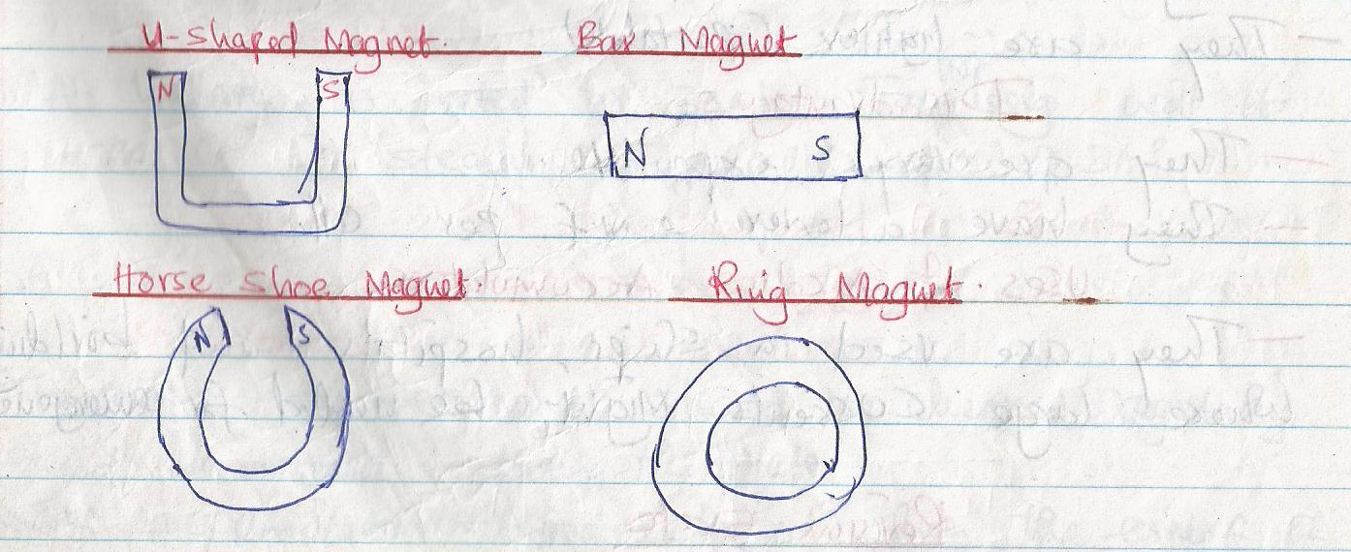

**Ceramic magnet-** Has poles at its faces. They are stronger than other magnets.

**MAGNETIC AND NON-MAGNETIC MATERIALS**

Magnets can be classified according to their magnetic properties. There are those materials that are attracted by magnets and others are not attracted by a magnet.

An object/material which is attracted by a magnet is called **a magnetic material.** Metals such as cobalt, iron, nickel together with their alloys are strongly attracted by magnets are called **ferromagnetic materials.**

An object/material which is not attracted by a magnet is called **non-magnetic material.** For example copper, brass, aluminium, wood, glass and plastics. These objects have very weak magnetic property.

**THE BASIC LAW OF MAGNETISM**

The basic law of magnetism can be summarised as **like poles repel and unlike poles attract.**

**Testing polarity of a magnet**

The polarity of a magnet can be tested by bringing both its poles, in turn, adjacent to the known poles of a suspended magnet. **Repulsion** only occurs between the like poles of a magnet. **Attraction** might occur between unlike poles and a magnetic material thus repulsion is the only sure way to test for **polarity.**

**MAGNETIC FIELD PATTERNS**

When a magnetic material is placed near one pole of a magnet, it is attracted. This shows that there is a magnetic effect in the space around a magnet. The region or space where the magnetic influence is felt is called **magnetic field.** The field is stronger near the poles of a magnet and is weaker farther away from the poles.

**DIRECTION OF A MAGNETIC FIELD**

The direction of a magnetic field at a point is the direction which a free north pole would move if placed at that point in the field.

Magnetic fields have the following properties,

* They originate from North Pole and end at the South Pole.
* They repel each other side ways and form closed paths never intersecting other lines of forces.
* They are closer together where the field is strongest.

For example,

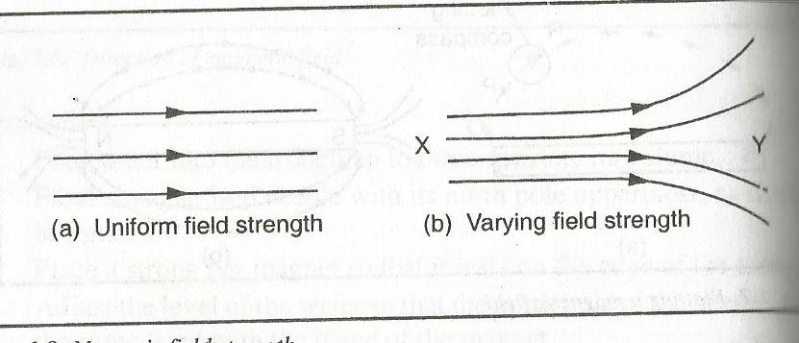

**MAGNETIC FIELD PATTERNS**

**Field patterns of a bar magnet**

The lines of force originate from North Pole and end at the South Pole as shown,

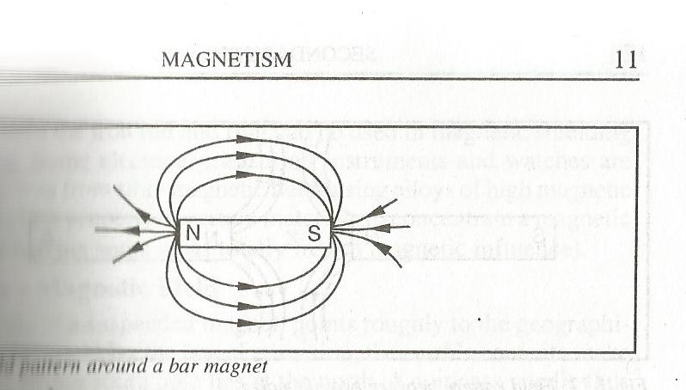

**Field pattern around a magnet**

**Field patterns between unlike poles**

Each magnet has it is own magnetic field. The two fields combine to form a single magnetic field as shown,

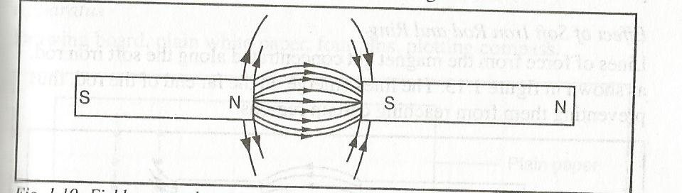

**Field patterns of Horse-shoe magnet**

The direction of the lines of force is from the North Pole to the South Pole. The field lines between the poles being more concentrated.

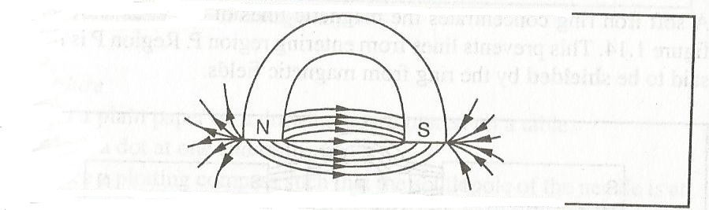

**FIELD PATTERNS BETWEEN LIKE POLES**

When like poles are placed adjacent to each other, the lines of force do not cross. Lines from one pole are deflected by the lines from the other pole. This indicates **repulsion.**

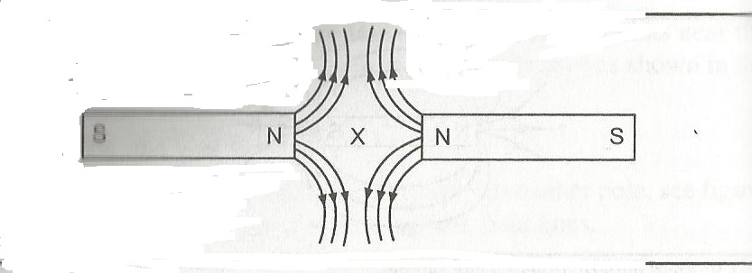

**Effects of soft iron rod and ring**

Lines of force from the magnet get concentrated along the soft iron rod. The lines emerge on the far end of the rod, thus preventing them from reaching certain regions as shown below,

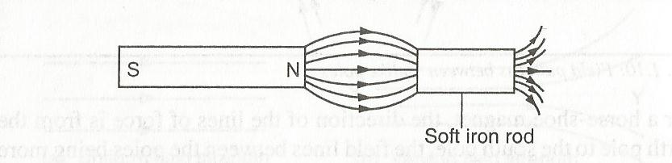

A soft iron ring concentrates the magnetic lines of force as shown

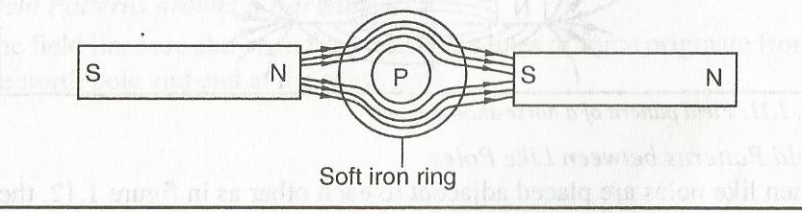

This prevents the lines of force from entering region P. Region P is thus said to be shielded by the ring from magnetic fields.

Both the iron rod and the ring can be used in magnetic shielding for screening.

**Earth’s Magnetic Field**

When a bar magnet is suspended freely, it comes to rest in North-South direction. This is as if the magnet is trying to align itself with a certain magnetic field. This alignment of the bar magnet is due to the **magnetic field of the earth.**

A bar magnet placed anywhere near the earth’s surface will have its magnetic field combining with the field of the earth as shown.

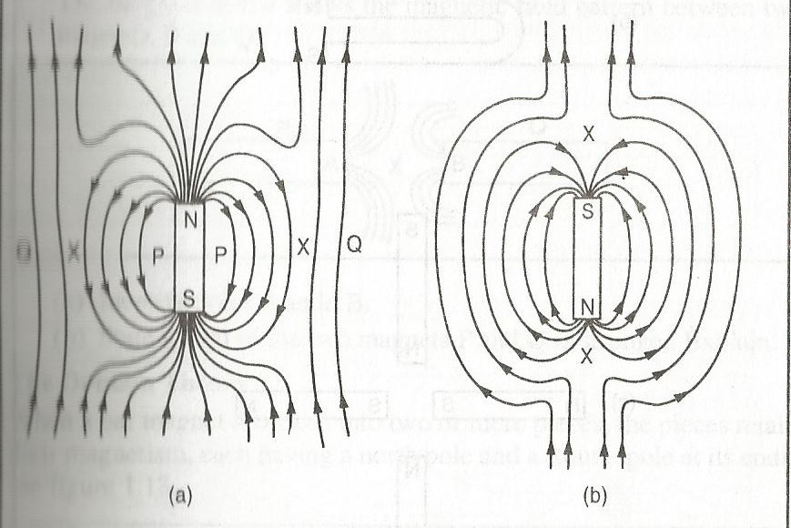

At point marked X, the magnetic field of the earth and that due to the magnet are equal and opposite. The resultant magnetic field is therefore zero at these points, which are called **neutral points.**

At P, the field of the magnet is stronger than that of the earth while it is weaker at Q.

**Example**

The diagram below shows the magnetic field pattern between two magnets, P and Q

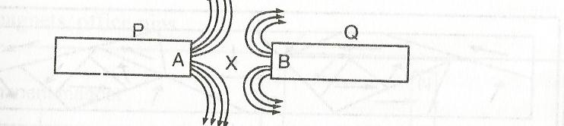

1. Identify the poles of P and Q
2. State which of the two magnets P and Q is stronger. Explain

**THE DOMAIN THEORY**

Magnets are made up of small magnetic groups called **domains** which are composed of smaller sub-atomic magnets called **magnetic dipoles.**

Magnetic dipoles in a given domain point towards a common direction. The domains vary in shape and size but with a common axis with one end being a North Pole and another South Pole.

In unmagnetized state, the dipoles are randomly arranged such that the resultant magnetism of all domains is zero as shown

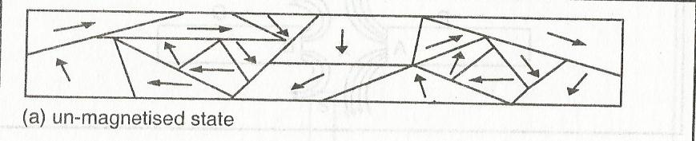

But when a material is placed in a magnetic field most of the domains are aligned in one direction and the material is said to be **magnetised** under the process of **magnetisation, as shown,**

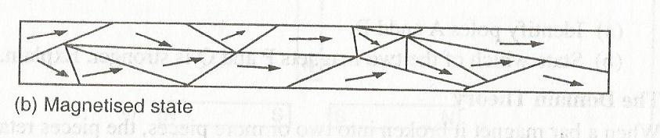

When all domains get aligned until no further alignment can take place even when the magnetic field is increased the material is **magnetically saturated.** (Strong magnet)

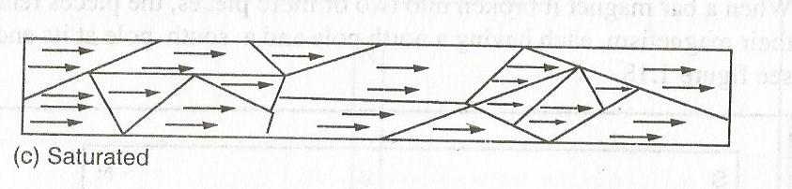

**MAGNETISATION OF A MAGNETIC MATERIAL**

**MAGNETISATION** is the process of making a magnet from a magnetic material.

There are four major methods of making magnets from a magnetic material,

1. Induction
2. Stroking i.e. single stroke and double stroke
3. Hammering
4. Electrical method

**INDUCTION**

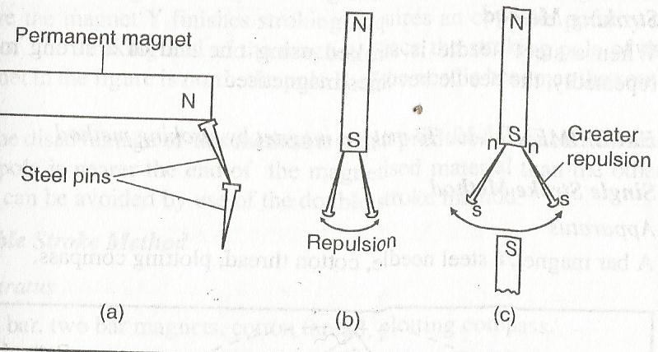

When a magnetic material e.g. steel pins is placed on the ends of a permanent magnet, the material acquire a polarity that is opposite to the magnetising pole while the other end acquire a similar pole to the one used.

The magnetic dipoles in the material get aligned along the magnetic axis of the magnetising magnet. However, the magnetism acquired by the steel pins is short lived (does not last for a long time) after the magnetising magnet is taken away. The material (steel pins) has been magnetised

**Example**

Explain the diagrams below

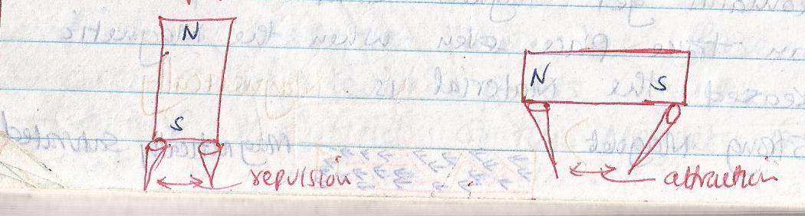

**STROKING METHOD**

When a steel needle (magnetic material) is stroked using one end of a strong magnet repeatedly, the magnet is magnetised.

**Single stroke**

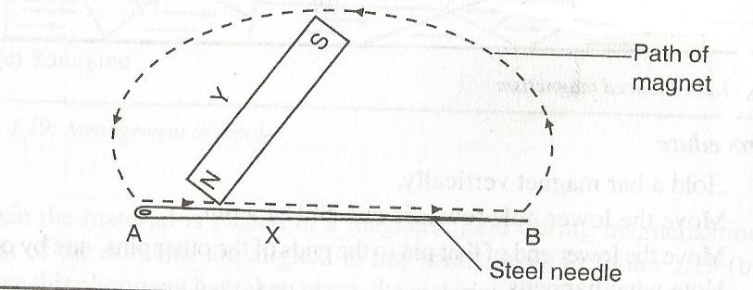

The dipoles in the steel needle align itself with the magnetic axis of the earth. The steel needle is magnetised by stroking method.

The end of the needle where the magnet Y finishes stroking acquires an **opposite polarity** to that of the stroking end of the magnet.

The disadvantage of this method is that it produces is that it produces magnets in which one pole is nearer the end of the magnetised material than the other. This is avoided by using double stroke method.

**Double stroke**

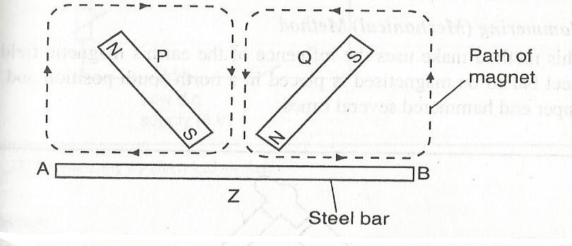

The end A of the steel bar acquires a North pole while end B acquires a South pole. The steel bar has been magnetised by double stroking.

If a steel bar is magnetised by the double stroke using North poles of two magnets, the bar acquires a South pole at each end and a double North pole at the centre as shown

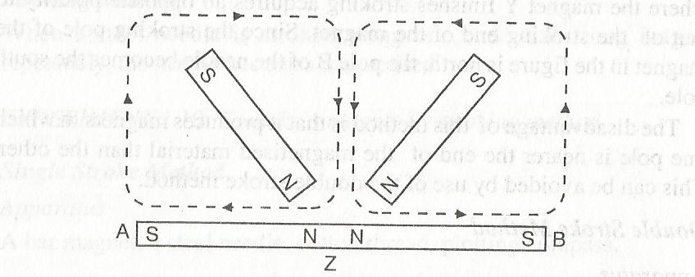

**HAMMERING**

This method makes use of the influence of the earth’s magnetic field. A steel bar to be magnetised is placed in a North-South position and the upper end hammered several times as shown

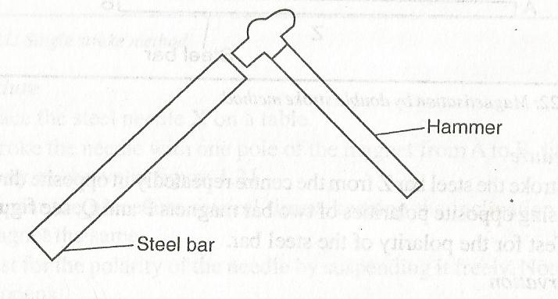

**ELECTRICAL METHOD**

It is the best and quickest method of making a magnet and it utilises the magnet effect of an electric current.

The method is widely used in industrial production of magnets.

A coil with many turns of insulated copper called **a solenoid** is used. A direct current (d.c) is passed through the solenoid.

**EXPERIMENT: To magnetise a steel bar by electrical method**

**APPARATUS:** steel bar, battery, switch, connecting wires

Connect the apparatus as shown below

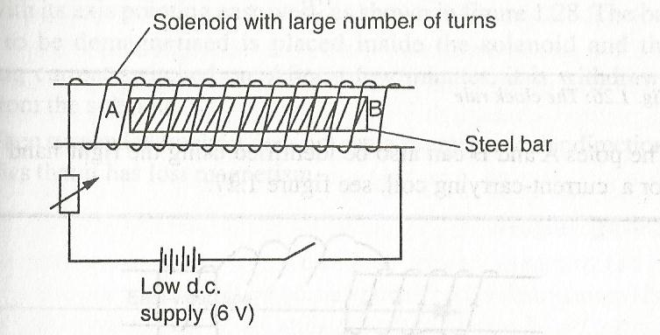

Switch on the current for some time and then switch off. Test for polarity of the steel bar.

**Observation**

The steel bar is magnetised. The polarity of the magnet depends on the direction of electric current.

The poles of A and B can be identified using **clock rule** which states that, **if on viewing on one end of the bar, the current flows in clockwise direction, then that end is a South pole. If anticlockwise then its a North pole.**

**Clock rule**

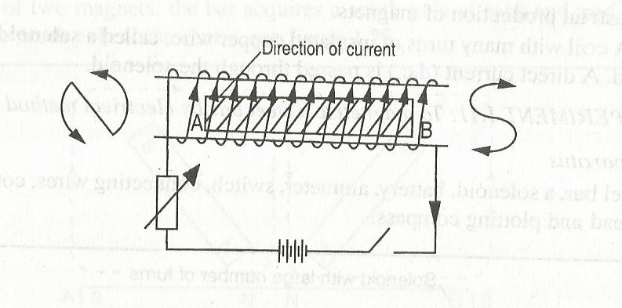

The poles of A and B can also be identified using the **right hand grip rule** for a current carrying coil.

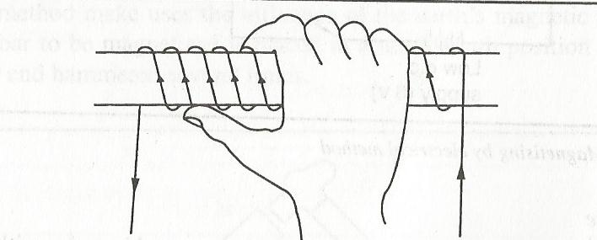

**Right hand grip rule**

The right hand grip rule states that **if a coil carrying a current is grasped in the right hand such that the fingers point in the direction of current in the coil, then the thumb points in the direction of North Pole.**

Allowing current to flow for a long time does not increase the extent of magnetic saturation but it only causes overheating of the solenoid which adversely affects magnetism.

**DEMAGNETISATION**

This is the disorientation of magnetic dipoles of a magnet. The disorientation of magnetic dipoles weakens or destroys the magnetic properties of a magnet.

This can be achieved by **hammering** or passing **alternating current** through the magnet placed in East-West direction (to avoid chances of the magnet acquiring any magnetism from the earth’s magnetic field)

Dropping magnets against hard surfaces destroys them

**Methods of Demagnetisation**

**Hammering and heating**

A magnet is demagnetised by heating or hammering it when placed in East-West direction. Magnetism is lost because mechanical hammering or heating disorients magnetic dipoles.

When heating, a magnet is heated until red hot and cooling it suddenly when resting in East-West direction.

**Electrical method**

A 12V alternating current (a.c) voltage is connected in series with a solenoid which is placed with its axis pointing East-West direction as shown

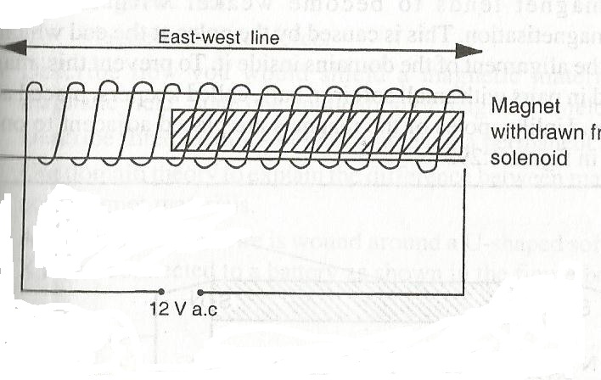

The bar magnet to be demagnetised is placed inside the solenoid and alternating current (a.c) switched on. After a few minutes its withdrawn slowly from the solenoid.

The magnet loses its magnetism because the alternating current (a.c) reverses many times per second, disorienting the magnetic dipoles.

The alternating current (a.c) disorients or disaligns the magnetic domains of a magnet.

**NOTE:** The magnets are placed in East-west direction so that they do not retain some magnetism due to the earth’s magnetic field.

**Hard and soft magnetic materials**

**Soft magnetic materials** are those magnetic materials that are easily magnetised but do not retain their magnetism for long e.g. soft iron, nickel e.t.c. they are used in making electromagnetic transformer cores.

**Hard magnetic materials** are those materials that are not easily magnetised but retain their magnetism for long after magnetisation e.g. steel. They are used in making permanent magnets.

**Storing magnets**

A bar magnet tends to become weaker with time due to self-demagnetisation. This is caused by the poles at the end which tend to upset the alignment of the domains inside it. To prevent this magnets are stored in pairs with small iron bars called **keepers** placed across their ends. Unlike poles of the magnet are placed adjacent to one another as shown

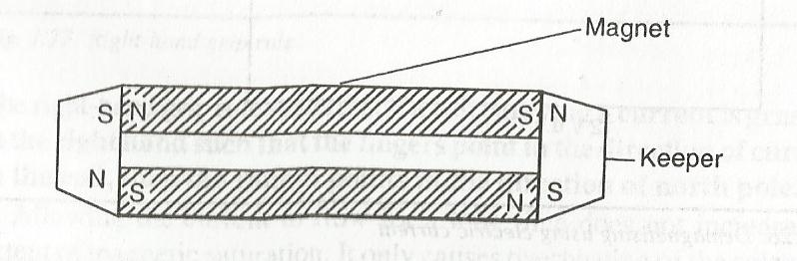

The keepers acquire polarities so that the dipoles in the magnet and the keepers form complete loops. The dipoles thus retain their orientation and magnetism is maintained.

**Uses of magnets**

Magnets have a wide application in real life. For example in hospitals, they are used to remove a piece of iron from the eye.

They are used in making compasses, loudspeakers, telephone receivers, bicycle dynamos, generators and electric motors.

**Magnetic field-**This is the region or space where the magnetic influence is felt.

**Magnetic lines of force-** This is the path along which a North Pole would move if free to do so.

**Shielding a magnetic material - A** process that limits the coupling of a magnetic field between two locations

**Self demagnetisation –** Is as a result of internal repulsion of like poles within the magnet.

**2.MEASUREMENT II**

**Engineer’s callipers**

It is used to measure distances on solid objects where ordinary metre rule cannot be used directly.

It consists of a pair of hinged steel jaws which are closed until they touch the object in the desired position.

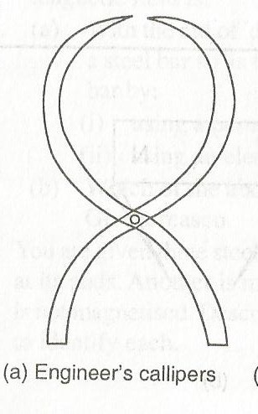

Diameters of round objects can be measured using outside and inside callipers. One kind is changed to the other by turning the jaws completely round as shown

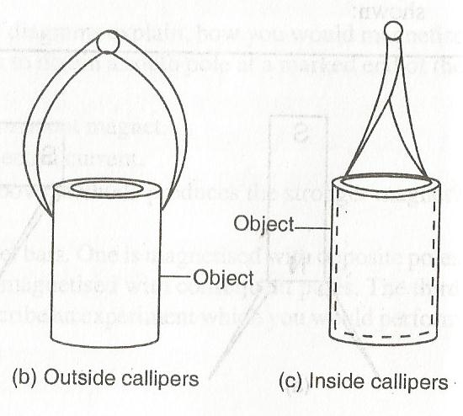

When using the callipers, the jaws are opened just to slip past the cylinder or the widest part of the sphere. The distance between the jaws is transferred and read on an ordinary scale as shown below

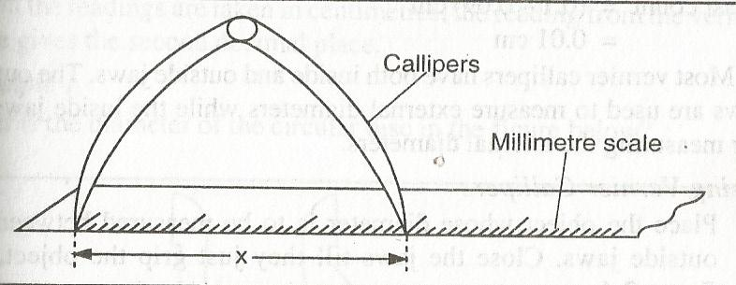

**VERNIER CALLIPERS**

A vernier calliper consists of a steel frame with a fixed jaw and a sliding jaw. The steel frame carries the main scale which is graduated in centimetres but also has millimetre division as shown

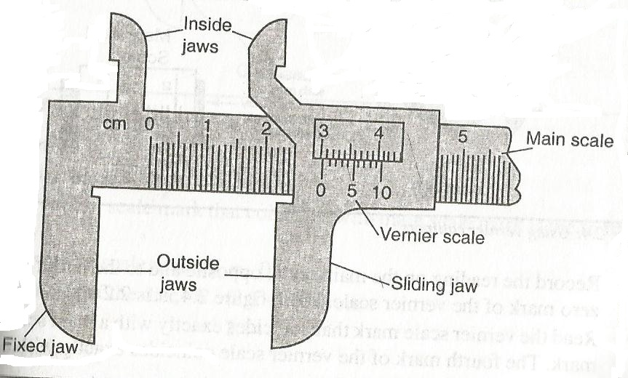

**Vernier calliper**

The name vernier refers to the special scale on the sliding jaw which gives reading to tenths of a millimetre. The vernier scale has 10 divisions which are slightly smaller than millimetres(actually) 0.9mm) this scale gives readings to 0.1 mm or 0.01 cm. The length of the vernier scale is 0.9cm. So, each division of the vernier scale is 0.09cm.

The difference in length between the main scale division and the vernier scale division is known as the **least count.**

**Least count=0.1-0.09=0.01cm**

Most vernier callipers have both inside and outside jaws. The outside jaws are used to measure external diameter while the inside jaws are used for measuring the internal diameter.

**Using vernier callipers**

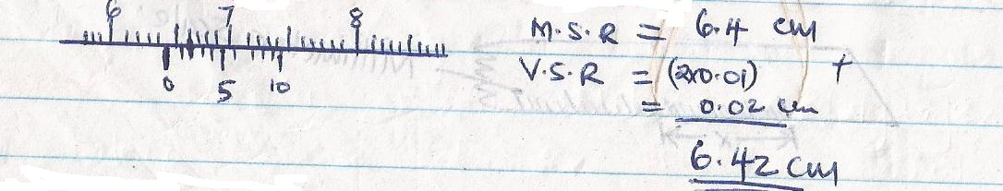

**Draw a vernier calliper with the following readings 5.08cm, 3.40cm and 0.87cm**

**ZERO ERROR**when the jaws of the vernier callipers are closed without an object between them, the zero mark should coincide with the zero mark of the vernier scale.

The vernier callipers have a zero error sometimes when the zero mark does not coincide with the zero mark of the vernier scale.

Measurements taken with such callipers are normally corrected by either adding or subtracting the zero error.

Negative errors are normally added to the reading and the positive errors are normally subtracted. The zero error can be positive or negative depending on the position of the zero mark.

**Example**

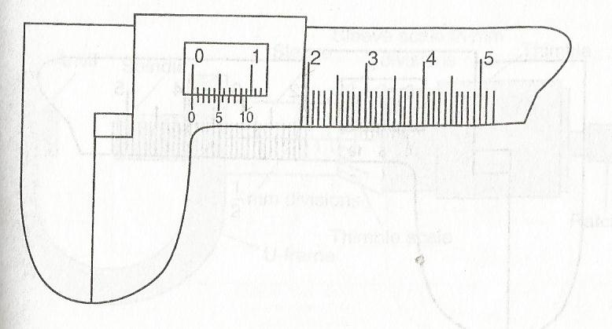

**Vernier calliper without a zero error**

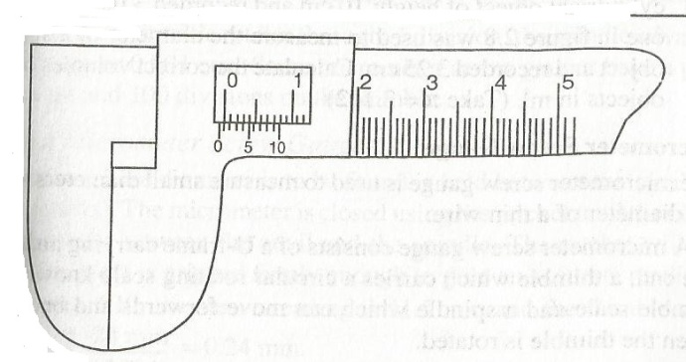

**Vernier calliper with a negative error (-0.03cm)**

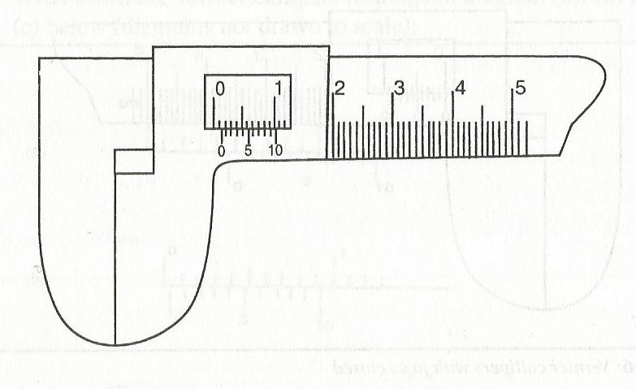 **Vernier callipers with a positive zero error (+0.14cm)**

**Example**

Use the vernier calliper in (b) above to get the correct reading in the vernier calliper below

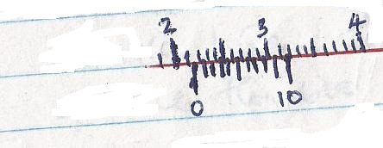

M.S.R= 2.10cm

V.S.R=3X0.01=0.03cm

2.13cm (add the zero error in (b) above)

0.03cm

2.16cm

**Assignment**

**a) Do exercise 2.2**

b) What is the reading indicated by the scale of the vernier calliper below?

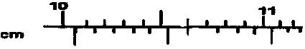

**MICROMETER SCREWGAUGE**

The micrometer screw gauge is used to measure small diameters such as the diameter of a thin wire. It consists of a U-frame carrying an anvil at one end, a thimble which carries a circular rotating scale known as a **thimble scale** and a spindle which can move forward and backwards when the thimble is rotated.

The ratchet at the end of the thimble prevents the user from exerting undue pressure on an object when the micrometer is in use. The sleeve has a linear scale in millimetre and the thimble has a circular scale of 50 equal divisions.

The distance moved by the spindle in one complete rotation of the thimble is known as the **pitch** of the micrometer.

The pitch of the micrometer is 0.5mm. Each division represents a spindle travel of

$(\frac{0.5}{50})mm$ = 0.01mm

If the thimble rotates through one division, the spindle advances by 0.01mm.

**NOTE:** Some micrometer screw gauges have a pitch of 1.0mm and 100 divisions on the thimble.

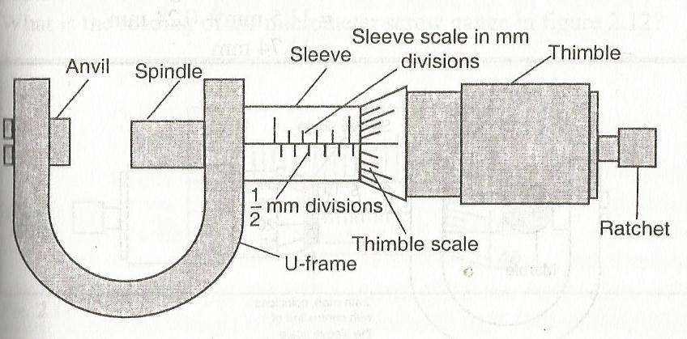

**USING A MICROMETER SCREWGAUGE**

The object whose diameter is to be found is held between the anvil and the spindle (jaws). The micrometer is closed using the ratchet until the object is held gently between the anvil and the spindle.The ratchet will slip when the object is gripped firmly enough to give accurate readings

**Example**

Find the reading in the figure below

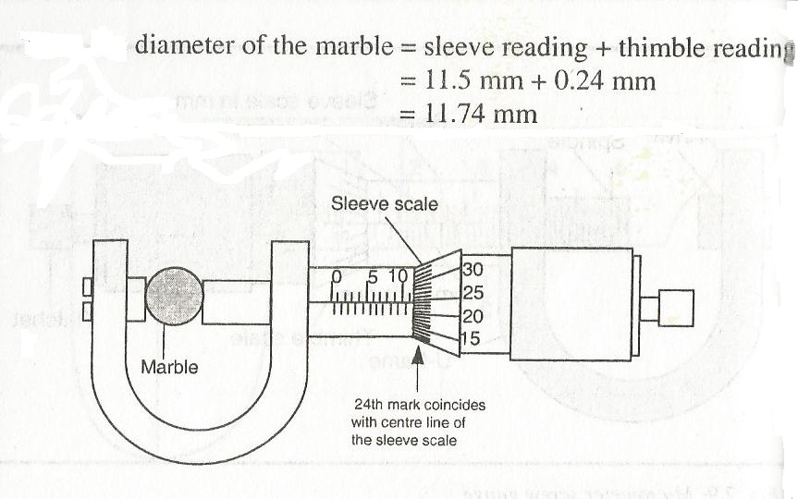

**Assignment**

Draw a micrometer screw gauge with the following readings; 5.52mm, 9.02mm

**ZERO ERROR**

**In** the micrometer screw gauge, there occurs a zero error. Arises when the zero mark of the thimble scale does not coincide exactly with the centre line of the sleeve scale when the micrometer is closed.

The anvil is used for adjustment of the zero error, so that the micrometer has no zero error.

However the zero error occurs when the centre line does not coincide with the zero mark of the thimble scale. For example in the figures shown below

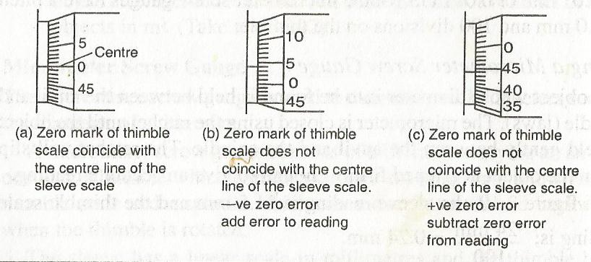

In (a) the zero mark of the thimble scale coincides with the centre line of the sleeve scale(no zero error).

In (b) above the zero mark of the thimble scale does not coincide with the centre line of the sleeve scale. It has a negative zero error and it is added to the reading.

In (c) the zero mark of thimble scale does not coincide with the centre line of the sleeve scale. It has a positive zero error and it is subtracted from the reading.

**EXAMPLE**

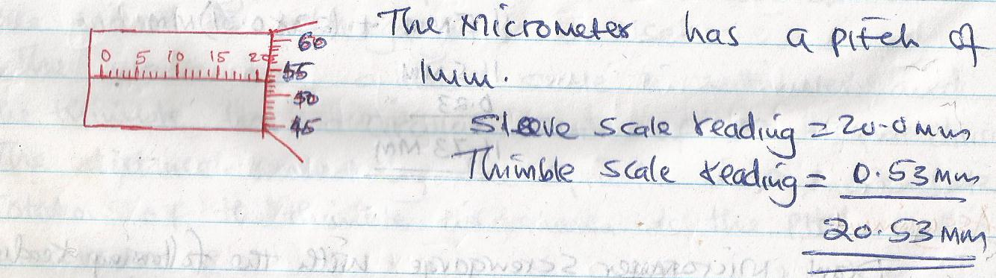

**SIGNIFICANT FIGURES**

The digits 1-9 are all significant when they appear in a number.

The first digit from the left of the number is the first significant number.

The number of significant figures is determined by counting the number of the digits from the first significant figure on the left.

Zero is sometimes significant and at times it is used as a place holder. When a zero occurs at the left end of a number, it is not significant. E.g. the zeros in 0.005m, 0.00025cm are just place holders. (in 0.075, the first significant number is 7).

If the zeros occurs between non-zero digits e.g. 20012 the zeros are considered significant.

If also zeros occurs at the right hand end after the decimal point, it is significant e.g. 2.0cm, 2.00cm ( 7.00m has 3 significant figures).

If the zero occurs at the right hand end of an integer it may or may not be significant e.g. 640000 could be correct to 2,3,4,5 or 6 significant figures. When expressed to 2 significant figures, none of the zeros is significant, conversely, to 6 significant figures all the zeros are considered significant.

**Example**

1. Find the area of a rectangle that measures 4.26m by 2.77m and write your answer correct to 2 significant figures and 4 significant figures.

**Solution**

**A=L X W = (4.26 X 2.77)CM2**

**11.8002CM2 (4 significant figure)**

**12 CM2 (2 significant figures)**

1. Calculate the area of a circle of radius 4.2cm correct to 3 significant figures. (take $Π=3.142)$

**THE STANDARD FORM**

A positive number is said to be in standard form when written as A x 10n, where A is such that 1≤A≤10 and the index n is an integer.

**Example**

**1026** can be written in standard form as 1.026 x 103

**NOTE:** when the number lies between 0 and 1, then the index n becomes negative E.g 0.00256 in standard form is 2.56 x 10-3

**Express the following numbers in standard form**

1. 2001
2. 0.087
3. 0.00000009876
4. 100000

The use of standard form is a convenient means of writing large and small quantities e.g. the speed of light is 3.0 x 108m/s.

**THE OIL DROP EXPERIMENT**

This is an experiment used to estimate the size of a molecule in a laboratory.

**THEORY**

When an oil drop is carefully put in contact with the surface of water, it spreads out to form a very thin layer, which is almost **circular.** This is because the oil breaks the surface tension of the water, whose particles pull away from the oil.

The thin layer is approximated to be one molecule thick.

**ASSUMPTIONS**

1. The oil is assumed to be **spherical** which can be calculated as **V=Πr3.**
2. The patch formed on the surface is almost **circular, A=Πr2.**
3. The thin layer is approximated to be **one molecule thick.**

Volume of the oil drop, V =Area of the patch, A x Thickness of the patch,(h)

V= Ah

h= $\frac{V}{A}$

h= $\frac{\frac{4}{3}Πr3.}{Πr2}$

**Estimating the size of a molecule**

**Examples**

1. In an experiment to estimate the size of a molecule of olive oil, a drop of oil of volume 0.12mm3 was placed on a clean water surface. The oil spread into a patch area of 6.0 x 104mm2. Estimate the size of a molecule of olive oil.

**V=V/A=0.12/6x104**

**=2.0 x10-6mm**

1. **In** an experiment to determine thickness of an oil molecule, a drop of oil of volume 1.0 x 10-4cm3 spreads to an area of 300cm2. Calculate the thickness of the film.
2. **Oil** contained in a needle’s 0.3mm wide, 0.6mm long and 0.2mm thick was used to form an oil film on water. The film was found to have a radius of 7cm. If the molecule in the oil film are spread into a single layer, estimate the thickness of the oil molecule

**TURNING EFFECT OF A FORCE**

The turning effect of a force is called **the moment of a force.** Force is that which changes the state of an object.

Moment of a force is the product of the force (F) and the perpendicular distance from the line of action of the force and the point of support. The point of support is called pivot/fulcrum.

Examples of activities in which a force produces a turning effect;

* Closing or opening a door
* Steering a car
* Turning of a water tap
* Tightening a nut

**Moment =Force(f) x Perpendicular distance**

**F x d**

The SI unit is Nm

**Example**

1. Find the moment of force in the figure below, if F=10N and d=30cm

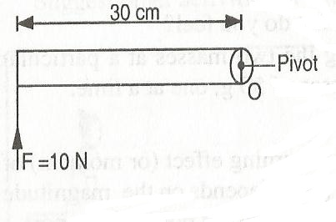

Moment of force about the pivot=Fd

=10 x 0.3= 3Nm

1. Find the moment of force in the figure below

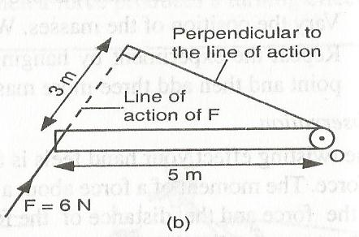

Moment =6 x 4

=24Nm

**PRINCIPLE OF MOMENTS**

Consider the following,

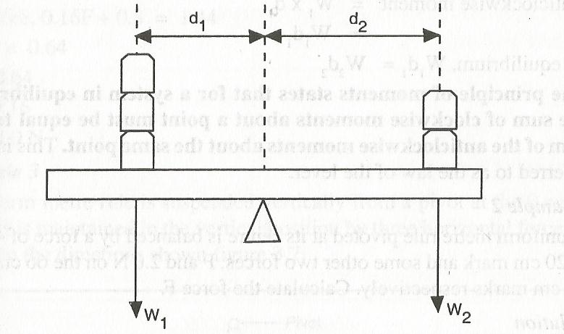

The force w1 tends to make the rule turn in an anticlockwise direction. The moment is due to w1 is called **anticlockwise moments.**

**The** force w2 tends to make the rule to turn in a clockwise direction. Its moment about the pivot is called **clockwise moments.**

**Clockwise moments=w2 x d2**

**Anticlockwise moments=w1 x d1**

**At equilibrium, w1 x d1 =w2 x d2**

**The principal of moments**

It states that, for a system in equilibrium, the sum of clockwise moments about a point must be equal to the sum of anticlockwise moments about the same point.

Also referred as the law of the lever

**Example**

1. A uniform metre rule pivoted at its centre is balanced by a force of 4.8N at 20cm mark and some other two forces, F and 2.0N on the 66cm and 90cm marks respectively. Calculate the force F.

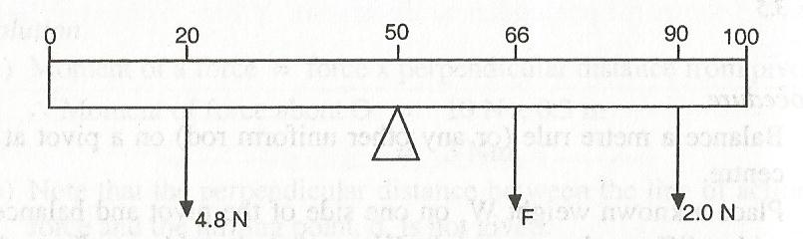

1. A uniform metre rule is suspended vertically from a pivot at the zero mark. It is maintained in the vertical position by three horizontal forces acting in the directions shown. Given that the 12.0N force acts through the 10cm mark while the 8.0N force acts through the 90cm, calculate F which acts through the 60cm mark.

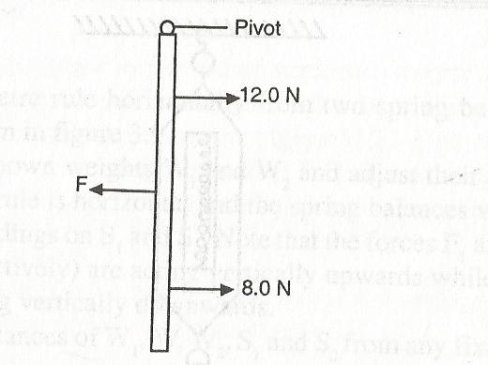

1. In the figure below shows a uniform bar which has negligible weight and is balanced under the action of force shown. Determine the value of X hence the length of the bar.
2. A very light uniform metre rule is balanced at its mid-point A, under forces of 10N, 5N and P acting at point 10cm, 80cm and 100cm points from the point respectively as shown. Find P

**Applications of anti-parallel forces**

1. **Steering wheel**

Cars are made to turn round corners by exerting two equal forces F, acting tangentially to the steering as shown.

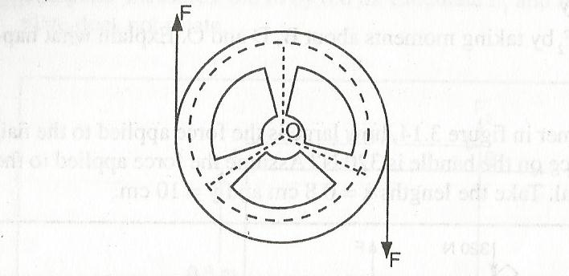

1. **Water taps**

A water tap is opened or closed by applying two equal forces as shown,

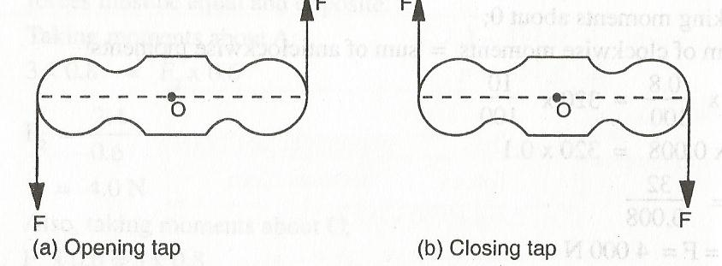

1. **Bicycle handle-bars**

When a bicycle is turned round a bend with both hands on the handle bars, two equal and opposite forces are applied.

The forces constitute anti-parallel forces which produce a moment about the axis of rotation O.

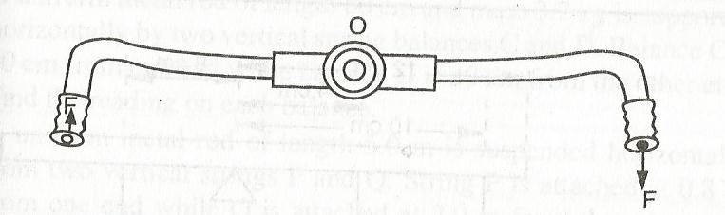

1. **Water sprinklers and wheel spanner**

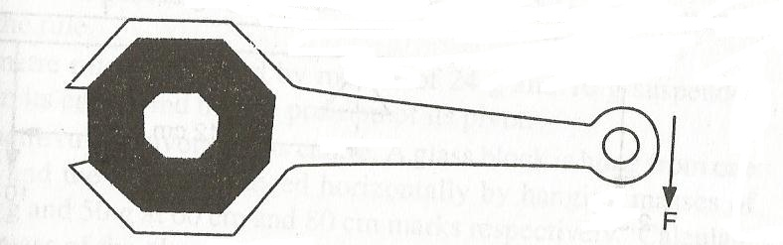

**EQUILBRIUM AND CENTRE OF GRAVITY**

**EQUILBRIUM** is the state of balance where the sum of clockwise moments is equal to the sum of anti-clockwise moments. When the state is achieved the body is said to be stable.

Stability depends on the **surface area of the base** and the **centre of gravity of the body.**

**The centre of gravity of a body** is the point where the whole weight of the body appears to act from or is the point of application of the resultant force due to the earth’s attraction on the body.

**Centre of gravity of objects with regular shapes**

The centre of gravity of a body depends on its shape. The centre og gravity can be determined by construction as shown,

|  |  |  |
| --- | --- | --- |
| **Object** | **Diagram** | **Centre of gravity** |
| Uniform rod | C:\Users\user\Documents\scanned pics\Scan.jpg | By balancing. The centre of gravity is at the centre of the rod |
| Metre rule | C:\Users\user\Documents\scanned pics\Scan.jpg | By balancing. The centre of gravity is at 50cm mark. |
| Square plate | C:\Users\user\Documents\scanned pics\Scan.jpg | Construct the diagonals. The point of intersection is the centre of gravity. |
| Rectangular plate | C:\Users\user\Documents\scanned pics\Scan.jpg | Construct the diagonals. The point of intersection is the centre of gravity. |
| Triangular plate | C:\Users\user\Documents\scanned pics\Scan.jpg | The point of intersection of the perpendicular bisectors of the sides is the centre of gravity. |
| Circular plate | C:\Users\user\Documents\scanned pics\Scan.jpg | The point of intersection of their diameters is the centre of gravity. |
| Cubic plate | C:\Users\user\Documents\scanned pics\Scan.jpg | The point of intersection of their diagonals is the centre of gravity |
| Cylinder | C:\Users\user\Documents\scanned pics\Scan.jpg | The point of intersection of vertical and horizontal axes (midpoints of axis) is the centre of gravity. |
| Sphere | C:\Users\user\Documents\scanned pics\Scan.jpg | The centre of the sphere (point of intersection of the diameter) is the centre of gravity. |
| Cone | C:\Users\user\Documents\scanned pics\Scan.jpg | Construct the perpendicular bisectors from the base. The point of intersection is the centre of gravity. |
| Ring | C:\Users\user\Documents\scanned pics\Scan.jpg | The point of intersection of the diameters is the centre of gravity |
| L-shape | C:\Users\user\Documents\scanned pics\Scan.jpg | Divide the shape into two. Construct the diagonals on each. Join the points of intersection and bisect the line. |
| Square with centre cut off | C:\Users\user\Documents\scanned pics\Scan.jpg | The point of intersections of the diagonals is the centre of gravity. |
|  |  |  |

**Centre of gravity of an irregularly shaped lamina**

**Experiment:** To determine the centre of gravity of an irregularly shaped object

**Apparatus:** Plump line, stand, cardboard on the edges

Set the apparatus as shown below,

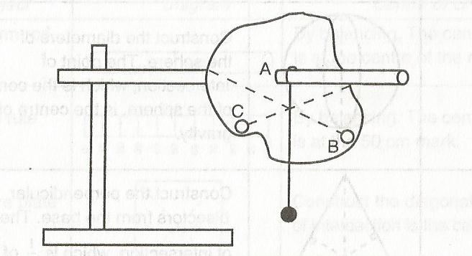

Remove the cardboard and balance it on the tip of a pencil.

**Observation**

**The** suspended object will always rest with its centre of gravity vertically below its point of support.

The object balances on the tip of the pencil it placed at its centre of gravity.

**Example**

1. **A** uniform metal bar, 100cm long balances at 20cm when a mass of 1.5kg is attached at the 0 cm mark as shown. Calculate the weight of the bar. (take g=10N/kg)

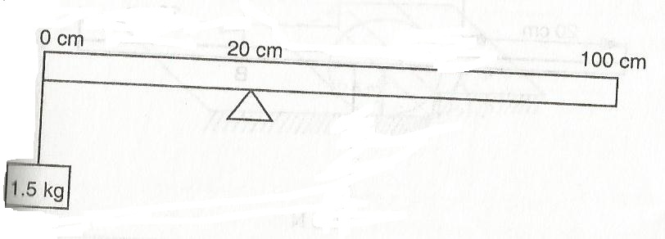

1. A uniform metre rule pivoted at the 60cm mark is kept horizontally by placing a 50g mass on 80cm mark. Calculate the mass of the metre rule. (take g=10N/kg)

**States of equilibrium**

There are three states of equilibrium;

1. Stable equilibrium
2. Unstable equilibrium
3. Neutral

Consider a wooden cone resting on a horizontal table in various positions i.e.

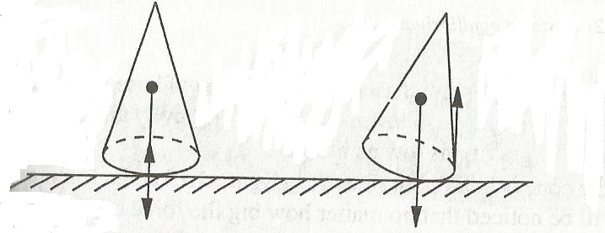

When the cone is tilted through a small angle by applying a force, the vertical line through the centre of gravity still falls inside the base. When the applied is withdrawn, the cone falls back to its original position. The cone is said to be **stable equilibrium.**

The cone has a broad base and low centre of gravity. When it is given a slight push, the centre of gravity is raised, but it falls back to make this centre of gravity as low as possible.

When the cone is balanced on its tip, a small sideway push causes the vertical line through its centre of gravity to fall outside the base. This makes the cone to topple over. The cone is said to be **unstable equilibrium**

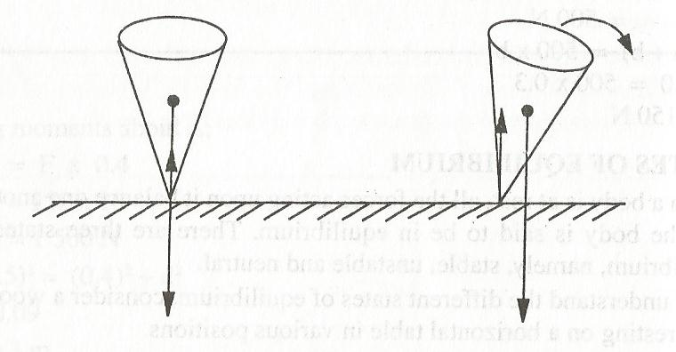

**The cone has a very small area** of base and high centre of gravity. A slight lowers its centre of gravity and it falls to make the centre of gravity as low as possible.

If the cone is laid on its sides, a force applied on it, will not change the centre of gravity. This condition is described as **neutral equilibrium**

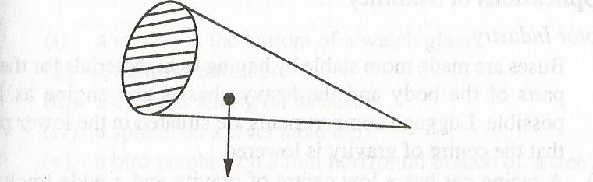

**Factors affecting stability of objects**

The stability of an object depends on the position of its centre of gravity and the turning effect of its weight about an axis or point.

1. **Area of the base**

If the base is large, the line through the centre of gravity of the body remains within the base even if the body is tilted through a large angle. A body with a broad base is more stable than the one with a narrow base.

1. **The position of the centre of gravity**

A body is more stable when its centre of gravity is as low as possible. This can be achieved by making the base heavier. Bodies with high centres of gravity are less stable.

**Applications of stability**

1. **Motor industry**

Bases are made more stable by having light materials for the upper parts of the body and heavy at the bottom.

A racing car has a low centre of gravity and a wide track which allows a large angle of tilt. It can negotiate corners with high speeds without toppling.

1. **Area of support**

* To alight from a moving bus, a person has to spread out his legs to increase the area of support. This lowers centre of gravity and increases stability.
* A person carrying a bucket of water in one hand has to lean or bend his body to the other side to adjust his centre of gravity.
* A Bunsen burner has a wide heavy base. This lowers centre of gravity.

**REFLECTION AT CURVED SURFACES**

Curved surfaces may be obtained from hollow shapes of spheres, cones or cylinders. When these surfaces are highly polished, they become reflectors.

In a sphere, if the inner surface is highly polished then the portion of the sphere is described as a **concave reflector** and if the outer portion of the sphere is highly polished, then the portion is described as a **convex reflector.**

**CURVED MIRRORS**

Curved mirrors whose reflecting surfaces curve inwards are called **concave mirrors** while those with reflecting surfaces bulging outwards are called **convex mirrors**

**Spherical mirrors..........**are mirrors made from spheres.

**A parabolic mirror..........is** a special curved mirror cut from a section of a cone.

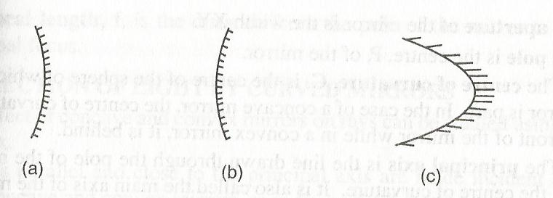

a)concave mirror b)convex mirror c)parabolic(concave) mirror

NOTE: silvering of the inner surface of glass produces a convex mirror, while a highly polished outer surface gives a concave reflector which behaves like a concave mirror.

**DEFINITION OF TERMS**

Consider the mirrors shown below,

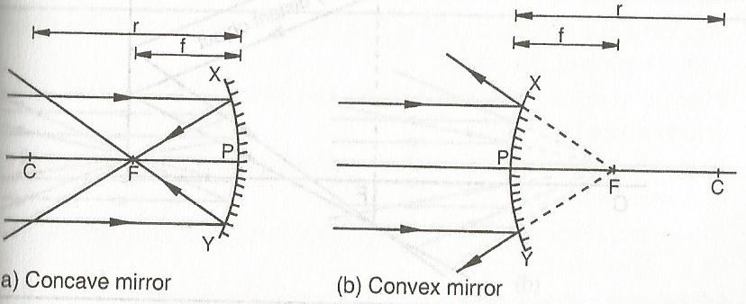

**TERMS**

1. **APERTURE**

This is the length of the curved mirror i.e. **XY**

1. **POLE**

This is the centre, P, of the mirror

1. **CENTRE OF CURVATURE, C**

This is the centre of the sphere which the mirror is part. For a concave mirror the centre of curvature is **in front of the mirror**, while for a convex mirror the centre of curvature is **behind the mirror.**

1. **PRINCIPAL AXIS**

Is the line joining the centre of curvature to the pole or centre of the mirror? (Main axis)

1. **PRINCIPAL FOCUS, F,**

Is a point on the principal axis to which all rays originally parallel and close to the principal axis converge (concave mirror) or from which they appear to diverge (convex mirror) after reflection by the mirror.

The principal focus of a concave mirror is a real focus, for the convex mirror the principal focus is virtual focus. (Not real)

1. **FOCAL PLANE**

A plane perpendicular to the principal axis and passes through the principal focus

1. **Radius of curvature(r)**

Is the radius of the sphere of which the mirror is part (distance PC)

1. **Focal length(f)**

Is the distance from the pole of the mirror to its principal focus?

A ray of light that is close to and parallel to principal axis meets a concave mirror and is reflected through a point on the principal axis called a **focal point.** For a convex mirror (diverging mirror), this is the point where the reflected ray appear to originate.

A concave mirror has a **real principal focus** while a convex mirror has a **virtual principal focus.**

**Virtual rays** are represented by dotted lines. All rays should be arrowed to show the direction in which the light is travelling.

If parallel rays, incident on the mirror are not parallel to the principal axis they will converge at a point of the principal axis such that the line joining that point to focal point is perpendicular to the principal axis.

For rays to be converged to a point they must be close to the principal axis or the aperture must be small.

**REFLECTION OF LIGHT BY CURVED MIRRORS**

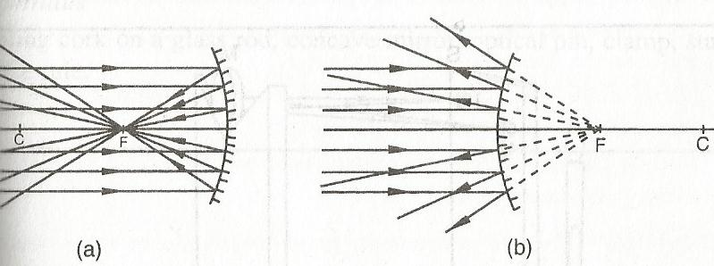

In a concave mirror, the rays converge at a point F, after reflection. For a convex mirror, the rays are reflected so that they all appear to diverge from the principal focus F behind the mirror.

For a ray converging at the principal focus (F), a parallel beam is obtained for both the concave and convex mirror after reflection as shown,

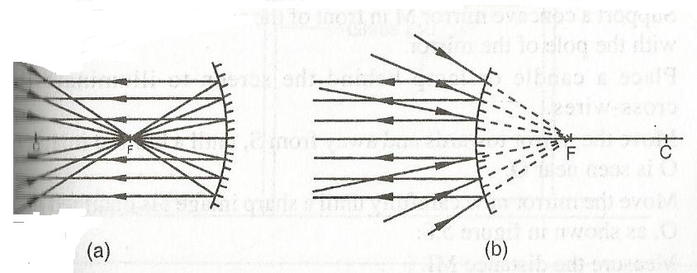

This shows that light rays are reversible. This is a demonstration of the **principle of reversibility of light** which states **that the paths of light rays are reversible.**

**LAWS OF REFLECTION AND CURVED MIRRORS**

Laws of reflection apply to both concave and convex mirrors i.e.

1. Incident ray, reflected ray and the normal lie on the same plane at the point of incident.
2. The incident angle is equal to the reflected angle, i=r

The normal drawn at the point of incidence in curved mirrors passes through the centre of curvature C.

An incident ray parallel and close to the principal axis is reflected through F in a concave mirror and appears to come from F in a convex mirror

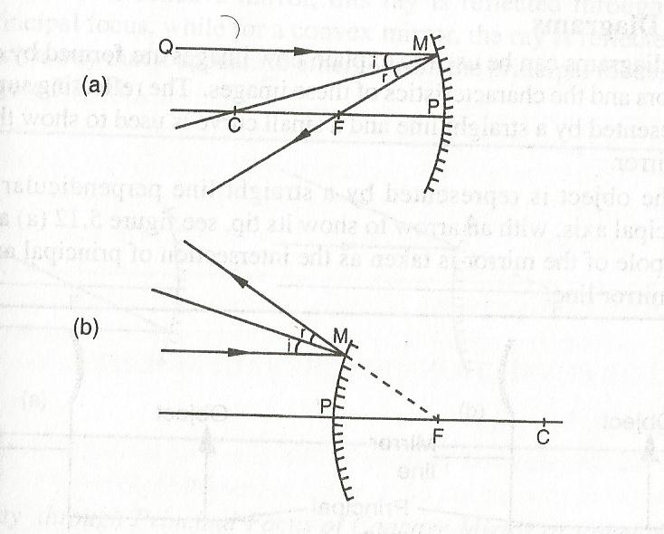

<i=<r

<ABC=<BCF

<i=<BCF

<CBF is isosceles

CF=BF

CF=1/2CP

CF=1/2r

CF=FP=focal length

F=1/2r or f=r/2

NB: The focal length of a concave mirror is half the radius of curvature, r (f=r/2)

**RAY DIAGRAMS**

Ray diagrams can be used to explain how images are formed by curved mirrors and the characteristics of these images.

The reflecting surface is represented by a straight line and a small curve used to show the type of mirror as shown

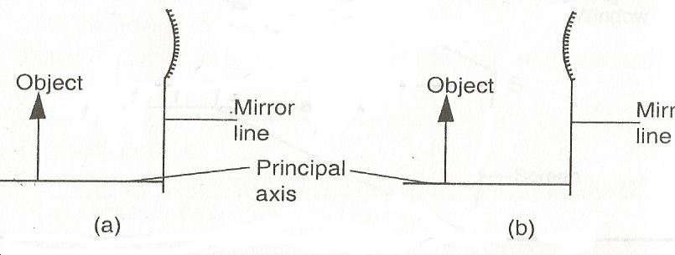

Concave convex

The following are used or observed in the construction of ray diagrams;

1. **A ray through C or passing through C**

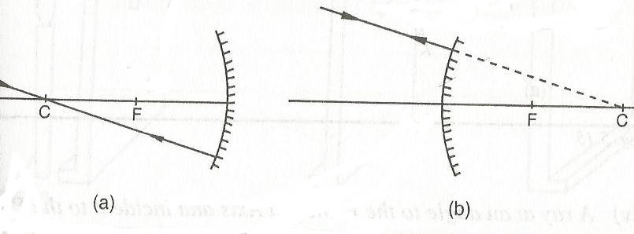

**Concave convex**

1. **A ray parallel and close to the principal axes passes through the focal point after reflection as shown**

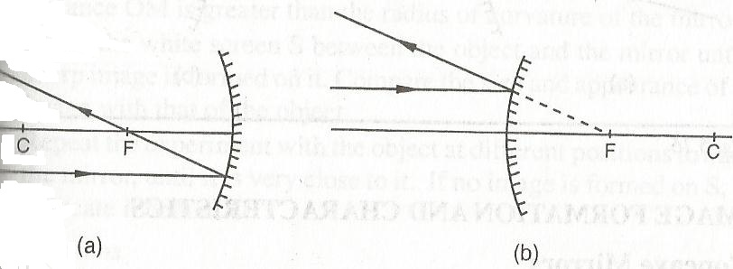

1. An incident ray passing through F is reflected parallel to the principal axis

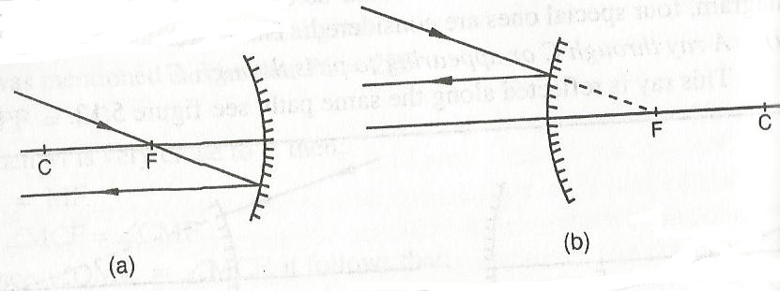

1. A ray at an angle to the principal axis and incident to the pole. The ray is reflected in a such a way that the angle of incidence is equal to the angle of reflection as shown

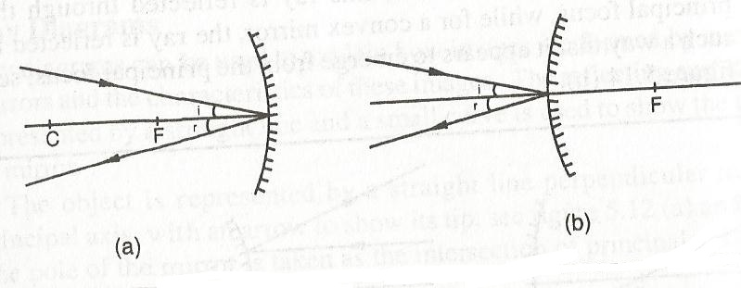

**IMAGE FORMATION AND CHARACTERISTICS**

The nature, size and position of the image of an object formed by a **concave mirror** depend on its position (distance) from the mirror,

1. **Object at infinity**

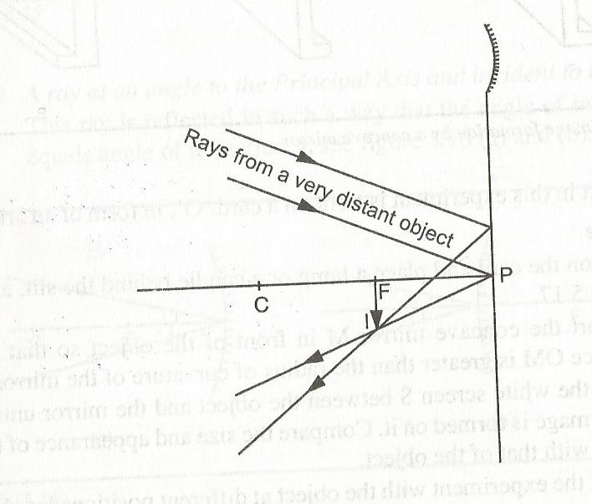

The image is;

1. The image formed is smaller than the object
2. Inverted
3. Real
4. Formed at F
5. **Object beyond C**

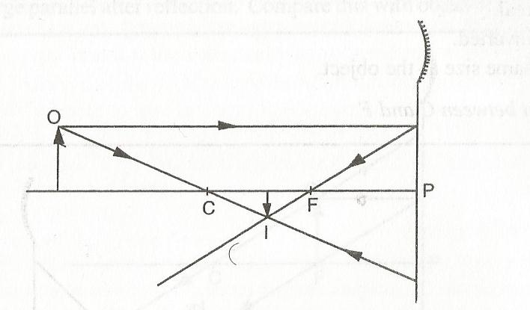

The image formed is,

1. Between C and F
2. Real
3. Inverted
4. Smaller than the object
5. **OBJECT AT C**

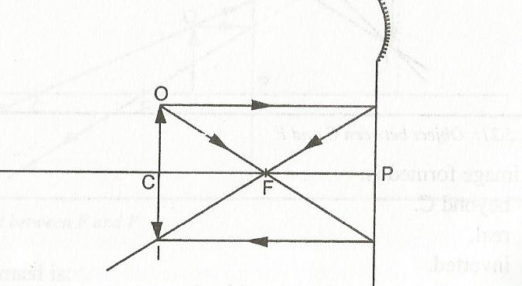

The image formed is;

1. At C
2. Real
3. Inverted
4. Same size as the object
5. **OBJECT BETWEEN C AND F**

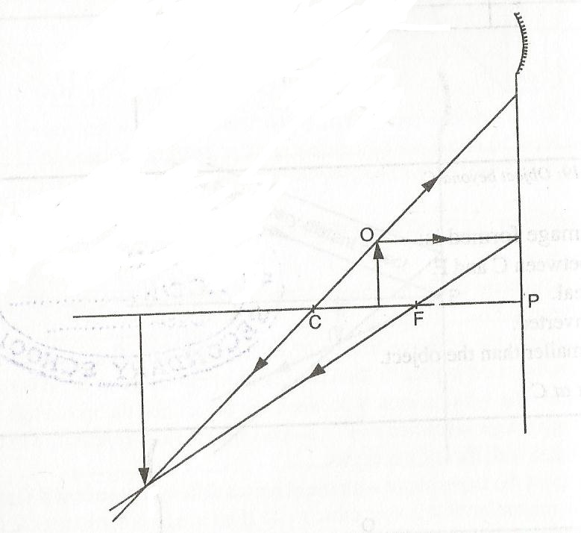

The image formed is;

1. Beyond C
2. Real
3. Inverted
4. Magnified (larger than the object)
5. **OBJECT AT F**

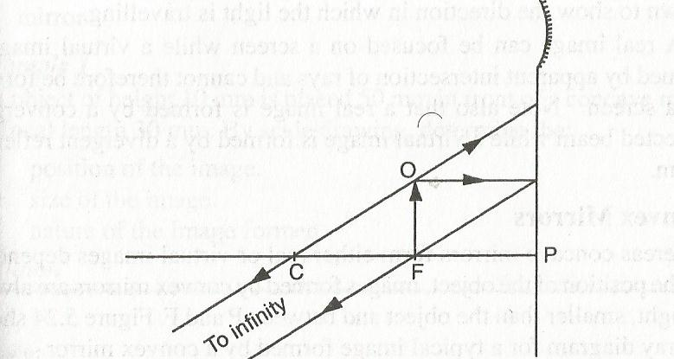

The object formed is at **infinity**

1. **OBJECT BETWEEN F ANF P**

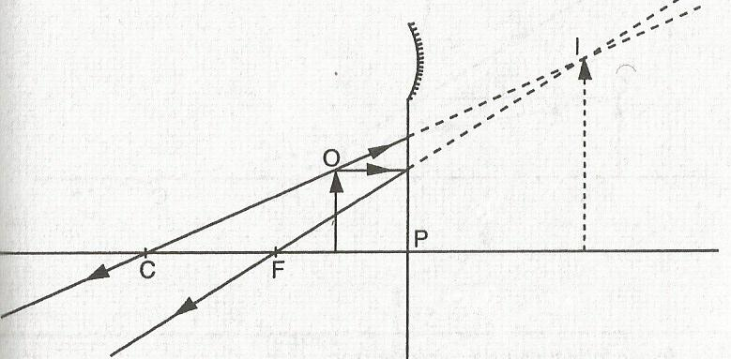

Image formed is;

1. Behind the mirror
2. Virtual (not real)
3. Erect (upright)
4. Larger than the object

**NOTE:** full lines represent **real rays** and **objects** while dotted lines represent **virtual rays and images.**

In a ray, an arrow is drawn to show the direction in which light is travelling.

A real image can be focussed on a screen while virtual images are formed by apparent intersection of rays and cannot be formed on a screen.

**CONVEX MIRRORS**

Concave mirrors form either real or virtual images depending on the position of the object. Images formed by convex mirrors are always **upright, smaller than the object and between P and F** as shown,

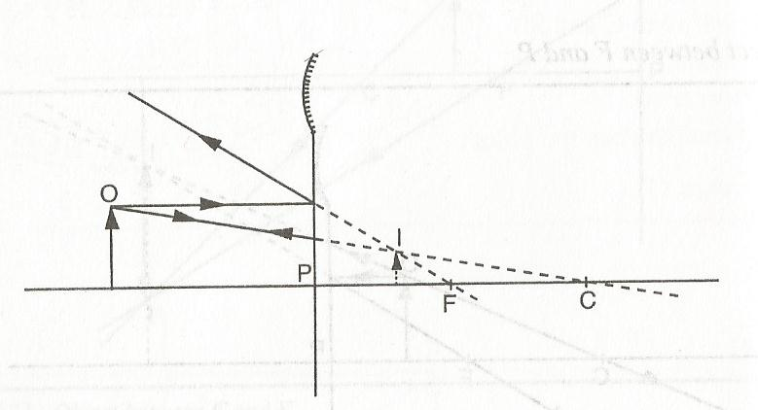

**GRAPHICAL CONSTRUCTION OF RAY DIAGRAMS**

Images obtained from a curved mirror can be drawn to scale in a ray diagram. The construction of a ray diagram is best done on a graph paper using a suitable scale.

**Examples**

1. An object of height 10mm is placed 50mm in front of a concave mirror of focal length 30mm. By scale drawing, determine;
2. Position of the image (distance)
3. Size of the image
4. Nature of the image formed
5. A convex mirror of focal length 9cm produces an image on its axis 6cm away from the mirror. If the image is 3cm high, determine by scale drawing;
6. The object distance from the mirror
7. The size of the object

**LINEAR MAGNIFICATION**

Images formed by curved mirrors vary in size. It is therefore important to compare the size of the object with that of the image formed.

The comparison of the image size with object size is called **magnification.**

**Magnification** is given by;

Magnification, M = $\frac{height of image}{height of object}$

Magnification can also be given by;

Magnification, M = $\frac{image distance (V)}{object distance (u)}$

Therefore, M= $\frac{v}{u}$

**Examples**

1. **A** concave mirror of focal length 20cm forms a sharply focussed image of a small object on a screen placed at a distance 80cm from the mirror. Graphically determine;
2. The position of the object
3. Linear magnification of the image.
4. A concave mirror of focal length 20cm produces an upright image of magnification 2. Graphically determine the object distance. (ho:hi)
5. **A** concave mirror of focal length 10cm forms a real image four times the size of the object. If the object. If the object height is 5cm, determine graphically;
6. The object distance
7. The image distance

**Relationship between focal length, f and radius of curvature, r**

F= $\frac{r}{2}$

**THE MIRROR FORMULA**

If an object is at a distance U from a curved mirror of focal length f, its image is formed at a distance V from the mirror.

The object distance U, image distance V and focal length f can be related by the formula;

$\frac{1}{f}$ = $\frac{1}{U}$ + $\frac{1}{V}$

This is called **the mirror formula** and applies to all spherical mirrors

$\frac{1}{f}$ = $\frac{1}{U}$ + $\frac{1}{V}$

$\frac{1}{f}$ = $\frac{U+V}{UV}$

f= $\frac{UV}{U+V}$

**SIGN CONVENTION**

To determine the position and nature of the image formed by curved mirror, a sign convention is normally used.

**Real-is-positive sign convention**

When applying this convention;

1. All distances are measured from the mirror as the origin.
2. Distances are real objects and real images are considered positive (+).
3. Distances of virtual objects and images are considered negative (-).
4. A concave mirror has real principal focus (F) and therefore **positive focal length,** while a convex mirror has a virtual principal focus hence has **a negative focal length.**

**Example**

1. An object is placed 30cm from a concave mirror of focal length 20cm. Calculate;
2. Image position
3. Magnification

f=+20cm, U= +30cm

$\frac{1}{f}$ = $\frac{1}{U}$ + $\frac{1}{V}$

$\frac{1}{20}$ = $\frac{1}{30}$ + $\frac{1}{V}$

V= +60cm

Image is 60cm from the mirror and real (+)

M = 60/30

=2

1. An object is placed a) 18cm and b) 4cm in front of a concave mirror of focal length 12cm. Determine the position and nature of the image formed in each case;
2. U= +18cm, f=+ 12cm

$\frac{1}{f}$ = $\frac{1}{U}$ + $\frac{1}{V}$

$\frac{1}{12}$ = $\frac{1}{18}$ + $\frac{1}{V}$

V =36cm

The image is formed 36cm from the mirror. The image is since it is positive.

1. U= +4cm, f= +12cm

$\frac{1}{f}$ = $\frac{1}{U}$ + $\frac{1}{V}$

$\frac{1}{12}$ = $\frac{1}{4}$ + $\frac{1}{V}$

V=-6cm

The image formed is 6cm from the mirror and is virtual since V is negative.

1. A convex mirror of focal length 9cm produces an image on its axis 6cm from the mirror. Determine the position of the object.

f= -9cm (convex mirror), V= -6cm

$\frac{1}{f}$ = $\frac{1}{U}$ + $\frac{1}{V}$

$\frac{1}{-9}$ = $\frac{1}{U}$ + $\frac{1}{-6}$

U= +18cm

The object is real since U is positive and 18cm in front of the mirror

**Practice questions**

1. A convex mirror of focal length 18cm produces an image on its axis 3cm from the mirror. Calculate the position and nature of the object.
2. An object is placed 18cm in front of a convex mirror of focal length 10cm. Calculate the image distance and state the nature of the image formed.
3. The distance between an erect image and the object is 30cm. The image is twice as tall as the object.
4. What is the object distance?
5. Determine the radius of curvature

**Graphical analysis of the mirror formula**

1. If a graph of 1/u against 1/v is plotted, a straight line with a negative gradient is obtained i.e

(cm-1)

(cm-1)

Therefore the image is inverted relative to the object.

The X-intercept and the Y-intercept gives $\frac{1}{f}$ of the mirror used.

1. If a graph of UV against (U+V) is plotted, a straight line passing through the origin is obtained i.e

UV(cm2) = + rearranging

f= $\frac{uv}{u+v}$

U+V (cm)

The gradient gives the focal length of the mirror

From the formula;

$\frac{1}{f}$ = $\frac{1}{U}$ + $\frac{1}{V}$ (multiply by V)

$\frac{v}{f}$ = $\frac{v}{u}$ + 1 but $\frac{v}{u}$ = m

$\frac{v}{f}$ = $m$ + 1 therefore m = $\frac{v}{f}$- 1

A graph of m against V is a straight line i.e.

m

-1 v (cm)

The gradient of the graph is $\frac{1}{f}$ and y-intercept is -1

**APPLICATIONS OF CURVED MIRRORS**

**CONCAVE MIRRORS**

They are used as;

1. **Shaving mirrors**

When the object is placed within the focal length of the mirror, a magnified erect image is obtained.

1. **By dentists when examining teeth**

When the object (teeth) is placed within the focal length of the mirror, a magnified erect image is obtained as shown;

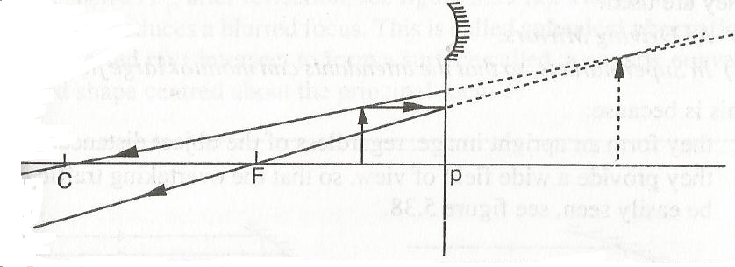

1. **In telescopes for astronomical observations**

When an object as at infinity (very far) e.g. a star, the rays from any point on it appears to originate from a particular point and is therefore parallel. The image is thus formed at the focal point.

1. **As a reflector behind a projector lamp**

The lamp is placed at the centre of curvature of the concave mirror to reflect light travelling away from the projector, hence increasing the illumination of the slide.

1. **Solar concentrators**

The heat and light energy from the sun can be brought to focus by a concave mirror e.g. in solar cookers, parallel rays are converged or concentrated at the focal point of a concave mirror.

**CONVEX MIRRORS**

They are used;

1. As driving mirrors
2. In supermarkets

This is because;

* The form an upright image regardless of the object distance
* They provide a wide field of view  
  **DISADVANTAGE**

In driving mirror, the image formed is diminished giving an impression that vehicles behind are further away than they actually are. This is dangerous.

**DEFECTS OF SPHERICAL REFLECTORS**

For a concave mirror, incident rays parallel and close to the principal axis called **paraxial rays,** converge at the principal focus F.

But rays parallel to the principal axis and not close to the principal axis called **marginal rays** are not brought to focus at the principal focus but behind it. The parallel beam produces **blurred** focus after reflection. This is called **spherical aberrations.** The reflected rays intersect to form a surface called **a caustic curve.**

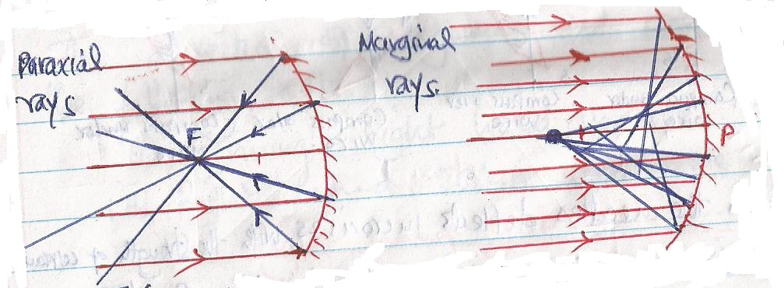

**Paraxial rays marginal rays**

This defect (spherical aberration) may be overcome by using **parabolic reflector** as shown,

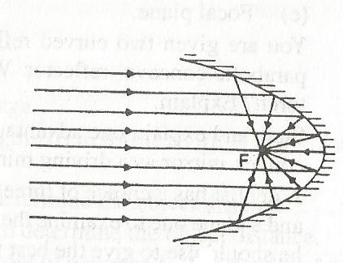

**Parabolic reflector............**focus the ray parallel (**marginal rays)** to a common focus.

**MAGNETIC EFFECT OF AN ELECTRIC CURRENT**

**Relationship between electric current and magnetism**

**(Oersted experiment)**

Magnetic effect of an electric current was discovered by Oersted in 1819.

He discovered that the direction of a compass needle near the current carrying conductor changes immediately the current the current is switched on.

The direction of the compass also depends on the relative position of the compass from the wire and also the direction of the current.

Therefore it implies that there is a relationship between an electric current and magnetism. i.e.

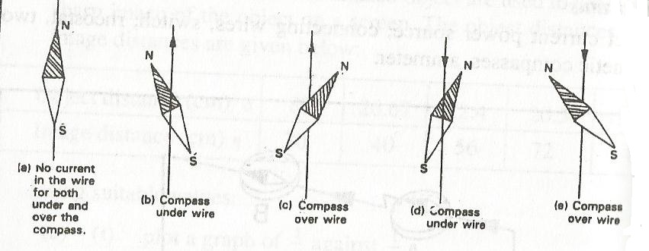

The extent to which the needles deflects increases with the strength of current flowing. Reversing the direction of current reverses the direction of deflection.

**Magnetic field due to electric current**

A magnetic field around a straight current carrying conductor is a pattern of concentric circles as shown

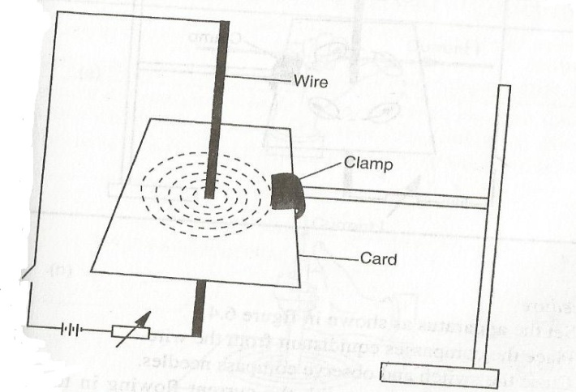

When the card is tapped, the iron filings settle in concentric circles round the wire due to influence of magnetic field around the wire. As the distance from the centre increases, the concentric circles become less significant.

**The direction of the magnetic field**

If several plotting compasses are used instead of iron filings we will have the following;

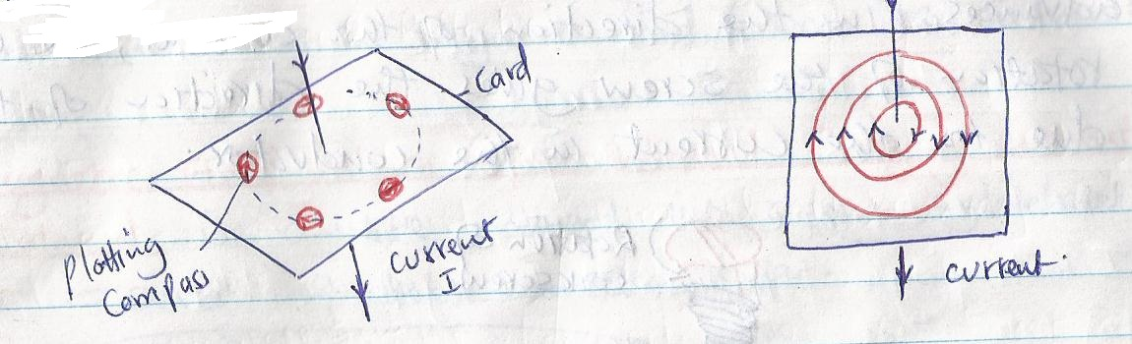

When the direction of current is reversed, the compass needle points in the opposite direction. This implies that the direction of the field reverses when the current direction is reversed.

**Rules for determining the direction of magnetic field**

The direction of magnetic field can be determined using the following rules

1. Fleming’s right hand grip rule
2. Right hand corks screw rule

**Fleming’s right hand grip rule**

If a conductor carrying current is grasped in the right hand and with the thumb pointing along the wire in the direction of **current,** the fingers will point in the direction of the **magnetic field** as shown below,

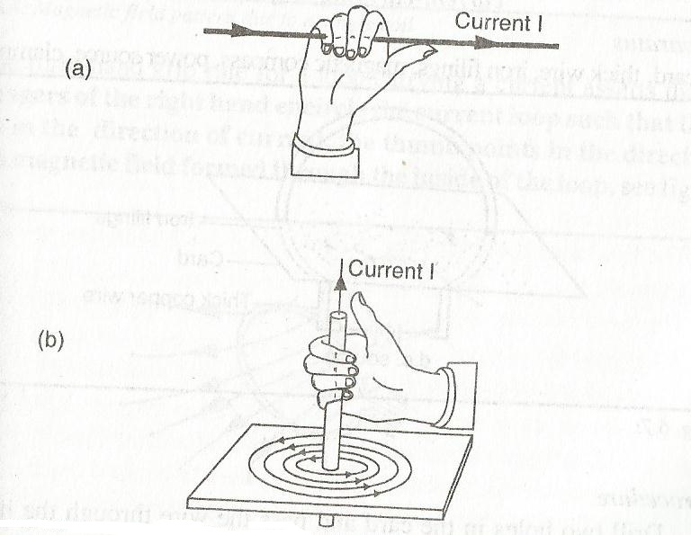

**Maxwell’s corkscrew rule**

If a right handed screw is driven forward in the direction of conventional current, then the direction of rotation of the screw is the direction of the field lines.

If you imagine holding and turning a screw in your right hand with the screw pointing in the direction of current, in turning it in clockwise so that it advances in the direction of the current, the clockwise rotation of the screw gives the direction of the field due to the current in the conductor.

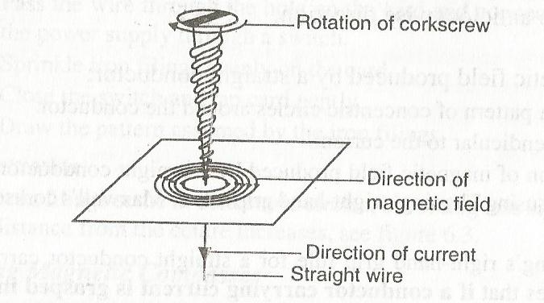

**Magnetic field pattern of a circular current-carrying conductor**

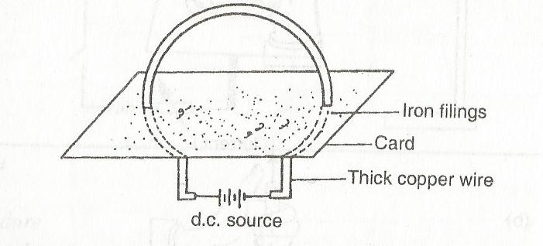

If iron filings are sprinkled on the cardboard in the above set up and the current switched on, the iron fillings form a pattern similar to a small magnet.

When current is switched and compass needles used instead of iron fillings they trace the magnetic field and give its direction when the switch is closed as shown.

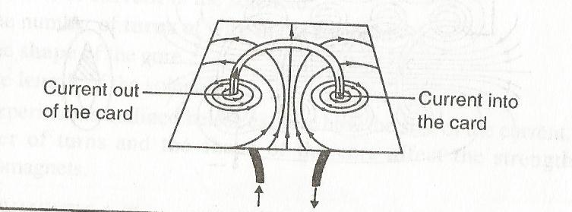

The right hand grip rule for current carrying loop states that, if fingers of the right hand encircle the current loop such that they point in the direction of current, the thumb points in the direction of the magnetic field formed through the inside of the loop.

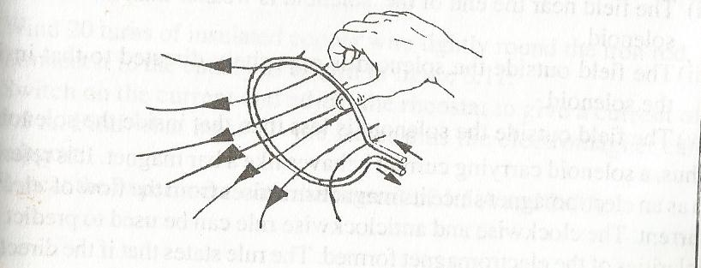

**Magnetic field pattern of a solenoid carrying current**

**A solenoid** is a wire wound into a long cylindrical coil with a series of interconnected loops as shown;

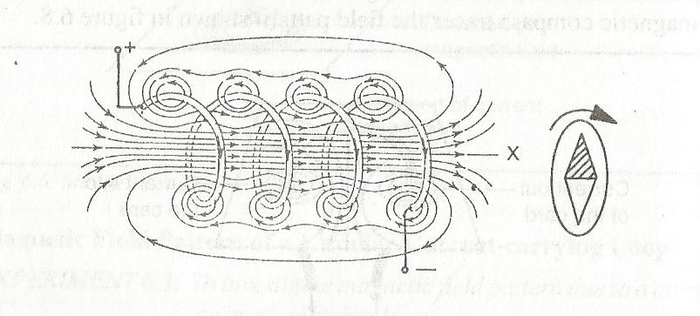

When a compass needle is placed at end X, its North Pole is repelled.

When the field inside and outside the solenoid is explored, the following properties emerge

1. The field near the ends is non-uniform compared to the field inside the solenoid.
2. The field near the end of the solenoid is weaker than that inside the solenoid.
3. The field outside the solenoid is oppositely direct to that inside the solenoid.
4. The field outside the solenoid is less than that inside the solenoid.

Thus a solenoid carrying current behaves like a bar magnet. It is referred as **electromagnet** since its magnetism arises from the flow of current.

The clockwise and anticlockwise rule can be applied to predict the polarities of the electromagnet formed. The rule states that, **if the direction of current in the coil as observed from one end is clockwise, this end is the south pole and if current is anticlockwise the end becomes the north pole.**

The right hand grip rule can also be applied to predict the north pole of an electromagnet as follows; **if a coil carrying current is held in the right hand such that the fingers encircle the loops while pointing in the direction of current flow, the thumb points in the direction of North Pole.**

Example

Identify the polarities in the figures below

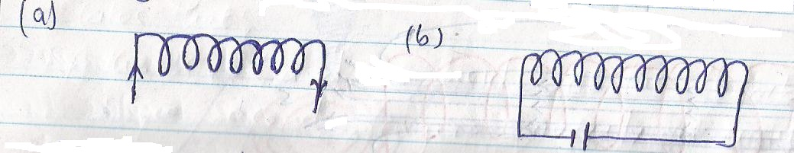

Practical electromagnets require that coils be wound on a soft iron core to increase magnetic power.

The factors affecting the strength of the electromagnet include;

1. **The size of current in the solenoid**

When current is increased the strength of the magnet also increases. Beyond a particular value, the strength of the electromagnet remains constant.

1. **The number of turns of wire in the solenoid**

Increasing the number of turns increases the strength of an electromagnet.

1. **The shape of the core**

The strength of an electromagnet depends on the shape of the core i.e. iron bar or u-shaped core.

1. **The length of the solenoid**

The strength of an electromagnet increases with increase in length.

**FORCE ON CURRENT-CARRYING CONDUCTOR IN A MAGNETIC FIELD**

Consider the figure below

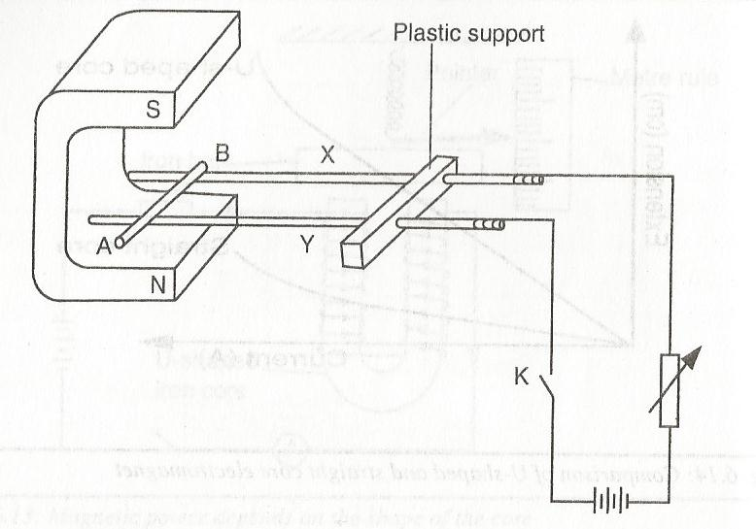

When the current flows along AB, the rod rolls along the brass rod X and Y towards the plastic support.

When either the direction of the current or that of the magnetic field is reversed, the direction of the movement of AB also changes.

When current is increased the rod moves faster.

When the magnet is turned so that the magnetic field is parallel to the length of AB, the rod remains stationary.

A force acts on a current-carrying conductor when it is placed in a magnetic field. The magnitude of this force increases with increase in current and therefore field strength.

The force is maximum when the angle between the conductor and the field is 90o and becomes zero when the conductor is parallel to the field.

The force also increases with increase in the length of the conductor in the magnetic fields.

The fields tend to concentrate more on one side than the other as shown below

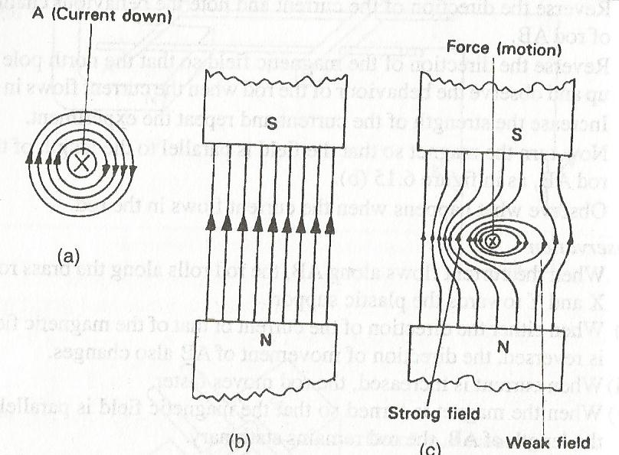

(as viewed from A)

The weak field is due to the two fields opposing each other. Magnetic lines of force act like elastic bands, concentration of the lines on the other side of the conductor produces a catapult effect that pushes the conductor in the opposite direction.

When the direction of current or magnetic field is reversed, the direction of the force on the conductor also reverses.

For a conductor carrying current in a magnetic field the direction of the force acting on it can be predicted using Fleming’s left hand rule.

**FLEMING’S LEFT HAND RULE (MORTAR RULE)**

States that;

If the left hand is held with the thumb, the first finger and the second finger mutually at right angles so that the first finger points in the direction of **field** and the second finger in the direction of the **current,** then the thumb points in the direction of **motion** as shown

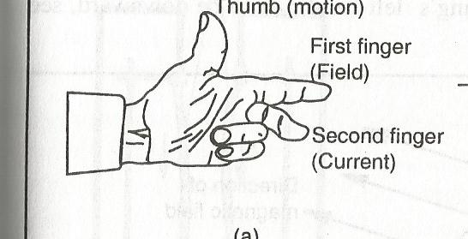

**NOTE:** The direction of current in this rule is the conventional direction, i.e. the direction of flow of positive charge. It should be noted that the rule applies only if the magnetic field and current are perpendicular to each other. When the field and current are parallel to each other, there is no force on the conductor.

**Force on a current carrying coil in a magnetic field**

The figure below shows a rectangular coil ABCD put in a magnetic field

, 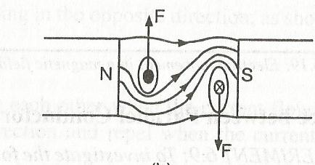

When the current flows through the coil in the direction DCBA, the resultant field pattern is as shown below

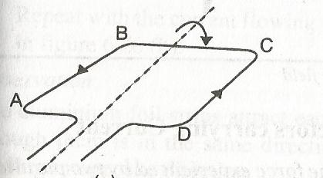

The catapult force acting on the sides of the coil causes it to turn in clockwise direction. Application of Fleming’s left hand rule makes it easier to predict the direction of motion than drawing the field pattern.

**FORCE ON A CHARGED PARTICLE IN A MAGNETIC FIELD**

Moving charges produce a magnetic field. An electron moving through a magnetic field will therefore experience a force.

Considering that the direction of movement of electron is opposite to the flow of conventional current, the direction of the force on the charge can be predicted using Fleming’s left hand rule to be downward as shown

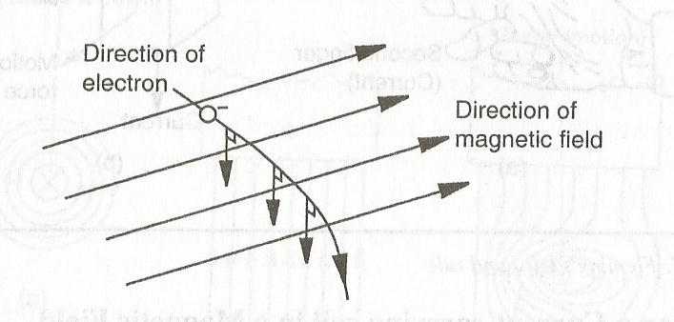

**FORCE BETWEEN PARALLEL CONDUCTORS CARRYING CURRENT**

Two parallel aluminium foil strips attract each other when current is flowing through them is in the same direction and repel when the current is flowing in the opposite direction.

The magnetic field patterns are as shown below,

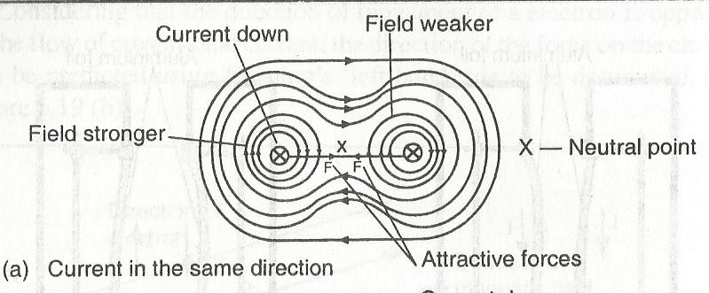

The fields between the strips cancel each other, leaving a region of zero resultant magnetic fields called **neutral point.**

The field on the outside part of each strip act as a catapult forces, pushing the two strips towards each other.

1. Current in opposite directions

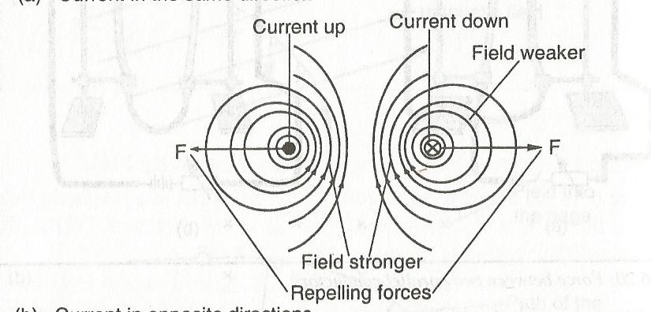

1. The magnetic fields between the two strips reinforce each other. The two strips therefore are pushed away from each other.

Fleming’s left hand rule can be applied to the two situations above.

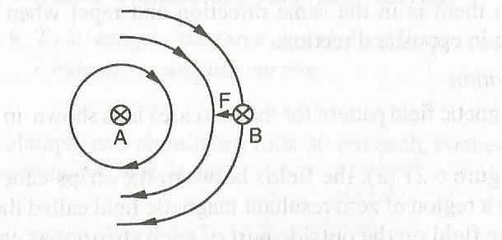

If strip A is taken to produce the field, Fleming’s left-hand rule applied at B is towards A. If strip B is taken to produce the field, the rule indicates that the force on A is towards B.

**Magnetic field patterns of a conductor carrying current in the earth’s magnetic field**

The earth’s magnetic field lines are taken to be parallel, except at the poles. The interaction of the field due to the earth and that due to the conductor produces the pattern shown below,

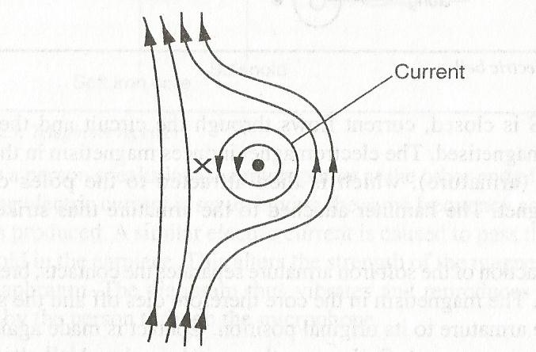

The conductor thus experiences a force

**USES OF ELECTROMAGNETS**

Electromagnets are used in various industrial and domestic instruments or devices such as;

1. **Electrical bell**

An electric bell consists of a u-shaped electromagnet whose winding on one arm is opposite to that of the other. A contact screw presses onto a soft iron strip, which acts as a spring. Its completed through a battery and switch S.

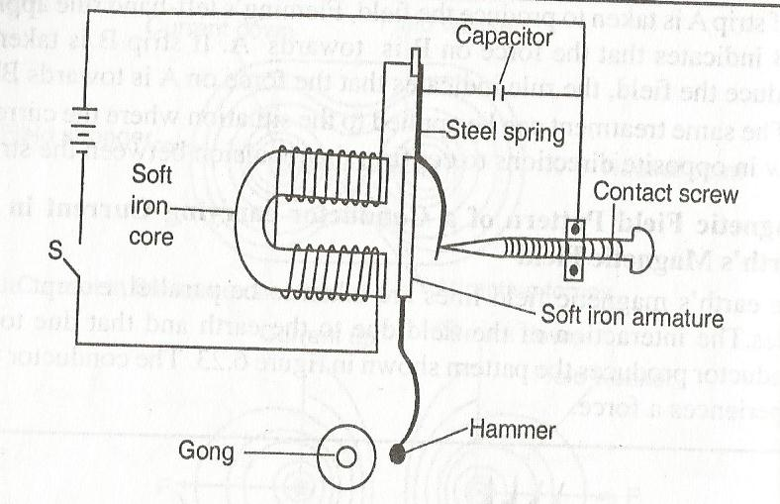

When the switch S is closed, the current flows through the circuit and the core becomes magnetised, the electromagnet induces magnetism in the soft iron strip (armature), which is then attracted to the poles of the electromagnet. The hammer attached to the armature thus strikes the gong.

The attraction of the soft iron armature separates the contacts breaking the circuit. The magnetism in the core therefore dies off and the spring returns the armature to its original position. Contact is made again and the process is repeated.

So long as the switch is closed, the hammer strikes the gong repeatedly, making continuous ringing sound. The steel spring and screw contact where the current is automatically switched on and off constitute a make-and-break mechanism. The frequency at which the make and break takes place is controlled by the screw.

1. **Electric motor**

An electric motor is a device that converts electrical energy to rotational kinetic energy.

A simple direct current electric motor consists of insulated wire ABCD, which can turn about a fixed axis and a strong curved permanent magnet to provide a radial magnet field as shown,

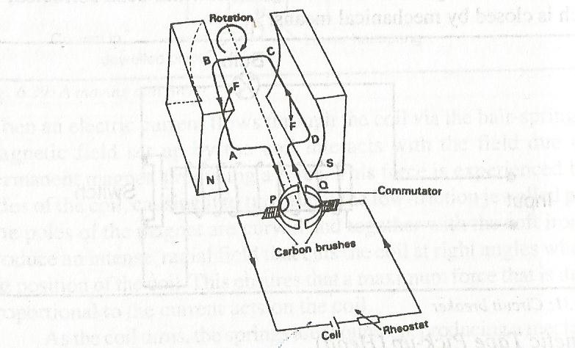

The current enters and leaves the coil through a split copper ring called **commutator** having two halves P and Q insulated from each other. Carbon brushes press slightly against the commutator and are connected to battery terminals.

When the coil is in horizontal as shown above, and the current switched on, it flows through the coil in the direction as shown. By Fleming’s left hand rule, side AB of the coil experiences an upward force and side CD a downward force. Since the current in both sides is the same, the forces are equal and opposite. This forces cause the coil to rotate in clockwise direction until it reaches its vertical position with side AB up and CD down.

In this position, the brushes touch the space between the two halves of the split rings, cutting off current flowing in the coil. Consequently, no force acts on the sides AB and CD. Since the coil is in rotation, its momentum carries it past this position and the two split rings exchange brushes. The direction of current through the coil is reversed and consequently the direction of force on each side of the coil changes. This process is called **commutation.**

Side AB is now on the right hand side and side CD on the left hand side. Side AB experiences a downward force and side CD an upward force. The coil ABCD will continue rotating in the clockwise direction so long as the current is flowing through it. The speed of rotation of the coil increases with increase in the strength of the current flowing through the coil.

If the terminals of the battery are interchanged, the direction of current reverses and the direction of rotation of the coil are reversed.

Sides AB and CD do not experience any force because current in these sides is parallel to the direction of the magnetic field.

The simple direct current electric motor described is not powerful. It can be improved by;

1. Winding the coil on a soft iron core. The soft iron core becomes magnetised and concentrates its magnetic field in the coil.
2. Increasing the number of turns of the rotating coil.
3. Using a stronger magnet
4. Multiplying the number of coils and commuter segments.

**HOOKE’S LAW**

Materials are selected for particular uses depending on their qualities to withstand the forces they may be subjected to. The following characteristics are used to describe materials;

1. **Strength**

This is the ability of a material to resist breakage when under stretching, compressing or shearing force. A strong material is one which can withstand a large force without breaking.

1. **Stiffness**

This is the resistance a material offers to forces which tend to change its shape or size. Stiff materials are not flexible and resist bending.

1. **Ductility**

This is the quality of a material which leads to permanent change of size and shape. Materials which elongate considerably under stretching forces and undergo plastic deformation until they break are known as **Ductile** materials e.g. plasticine, lead, copper and wrought iron.

Ductile materials can be rolled into sheets, drawn into wires or worked into useful shapes without breaking. They are used in making such implements as stables, rivets and paper clips.

1. **Brittleness**

This is the quality of a material which leads to breakage just after the elastic limit is reached. Brittle materials are fragile and do not undergo any noticeable extension on stretching, but snap suddenly without any warning e.g. chalks, bricks, cast iron, glass and dry biscuits.

1. **Elasticity**

This is the ability of a material to recover to its original shape and size after the force causing deformation is removed.

A material which does not recover but deformed permanently is called **plastic** e.g. plasticine while those that can regain their shapes once the force causing deformation is withdrawn are called **elastic** e.g. rubber bands, springs and metal wires.

**STRETCHING OF MATERIALS**

The forces between the molecules in a solid account for its characteristic elastic or stretching properties. When a solid is stretched, the spaces between its molecules increase slightly. The tension felt in a stretched material e.g. rubber band, is due to all the forces of attraction between molecules in it.

**EXPERIMENT: To investigate the stretching of a spiral spring**

**APPARATUS:** A spiral spring with a pointer attached to it, a metre rule, retort stand, two sets of clamps and bosses, 20g masses.

Arrange the apparatus as shown,

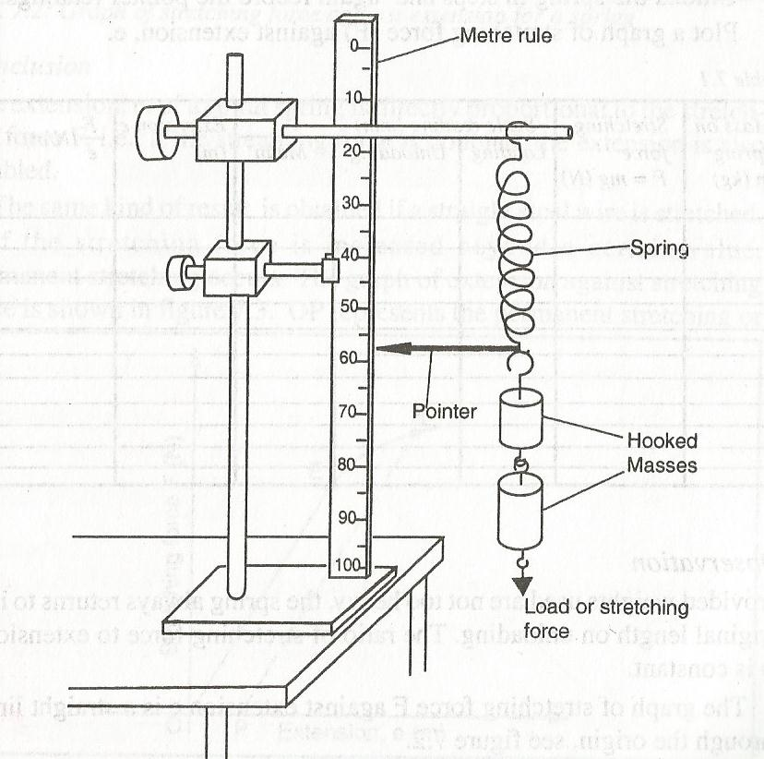

Note the position of the pointer when the spring is unstretched, or not loaded.

Suspend a mass at the end of the spring and note the new position of the pointer.

Increase the load in steps of 20g and record the reading of the pointer for each load as shown in the table.

Unload the spring in steps and again record the pointer readings.

**NOTE:** Care should be taken not to use too heavy weights which would overstretch the spring.

|  |  |  |  |  |  |  |
| --- | --- | --- | --- | --- | --- | --- |
| Mass on the spring m (kg) | Stretching force F=mg(N) | Scale reading (Cm) | | | Extension, e( m) | F/e (N/m) |
| loading | unloading | mean |
|  |  |  |  |  |  |  |
|  |  |  |  |  |  |  |
|  |  |  |  |  |  |  |
|  |  |  |  |  |  |  |
|  |  |  |  |  |  |  |
|  |  |  |  |  |  |  |

Plot a graph of stretching force (F) against extension, e

**Observation**

Provided the weights are not too heavy, the spring always returns to its original length on unloading. The ratio of stretching force to extension is constant.

The graph of stretching force F against extension, e is a straight line through the origin as shown

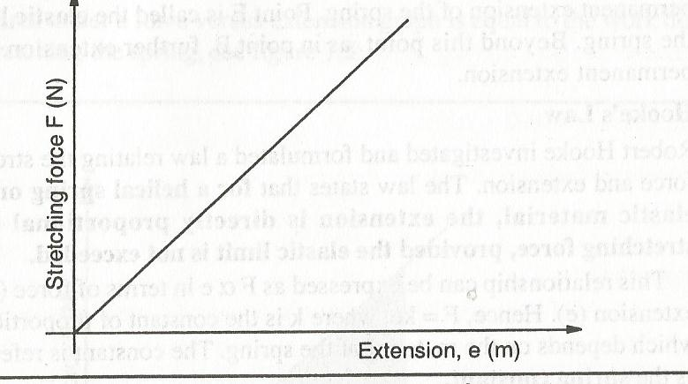

**Conclusion**

The extension, e, of a spiral spring is directly proportional to the stretching force F.

The same kind of result is obtained if a straight steel wire is stretched. If the stretching force is increased beyond a certain value, permanent stretching occurs. The graph of extension against stretching force is as shown

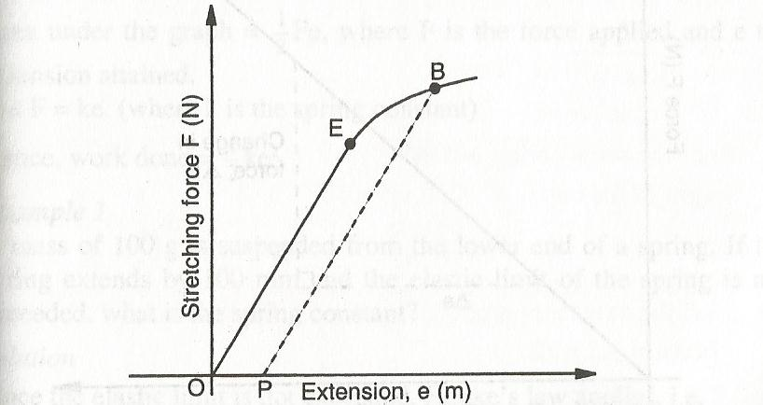

Beyond point B, further extension causes permanent extension

**HOOKE’S LAW**

This is a law relating the stretching force and extension. It states that for a helical spring or other elastic material, **the extension is directly proportional to the stretching force provided the elastic limit is not exceeded i.e.**

**F∞e**

**Hence F= Ke** ( K is a constant of proportionality and it depends on the material of the spring)

The constant is also referred as **spring constant**

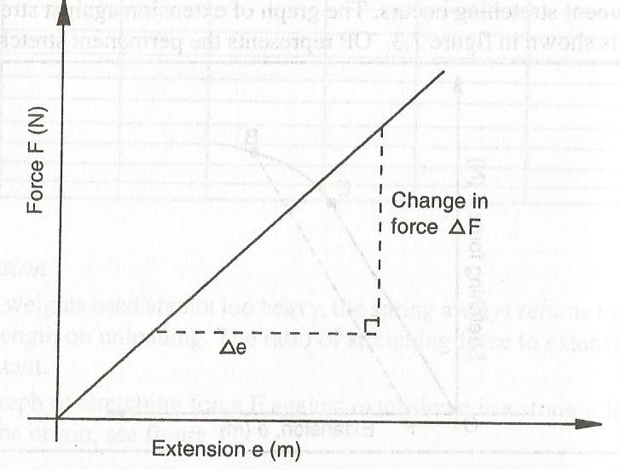

The gradient from the figure above is the spring constant, whose units are N/m or Nm-1.

The area under a force against extension graph is equal to the work done in stretching the spring as shown

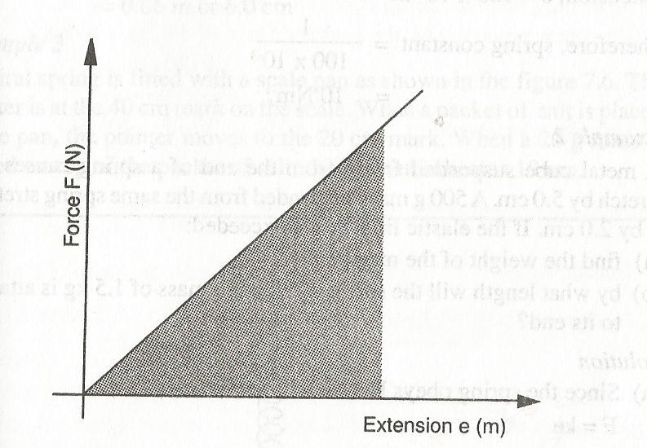

Area under the graph = ½ Fe but f=Ke and K=F/e

Area =½Ke2

Hence work done =½Ke2

Examples

1. A mass of 100g is suspended from the lower end of a spring. If the spring extends by 100mm and elastic limit is not exceeded, what is the spring constant?
2. A metal cube suspended freely from the end of a spring causes it to stretch by 5.0cm. a 500g mass suspended from the same spring stretches it by 2.0cm. if elastic limit is not exceeded;
3. Find the weight of the metal cube
4. By what length will the spring stretch if a mass of 1.5kg is attached to its end?

**Compressing a spring**

When the two ends of a spring are squeezed together, it shortens. There is change in length that is referred to as **compression.** The spring on its part exerts a counter force which resists the **compression.**

The variation of length against compression of a spring obeys Hooke’s law as shown

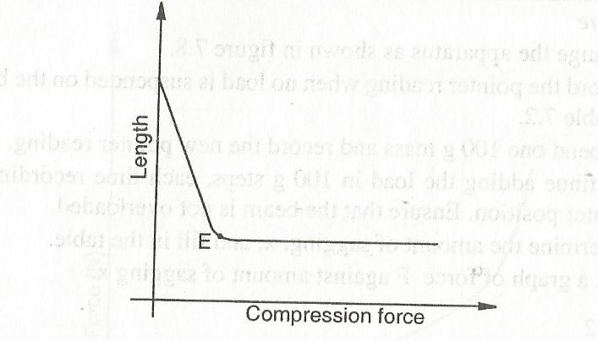

Beyond the point E, the turns of coils are virtually pressing onto one another and further increase in the force achieves no noticeable decrease in length

**Hooke’s Law applied to loading of Beams**

**(Experiment: 7.2: To investigate the sagging of beams)**

A graph of load against amount of sagging, X, is a straight line through the origin. This shows that the sagging is in accordance with Hooke’s law.

Some materials regain their original shapes after being stretched, even though they do not extend according to Hooke’s law e.g. rubber. Rubber stretches by a large amount for a small increase of force but beyond a certain point tends to stiffen up showing a very little extension with increase in force.

Brittle materials like concrete and glass exhibit elasticity but suddenly snap without becoming plastic.

Materials like polythene and metal wires display elasticity, but go through plasticity before snapping.

**Combination of springs in series and parallel**

**Series combination**

Ks=½K1 (K1 is one of the spring constants)

Ks=K1/n (where n is the number of springs)

**Parallel combination**

Kp=2K1 (K1 is one of the spring constants)

Kp=nK1 (n is the number of springs)

**Example**

A spiral spring produces an extension of 6mm when a force of 3.0N is applied to it. Calculate the spring constant for a system when two such springs are arranged in (a) series (b) parallel

**Waves**

A wave is a transmission of a disturbance. Waves can be classified as;

1. Electromagnet waves
2. Mechanical waves

**Electromagnetic waves**

These waves do not require material medium for transmission e.g. radio waves, radiant heat, light and microwaves

**Mechanical waves**

They require a material medium for transmission. This transmission is effected by the vibration of the particles in the medium e.g. water waves and sound waves.

Mechanical waves can either be transverse or longitudinal

**Transverse waves**

The vibration of the particles is at right angles to the direction of the wave travel e.g. water waves, waves on a string and electromagnetic waves (light, radio and microwaves)

Formation of transverse waves on a slinky spring or a rope may be used. The spring or rope is stretched along a smooth floor or bench top. One end is attached to a rigid support while the other end is held in the hand. The end held in the hand is swung up and down at right angles to the spring or rope as shown;

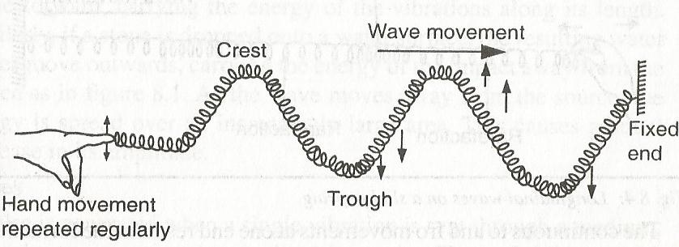

The displacement of an individual particle in relation to the direction of wave motion is as shown;

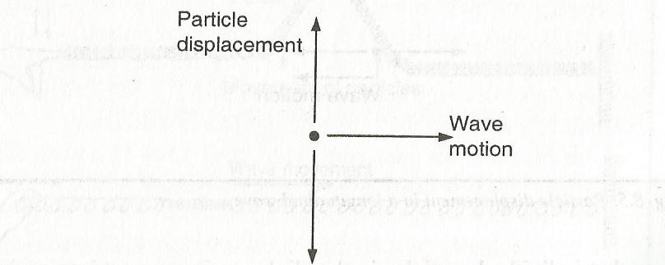

**Longitudinal waves**

The vibration of the particles is in the direction parallel to the direction of the wave travel e.g. sound waves.

Formation of a longitudinal wave, a slinky spring may be used as shown;

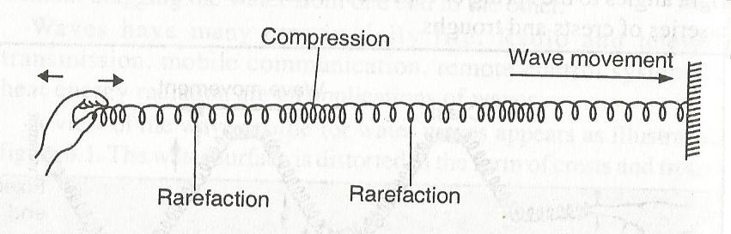

The continuous to and fro movements at one end result in the formation of sections of compression alternating with rarefactions along the length of the spring.

The displacement of a particle in a longitudinal wave in relation to the direction of wave motion is as shown

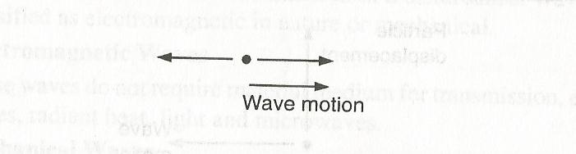

The wave motion affects the inter-particle spacing. Particles in the sections of compression are pushed closer together while in those in rare factions are pulled slightly farther apart.

Variation in inter-particle separation is accompanied by variation in pressure, so that sections under compressions are at higher pressure while those under rare faction are at low pressure. This variation causes the wave motion.

**Progressive Waves**

These are waves that move continually away from the source. They can be transverse or longitudinal. For example if a long slinky spring is continuously vibrated at one end, the waves move forward, carrying the energy of the vibrations along its length. Also a stone dropped in a water surface, the resulting water waves move outwards carrying the energy of the impact away from the source. As the waves moves away from the source, the energy is spread over an increasing large area. This causes gradual decrease in wavelength.

**Pulses**

**A** pulse is generated when a single vibration is sent through a medium. It can be transverse or longitudinal in nature as shown;

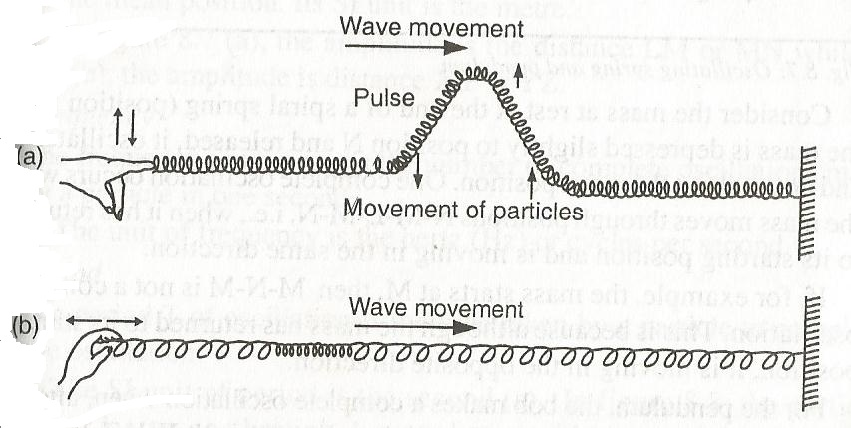

**Note: W**ave trains are generated as a result of continuous vibrations at a constant rate in a medium. The medium is distorted into repeated patterns of crests alternating with troughs for transverse waves while for longitudinal wave train; the medium is set into repeated patterns of section of compression alternating with those of rarefaction.

**Characteristics of wave motion**

Can be explained with reference to the oscillatory motion of a mass attached to a spring or that of the bob of a swinging pendulum as shown;

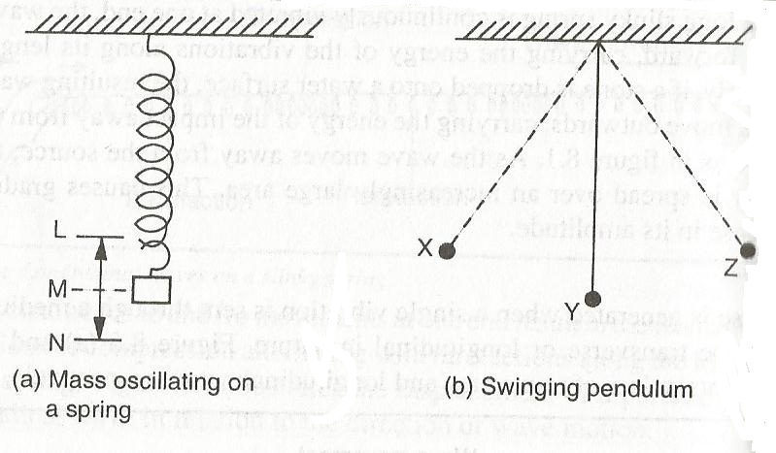

One complete oscillation occurs when the mass moves through positions N-M-L-M-N i.e. when it has returned to its starting position and is moving in the same direction.

**NOTE:** M-N-M is not a complete oscillation. This is because although the mass has returned to its starting position, it is moving in the opposite direction.

For the pendulum, the bob makes a complete oscillation when, after an initial displacement to say, position X, it swings through X-Y-Z-Y-X as shown above.

If the mass takes 2 seconds to a complete oscillation, a sketch of displacement-time graph for the motion will appear as shown

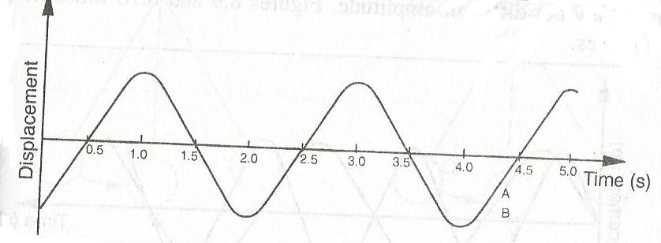

**The following terms are associated with waves,**

1. **Amplitude**

The amplitude A of a wave is the maximum displacement on either side of the mean position. S.I unit is metre (m).

LM or MN and XY and YZ are the amplitudes of the waves.

1. **Frequency**

The frequency f of a wave is the number of complete oscillations made by a particle in one second.

The S.I unit of frequency is the **hertz (Hz)** or cycles per second.

1. **Period**

The period T of oscillation is the time taken by a particle to complete one oscillation.

The S.I unit of period is seconds (s).

In the figure above, the particle takes 2 seconds to go through one complete oscillation and its period therefore 2 seconds.

F= $1/T$ and

T=1/f =1/2 = 0.5 Hz

1. **Wavelength ,λ**

A transverse wave train viewed from the side would give a displacement-position graph as shown below;

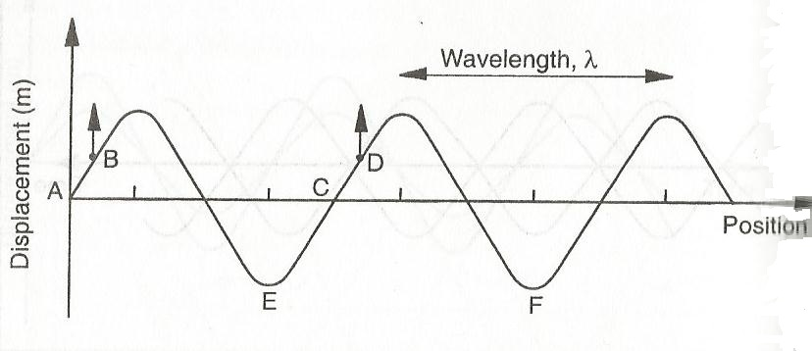

The wavelength, λ is the distance between two points on a wave train which are in phase. Also defined as the **distance between two successive crests or troughs in a transverse wave** or the **distance between two successive rare factions or compressions in a longitudinal wave**.

Wavelength is measured in metres

Distances AC, BD and EF are all equivalent to one wavelength.

1. **Speed**

The speed V is the distance covered by a wave in one second. Its S.I unit is m/s.

**Relationship between speed, wavelength and frequency**

Suppose the period of a wave is T. Then, the distance covered in time t is λ,

V= $\frac{distance}{time}$

= $\frac{λ}{T}$ but T= $\frac{1}{f}$

= $\frac{λ}{\frac{1}{f}}$

=λf

This implies that **velocity, V =λf**

NOTE: While the rate of vibration of the source determines the frequency, the speed in a given medium is constant.

From **V =λf,** an increase in frequency results in a decrease in wavelength.

**Examples**

1. Waves on a spring are produced at the rate of 20 wavelengths every 5 seconds.
2. Find the frequency of the wave motion
3. If the wavelength of the waves is 0.01, find the speed of the wave.
4. Find the period of the wave
5. **Frequency = $\frac{no.of complete wavelengths}{time taken}$**

= $\frac{20}{5}$ = 4Hz

1. **V =λf**

V=4 x 0.01

=0.04m/s

1. T= $\frac{1}{f}$ =1/4 =0.25 seconds
2. A water wave travels 12m in 4 s. If the frequency of the wave is 2Hz, calculate;
3. The speed of the wave
4. The wavelength of the wave
5. **V= 12/4 = 3m/s**
6. **F=v/λ =3/2 = 1.5m**

**More Examples and exercises**

**Sound**

Sound originates from vibrating bodies. The nature of these vibrations determines the type of sound produced.

The vibrations may be felt or seen e.g. when a string of a guitar is plucked or when a tuning fork is struck. In some cases, the vibrating origin of sound may not be felt or seen.

**Sources of sound**

1. Vibrating wooden strip
2. Vibrating wire
3. Vibrating drum
4. Tuning fork
5. Vibrating air columns
6. Air siren
7. Cog wheel and card
8. Voice box (larynx)
9. Loudspeakers
10. Cell phone or telephone membrane

**Propagation of sound energy**

Sound waves from vibrating prongs of a tuning fork produce compression (areas of high pressure) and rare faction (areas of low pressure) of air molecules as shown,

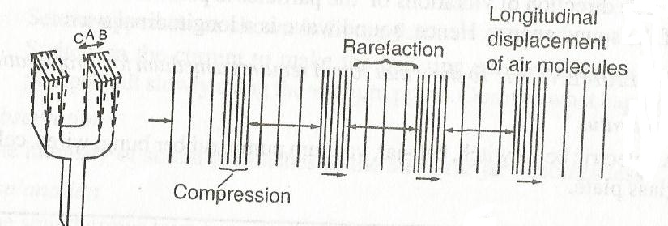

As the prong or the tuning fork moves from A to B, it compresses the air molecules, transferring energy to the molecules in the direction in which compression occurs.

A high pressure region is thus created. This leaves a region of low pressure (a rare faction) on the left of A. The prong moves back to A and then to C and the process is repeated.

A series of compressions and rare factions are thus produced transferring energy to the air particles (molecules) to the left and right. The energy transfer alternates in the direction just as the motion of the prong.

A progressive sound wave in air may be described as a travelling pressure wave as shown,

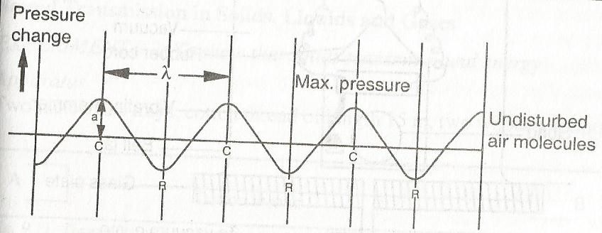

Sound energy moves forward in the medium without net forward movement of the medium.

The direction of vibrations of the particles is parallel to the direction of the sound energy. Hence, sound wave is a longitudinal wave

**To show that sound requires a medium for propagation**

Set the apparatus as shown,

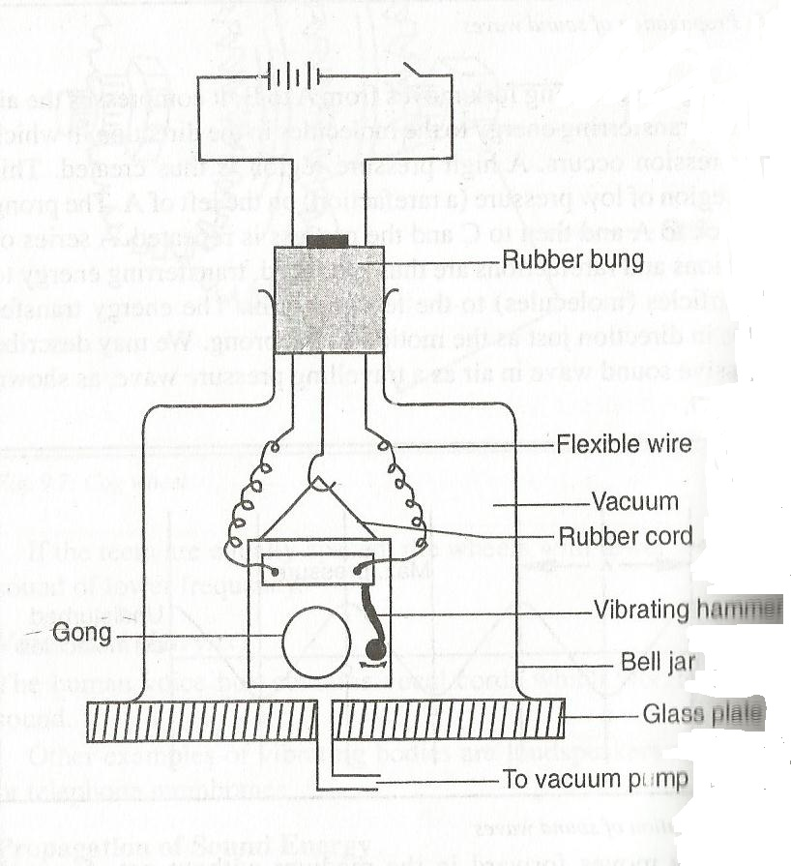

Switch on the current to make the bell ring continuously as air pumped slowly out using the vacuum pump.

**Observation**

The intensity of sound diminishes as the air in the jar becomes less.

**Explanation**

The sound grows faint because the jar is deprived of air. A vacuum does not transmit sound and the little sound that reaches us does so only through the connecting wires, rubber and the walls of the jar.

**Factors affecting velocity of sound in air**

In normal conditions, the speed of sound in air is about 330m/s. This speed is however dependent on;

1. **Temperature**

Sound travels faster in hot air than in cold air.

1. **Humidity of the air**

The velocity of sound in air increases with humidity.

1. **Wind**

Wind blowing in the same direction as sound increases the velocity of the latter.

**Sound transmission in solids, liquids and gases**

**To show that solids transmit sound energy**

Set the apparatus as shown,

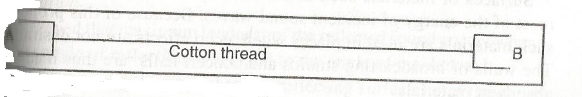

Hold the tray boxes so that the string is taut. Let one student speak at end A as another listens at end B. Note what happens

**Observation**

When the student speaks at one end softly, the other student hears clearly.

**Explanation**

Sound travels through a solid medium

Generally, solids transmit sound at a speed of 6,00m/s. This velocity varies from solid to solid depending on the density of the material. Denser solids transmit sound faster.

In addition to gases and solids, liquids also propagate sound energy. A swimmer easily hears sound of water waves when underneath the water and fish similarly respond to sounds produced in water.

Liquids transmit sound energy at different speeds depending on their densities. The velocity of sound in fresh water is 1400m/s and in salty water is 1500m/s.

Gases transmit sound slowest, while solids transmit sound fastest.

**Properties of sound waves**

**Reflection of sound**

When a sharp sound falls on an obstacle, it is reflected. Reflected sound is called **an echo.**

Reflected sound is more pronounced from hard surfaces such as wood, stone walls and metal surfaces. Reflection from liquid surfaces is considerably weaker.

In some halls, sound waves are reflected from the walls, floor and ceiling. Since the echo time is very short, the echo overlaps with the original sound. The original sound thus seems to be prolonged, an effect called **reverberation.**

Surfaces of materials such as cotton wool and foam rubber **absorb most of the energy** of incident sound waves. Because of this property, such materials are used in places where echo effects are not desirable. The walls of broadcasting studios and concert halls are thus made of **absorbent** materials.

**To demonstrate reflection of sound**

**Apparatus:** Two plastic tubes, a ticking clock, a smooth hard wall

**Procedure:** Place the clock near the end of one of one of the tubes as shown

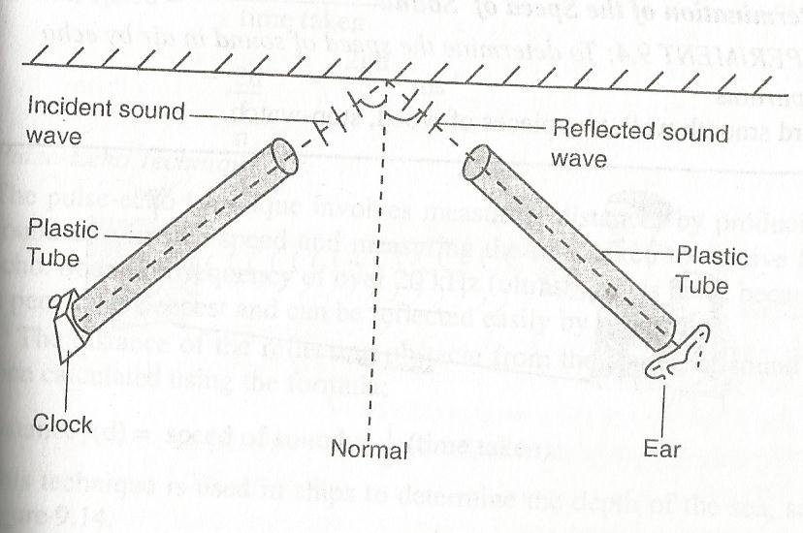

Point the open end of the tube towards a hard wall at an angle of incidence, i.

With the ear close to the end of the second open tube, listen to the reflection of sound from the wall at different angles of reflection, r and note the angle at which the reflected sound is loudest.

**Observation**

The maximum loudness of the reflected sound occurs when;

1. The angle of reflection, r is equal to the angle of incidence, i.
2. Both tubes and the normal to the reflecting surface lie in the same plane.

**Conclusion**

Sound waves obey the laws of reflection.

**Applications of reflection of sound**

**Determination of the speed of sound**

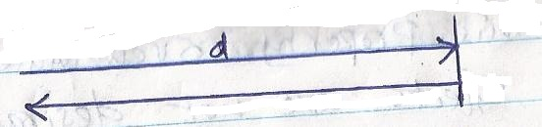

The echo from one tap coincides with the sound from the next tap, the time taken to make a tap after the proceeding one equals the time taken by sound to travel from the observer to the wall and back.

If the distance between the observer and the wall is d metres, the number of tap intervals n and the time t seconds, the sound travels 2d metres in $\frac{t}{n}$ seconds.

Hence, speed $=\frac{distance travelled}{time taken}$

V= $\frac{2d}{\frac{t}{n}}$

**V= $\frac{2nd}{t}$ m/s**

**Pulse-Echo technique**

The pulse-echo technique involves measuring distances by producing sound of known speed and measuring the time taken to receive the echo.

Sound of frequency of over 20 kHz (ultrasound) is used, because it penetrates deepest and can be easily reflected by tiny grains.

The distance of the reflecting obstacle from the source of sound is then calculated using the formula;

Distance, d = speed of sound x ½ (time taken)

This technique is used in ships **to determine the depth of the sea.**

The technique is also used;

1. In under-water exploration for gas and oil.
2. In fishing boats with pulse-echo equipment to locate shoals of fish.
3. In special types of spectacles used by blind people to tell how far objects are ahead of them. The spectacles have transmitters that emit ultrasound and receivers that collect the echo and convert them into audible sound.

Bats use echoes to detect the presence of obstacles in their flight path.

**Examples**

1. A disc siren with 100 holes is rotated at constant speed making 0.20 revolutions per second. If air is blown towards the holes, calculate;
2. The frequency of sound produced
3. The wavelength of sound produced, if velocity of sound in air is 340m/s.
4. A cog wheel rotating uniformly produces sound of wavelength 1.65m. if it makes 10 revolutions per second, find the number of teeth on the wheel, given that the velocity of sound in air is 330m/s.
5. Two boys stand 200m from a wall. One bangs two pieces of wood together while the second starts a stop-watch and stops it when he hears the echo. If the time shown on the stop-watch is 1.2 seconds, calculate the speed of sound.
6. The speed of sound in air is 340m/s. A loudspeaker placed between two walls A and B, but nearer to wall A than wall B, is sending out constant sound pulses. How far is the speaker from wall B if it is 200m from wall A and the time between the two echoes received is 0.176 seconds?
7. Two people stand facing each other 200m apart on one side of a high wall and at the same perpendicular distance from it. When one fires a pistol, the other hears a report 0.6 seconds after the flash and a second sound 0.25 seconds later. Explain this and calculate;
8. The velocity of sound in air
9. The perpendicular distance of the people from the wall.
10. a. The speed of sound at the top of Mount Kenya is less than the speed of sound at Mombasa. Explain this observation.

b.A girl is 120m away from a high wall. She claps two blocks of wood at a constant rate such that 40 claps are made in 30 seconds. If each clap coincides with the echo of one before, determine the speed of sound

**Fluid flow**

**A fluid** refers to both gases and liquids. A fluid flows as a result of **pressure difference.**

**Types of flow**

1. **streamline (steady) flow**

If all the particles passing through any given point in a fluid have the same velocity, they trace same path called **the line of flow** as shown,

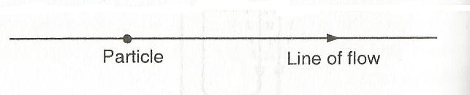

A streamline is a curve whose tangent at a given point is along the direction of the displacement of the fluid particle at that point as shown

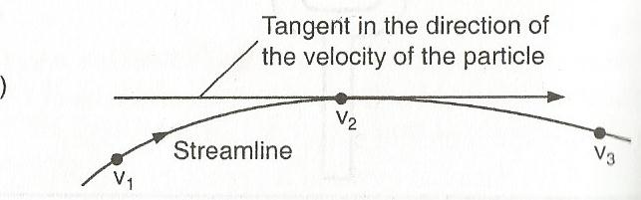

1. **Laminar flow**

A moving fluid has many streamlines or layers. The flow is laminar if the particles in a given streamline or layers have the same velocity, which may be different from other particles in the adjacent parallel layers as shown,

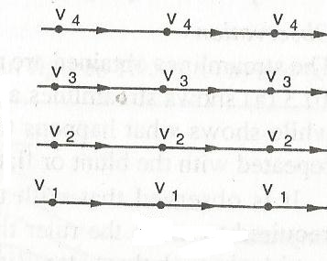

**Effects of a ruler on streamlines**

Study the figures shown below,

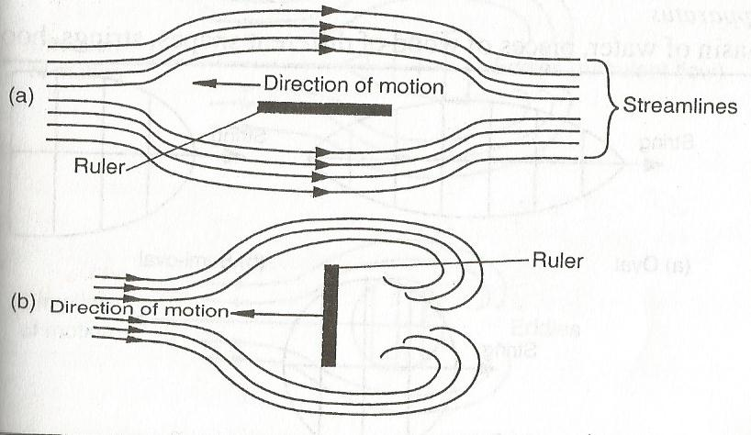

The streamlines are as shown above. With the flat side of the ruler, more effort is required to move the ruler than when it is moved with its sharp edge cutting through the water. Ripples are set up in the water, which tend to follow the ruler as it moves.

This breaking of streamlines into ripples (disorderly flow) is referred to as **turbulent flow,** i.e, flow in which the speed and direction of the fluid particles passing any point vary with time. The ripples or eddies have a drag effect on the object moving through the fluid.

**Effects of various shapes on streamlines**

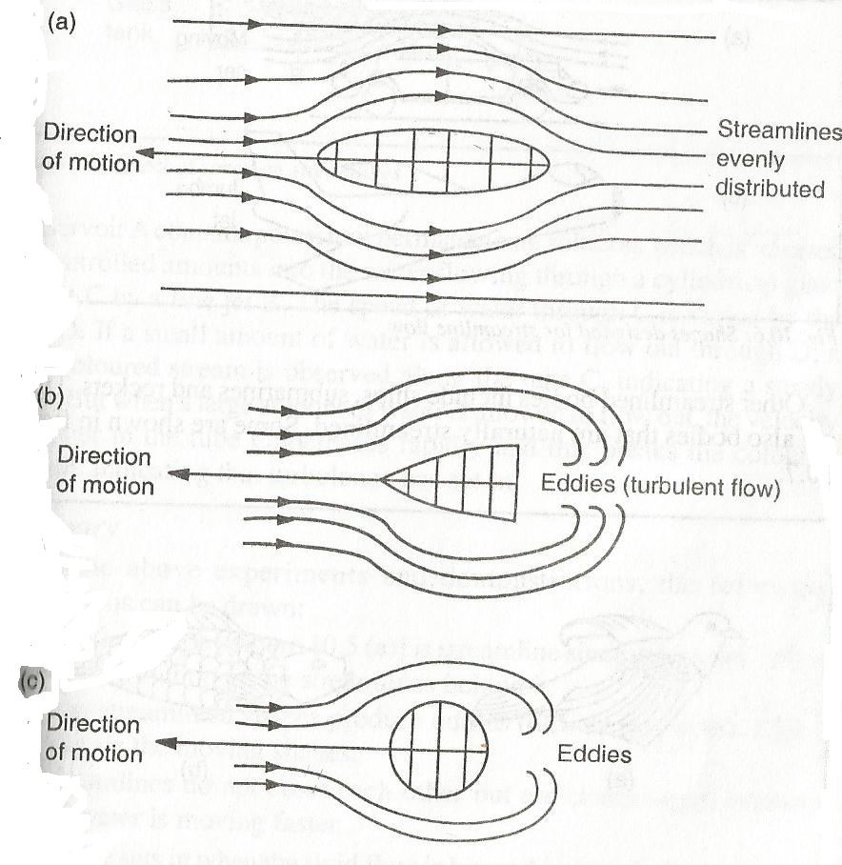

In shape (a) requires little effort to move and has no eddies behind it. Shape (b) requires more effort than (a) and gives rise to more eddies than (c). Shape (c) requires more effort than (a), but less effort than (b).

**Shapes designed for streamline flow**

Shapes suited to streamline flow are designed in such a way that they easily cut through fluids and reduce the formation of eddies behind them. This reduces resistance to their motion e.g. a moving car, jumbo jet e.t.c.

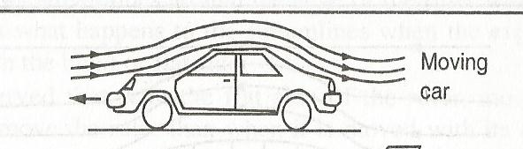

Other streamlined bodies include ships, submarines and rockets.

There are also bodies that are naturally streamlined e.g. birds, fish e.t.c.

**Effects of speed of flow on streamlines**

The set up below can be used to study the effect of speed of flow of streamlines,

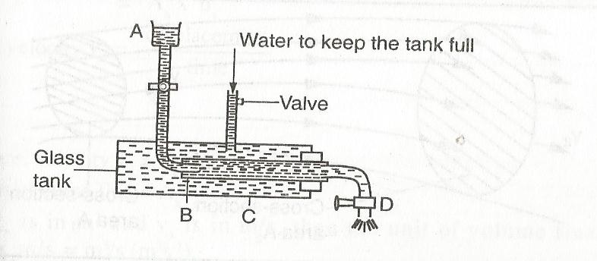

Reservoir A contains potassium permanganate solution, which is released in controlled amounts into the water flowing through a cylindrical glass jacket C by a fine jet B. The speed of water through C is varied by the clip D. If a small amount is allowed to flow out through D, a fine coloured stream is observed along the tube C, indicating a steady flow.

but when a large amount of water is allowed to flow out, the velocity of water in the tube increases rapidly and this breaks the coloured stream, indicating that turbulence has set in.

**Summary**

1. Streamlined bodies do not affect the distribution of the streamlines behind it.
2. Non-streamlined shapes produce eddies (turbulence) which offers a drag on the moving shapes.
3. Streamlines do not cross each other but are closer together where the water is moving faster.

**Note:** Turbulence sets in when the fluid flow is beyond a certain velocity known as **critical velocity.**

**TUBE OF FLOW**

It is possible to define boundaries to a set of streamlines in a fluid flow. If the boundaries encompass a tubular region, then the resulting section is called a **tube of flow** as shown,

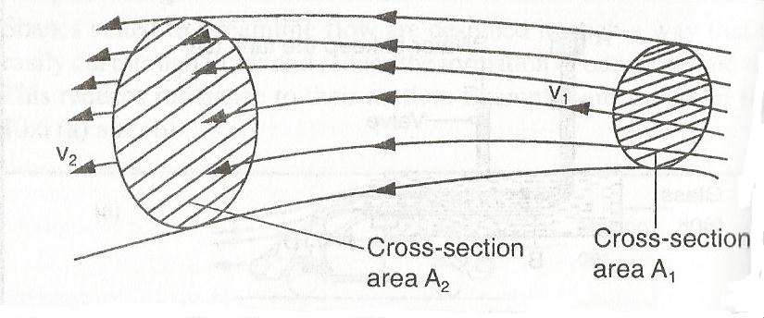

**The equation of continuity**

In deriving the equation of continuity, the assumptions made are that, the fluid is;

1. Flowing steadily
2. Incompressible, i.e, changes in temperature produces insignificant change in density.
3. Non-viscous

**Definitions**

1. **Volume flux (flow rate)**

The volume flux is the volume of a fluid passing through a given section of a tube of flow per unit time as shown,

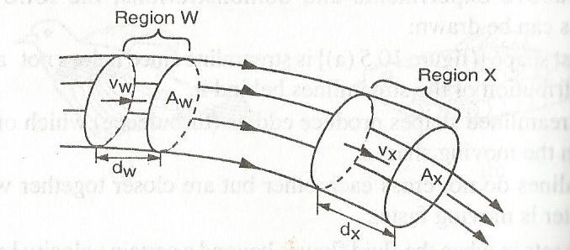

From the figure,

Volume flux = area of cross section x distance

= Ax x dx

But velocity Vx = =

Hence, velocity Vx = dx since t= 1 second

Thus **volume flux = Ax x dx**

**The** S.I unit of volume flux is m3/s or m3s-1

1. **Mass flux**

Density= $\frac{mass}{volume}$ 
mass= Density x volume

Hence mass flux = Density x volume flux

=ᵉxAxVx

=AxVxᵉ

The unit of mass flux is kg/s or kgs-1

**Mass flux** is the mass of the fluid that flow through a given section per unit time.

Since the fluid is incompressible, the mass of the fluid entering region X is equal to the mass of the fluid leaving region W with the same period, i.e., mass is conserved

Mass flux at W = mass flux at X

AwVwᵉ = AxVxᵉ

Hence**, AwVw  = AxVx**

This is the equation of continuity. **AwVw  or AxVx** is called the flow rate and is constant

Area x velocity = constant

**AV = K**

Therefore it can be deduced that for non-viscous steady flow, the area of cross-section of the fluid is inversely proportional to the velocity of the fluid.

The speed of the fluid increases when it flows from a pipe of big cross-section area to a smaller one and vice versa as shown

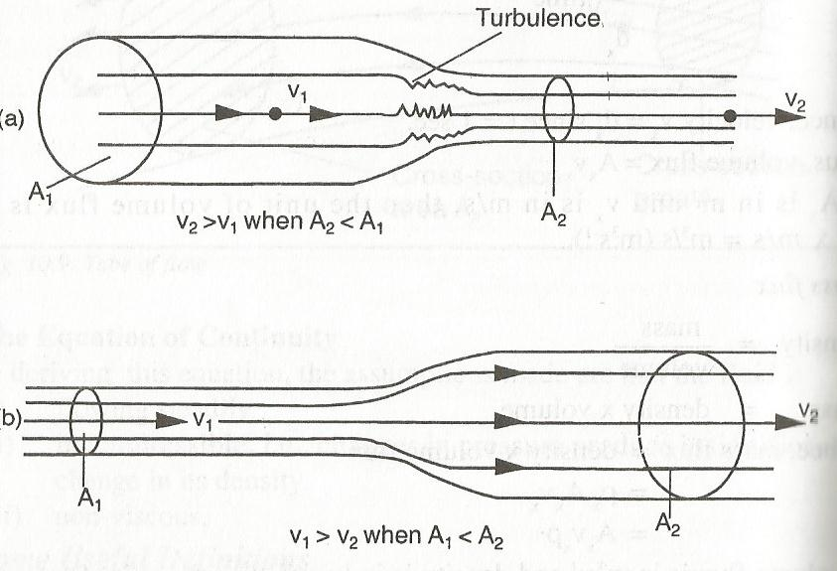

**Examples**

1. A lawn sprinkler has 40 holes, each of cross-section area 2.0 x 10-2 cm2. It is connected to a hose-pipe of cross-section 1.6 cm2. If the speed of the water in the hose-pipe is 1.2m/s. Calculate;
2. The flow rate in the hose-pipe
3. The speed at which water emerges from the holes

**Solution**

1. Flow rate = AV

**= 1.6 x10-4 x 1.2**

**=1.92 x 10-4m3/s**

1. **A1V1 = A2V2**

**40 x 2 x 10-2 x 10-4 xV1 =1.6 x10-4 x 1.2**

**V1 = 2.4m/s**

1. Water flows along a horizontal pipe of cross-section area 40cm2 which has also a constriction of cross-section area 5cm2. If the speed at the constriction is 4m/s, calculate;
2. **The**  speed in the wide section
3. The mass flux (density of water = 1000kg/m3)

**Solution**

1. **A1V1 = A2V2**

**40 x 10-4 x V = 5 x 10-4 x 4**

**V= 0.5m/s**

1. **Mass flux =ᵉ x AV**

**=1000 x 5 x 10-4 x 4**

**=2kg/s**

1. 250cm3 of fluid flows out of a tube, whose inner diameter is 7mm, in time of 41seconds. What is the average velocity of the fluid in the tube?

**A =Πr2 = 3.142 x (3.5 x 10-3)2**

**=3.85 x 10-5m2**

**Volume flux = =**

**=6.098 x 10-6**

**But volume flux = AV**

**6.098 x 10-6 = 3.85 x 10-5m2 x V**

**V =0.158m/s**

1. The velocity of glycerine in 5cm internal diameter pipe is 1.0m/s. Find the velocity in a 3cm internal diameter pipe that connects with it, both pipes flowing fully

**A1V1 = A2V2**

* 1. **x (2.5 x 10-2)2 x 1 = 3.142 x (1.5 x 10-2)2 x v**

**V=**

**BERNOULLI’S PRINCIPLE**

The pressure of a fluid at rest in a uniform tube is the same at all points in the tube. However, if the fluid flows, the pressure will vary from point to point as shown,

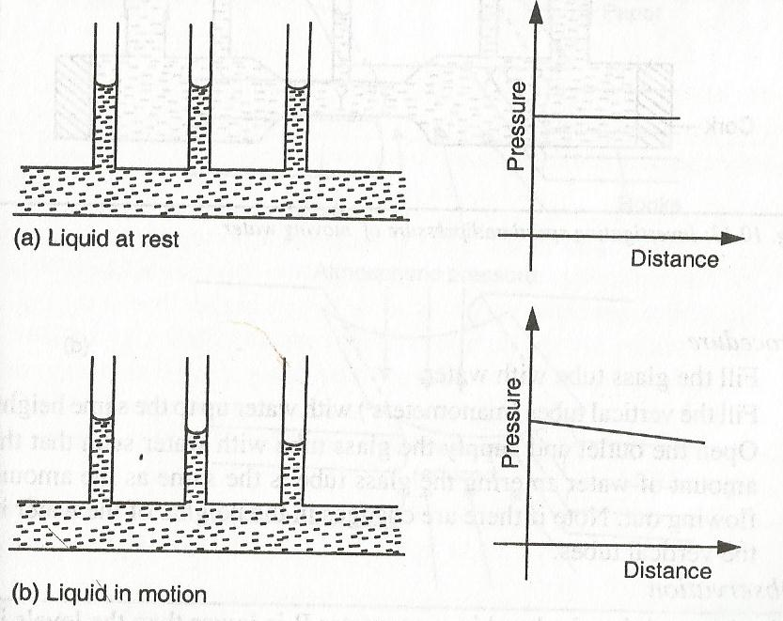

A pressure gradient is needed to make a liquid flow through a pipe. The cause of the pressure difference is the friction between the liquid and the walls of the pipe.

**Relationship between speed of water and the pressure it exerts**

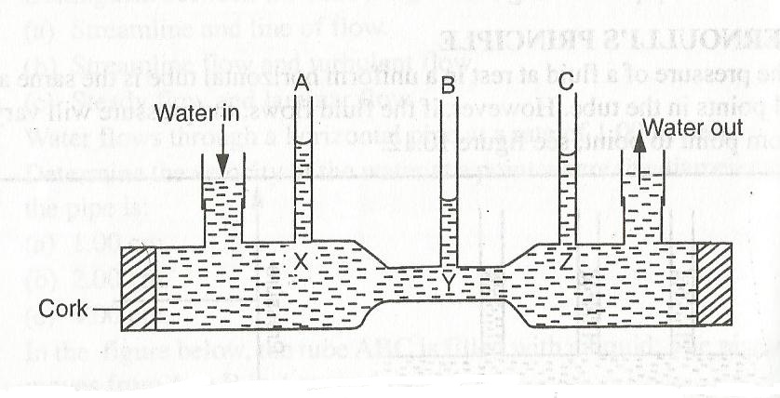

The level in manometer B is lower than the levels in other tubes.

**Explanation**

Pressure in the stationary fluids is given by pressure = hᵉg (ᵉ is density). Hence, the pressure exerted by the fluid in the narrow constriction is lower than that at X and Z. It is also slightly lower at Z than at X.

Velocity also in the narrow constriction is higher than that at wider sections. Thus, the higher the speed of the fluid the lower the pressure it exerts. This relation is known as **Bernoulli’s effect,** which is stated as **provided a fluid is non-viscous, incompressible and its flow streamline, an increase in its velocity produces a corresponding decrease in the pressure it exerts.**

**Bernoulli’s effect in air**

1. Some books are arranged on a table and a piece of paper placed on them.

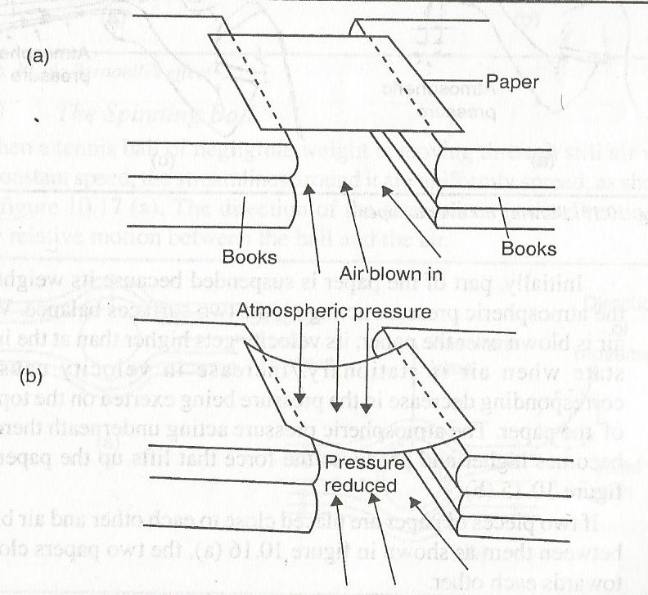

When air is blown into the channel made by the books, the pressure under the paper decreases and the atmospheric pressure acting on top of the paper presses it down. The paper thus curves downwards.

The pressure in the channel decreases because the velocity of air in the channel increases.

1. If a light paper is held in front of the mouth and air blown horizontally over the paper, it will be observed that the paper gets lifted up.

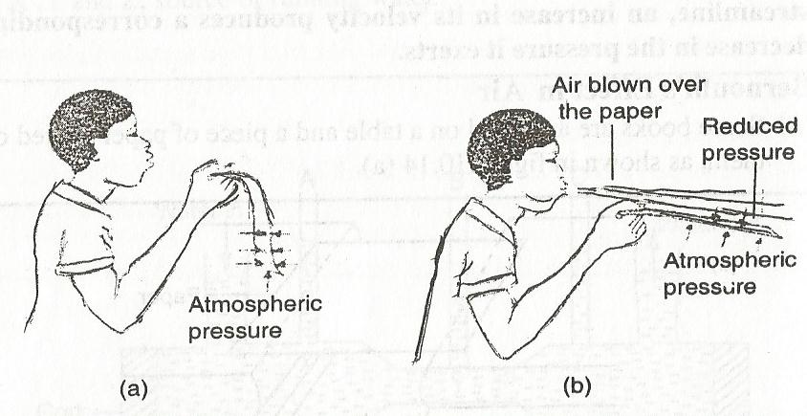

Initially, part of the paper suspended because its weight and the atmospheric pressure acting on the two surfaces balance. When air is blown over the paper, its velocity gets higher than the initial state when air is stationary. Increase in velocity causes a corresponding decrease in the pressure being exerted on the top side of the paper. The atmospheric pressure acting underneath becomes higher and produces the force that lifts up the paper.

1. If two pieces of paper are held close to each other and air blown between them, the two papers close in towards each other. The moving air between the papers lowers the pressure it exerts on their inner surfaces. The higher atmospheric pressure acting on the outside surfaces causes the papers to move closer to each other.

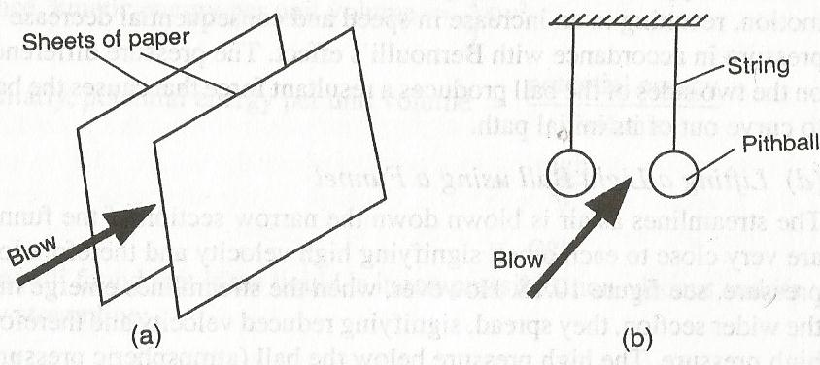

The same effect is observed when air is blown between two suspended pith balls.

1. **The spinning ball**

When a tennis ball of negligible weight is moving through still air with a constant speed, the streamlines around it are uniformly spread as shown,

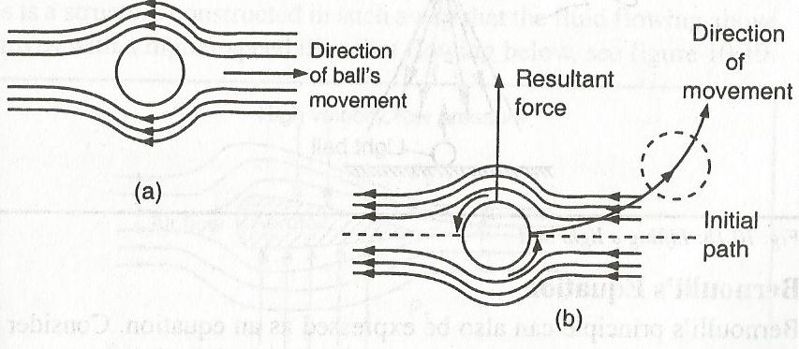

The direction of the streamlines is in the direction of the relative motion between the ball and air.

If the ball is now made to spin as it moves, it is moved to curve out of its initial path. As the ball spins, it drags air along with it, which opposes the relative motion on one side of the ball. This causes a reduction in the relative speed and the streamlines are spread as shown,

On the opposite side, the dragged air is in the direction of the relative motion, resulting in an increase in speed and consequential decrease in pressure. The pressure difference on the two sides of the ball produces a resultant force that causes the ball to curve out of its initial path.

1. **Lifting a light ball using a funnel**

The streamlines as air is blown down the narrow section of the funnel are very close to each other, signifying high velocity and therefore low pressure. When streamlines emerge into the wider region, they spread, signifying reduced velocity and therefore high pressure. The high pressure below the ball (atmospheric pressure) lifts the ball up the neck of the funnel as shown,

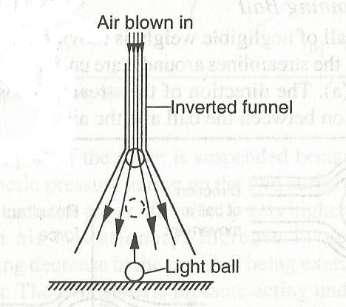

**BERNOULLI’S EQUATION**

Bernoulli’s principle can be expressed as an equation.

Consider a liquid of mass m flowing through a pipe with velocity V. Let the pressure at a given point be P,

Then, kinetic energy per unit volume = $\frac{mv2}{2v}$ but e = $\frac{m}{v}$

Hence kinetic energy per unit volume = ½ eV2

Similarly, potential energy per unit volume = $\frac{mgh}{V}$ but e = $\frac{m}{v}$

= egh

Bernoulli found that if the liquid is incompressible, non-viscous and its flow streamline,

**P+** **½ eV2 + egh =constant**

That is, **the sum of pressure, kinetic energy per unit volume and potential energy per unit volume is a constant.** This is Bernoulli’s Principle.

**Applications of Bernoulli’s principle**

1. **The Aerofoil**

This is a structure constructed in a such a way that the fluid above it moves with a higher velocity than that flowing below as shown,

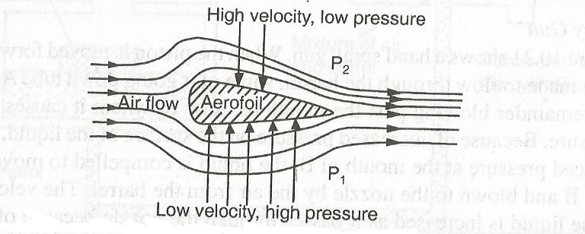

Aircraft wings and helicopter rotor blades are examples of aerofoils.

Because the fluid flowing above the aerofoil has to travel a longer distance than that flowing below, it has to travel at a higher speed (low pressure) compared to the low speed (high pressure) underneath.

The pressure difference (P­1 – P2) gives rise to the lift of the aerofoil, called the dynamic lift. The force of the lift is given **by F = (P­1 – P2) A** where A is the area of the aerofoil

1. **Bunsen burner**

When a gas is made to flow into the Bunsen burner from the gas cylinder, its velocity is increased when it passes through the nozzle. Because of the atmospheric pressure outside the barrel, air is then drawn in as shown,

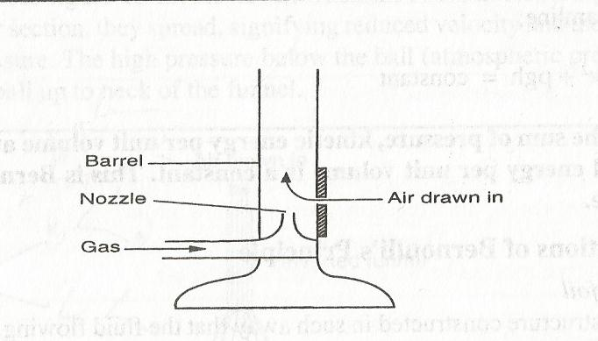

The air and the gas then mix as they rise up and when ignited, a flame is produced.

1. **Spray gun**

The figure below shows a hand spray gun

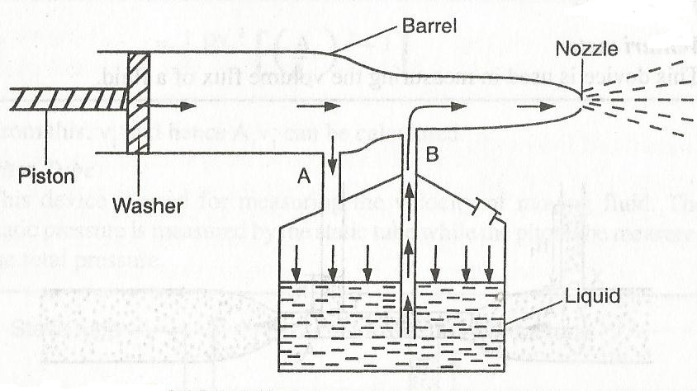

When the piston is moved forward, air is made to flow through the barrel, some of it going down tube A and the remainder blowing past the mouth of tube B, where it causes low pressure. Because of increased pressure on the surface of the liquid and reduced pressure at the mouth B, the liquid is compelled to move up tube B and blown to the nozzle by the air from the barrel.

The velocity of the liquid is increased as it passes through the nozzle because of reduced cross-section area. The liquid thus emerges as a fine spray.

1. **The carburettor**

Due to action of the engine pistons, air is drawn into the venturi as shown,

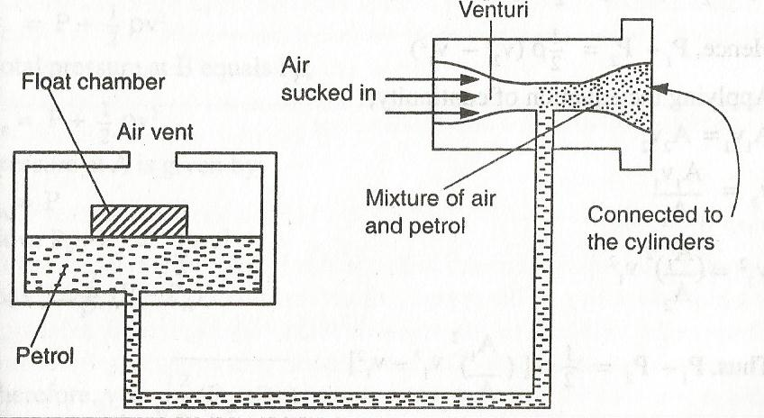

The fast moving air causes low pressure above the petrol pipe. Petrol is drawn into the venturi due to low pressure in the venture and atmospheric pressure in the float chamber. The mixture of air petrol is thus drawn into the cylinders for combustion.

**Flow meters**

1. Venture meters

A device used in measuring the volume flux of a fluid.

1. Pitot tube

It is used for measuring velocity of a moving fluid.

**HARZADS OF BERNOULLI’S EFFECT**

1. **Blowing off of roof-tops**

The air flowing over a roof-top has a high velocity compared to the one flowing underneath. Consequently, the pressure acting on the roof from underneath will be higher than that acting from above. Hence, the roof is blown off.

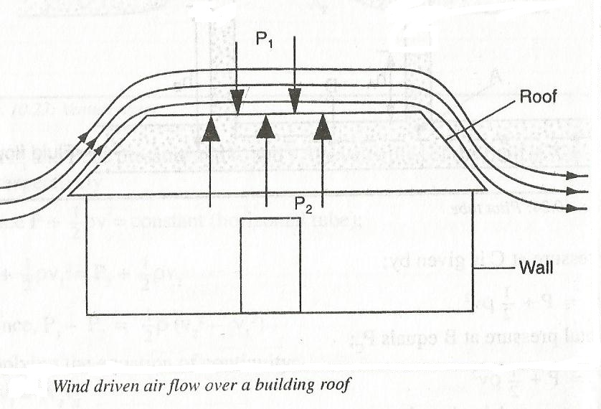

1. **Road accidents**

A small car travelling at a very high velocity is likely to be dragged into a long track travelling in the opposite direction, also at high speed.

This is because the air between them moves with very high speed, reducing the pressure between them. The atmospheric pressure acting from the sides of the two vehicles will push them closer together, increasing chances of an accident.

**Examples**

1. Water with negligible viscosity flows steadily through a horizontal pipe of varying cross-section area. At the A of cross-section area 10cm2, the velocity is 0.2m/s. Calculate the velocity at point B, of cross-section 2.5cm2.
2. Water flows steadily along a horizontal pipe at a volume rate of 8 x 10-3m3/s. If the area of cross-section of the pipe is 20cm2. Calculate the velocity of the fluid.