**CHAPTER SIX**

**WAVES II**

Properties of waves

Waves exhibit various properties which can be conveniently demonstrated using the ripple tank. It consists of a transparent tray filled with water and a white screen as the bottom. On top we have a source of light. A small electric motor (vibrator) is connected to cause the disturbance which produces waves.

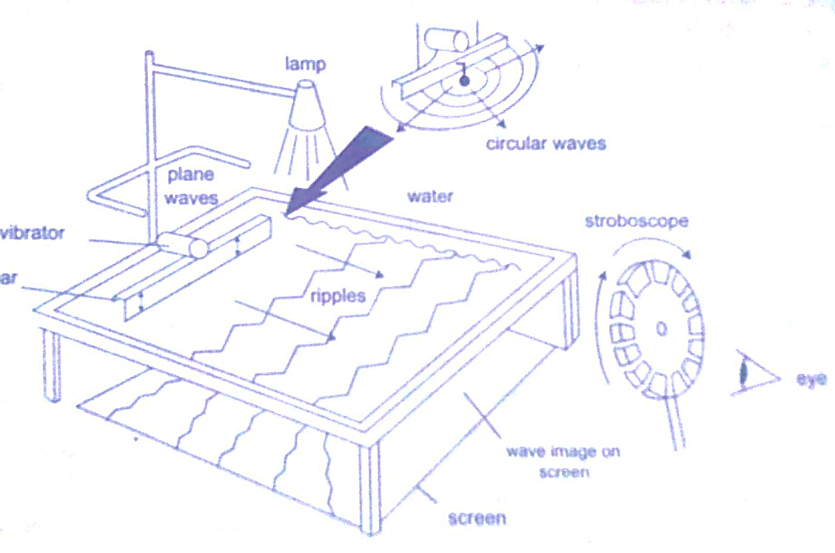

The wave fronts represent wave patterns as they move along.

Rectilinear propagation

This is the property of the waves travelling in straight lines and perpendicular to the wave front. The following diagrams represent rectilinear propagation of water waves.

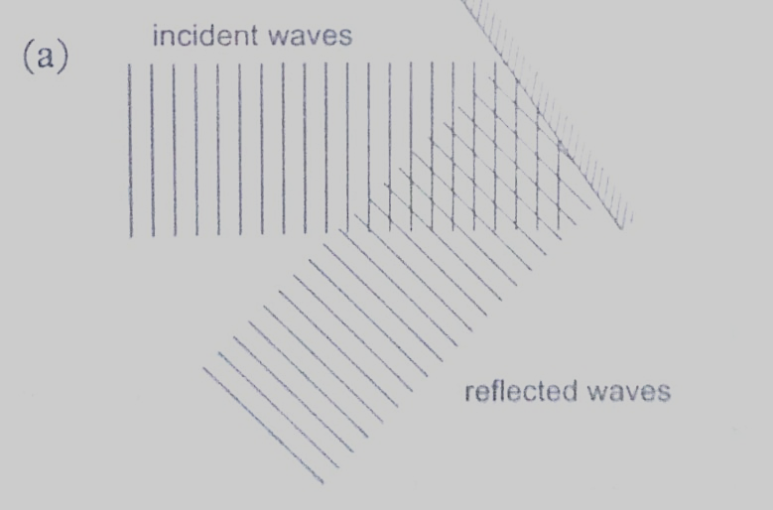

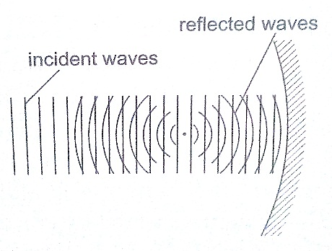

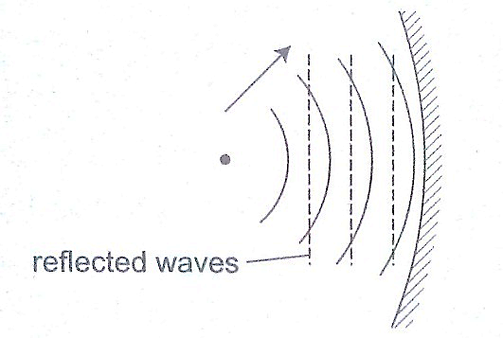

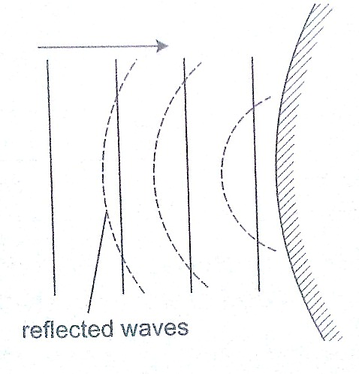

Refraction

***This is the change of direction of waves at a boundary when they move from one medium to another***. This occurs when an obstacle is placed in the path of the waves. The change of direction occurs at the boundary between deep and shallow waters and only when the waves hit the boundary at an angle.

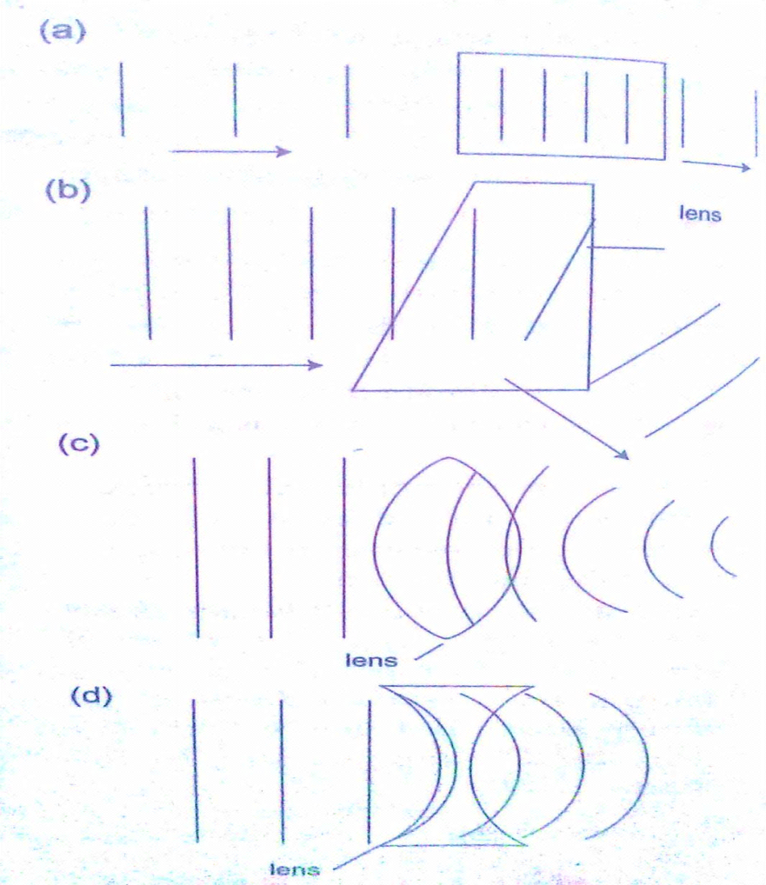

Diffraction of waves

***This occurs when waves pass an edge of an obstacle or a narrow gap, they tend to bend around the corner and spread out beyond the obstacle or gap.***

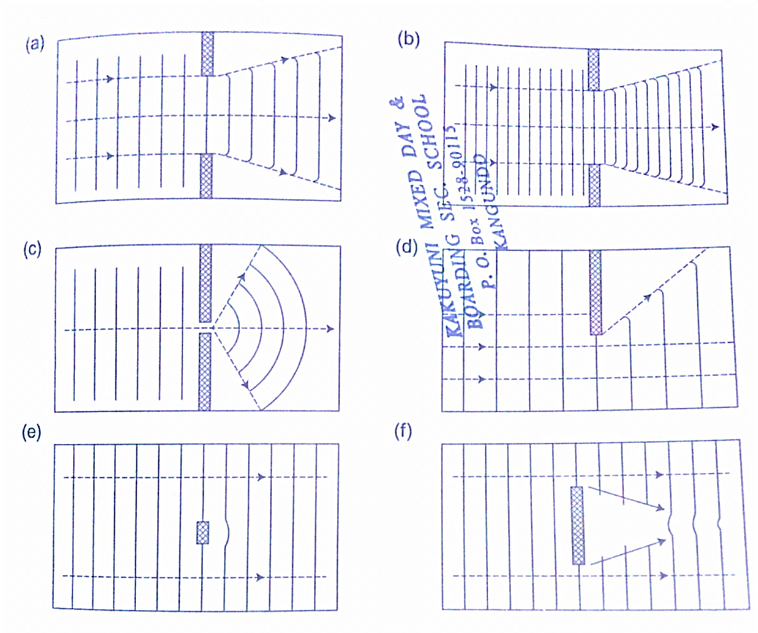

Interference of waves

***This occurs when two waves merge and the result can be a much larger wave, smaller wave or no wave at all***. When the waves are in phase they add up and reinforce each other. This is called a constructive interference and when out of phase they cancel each other out and this is known as destructive interference.

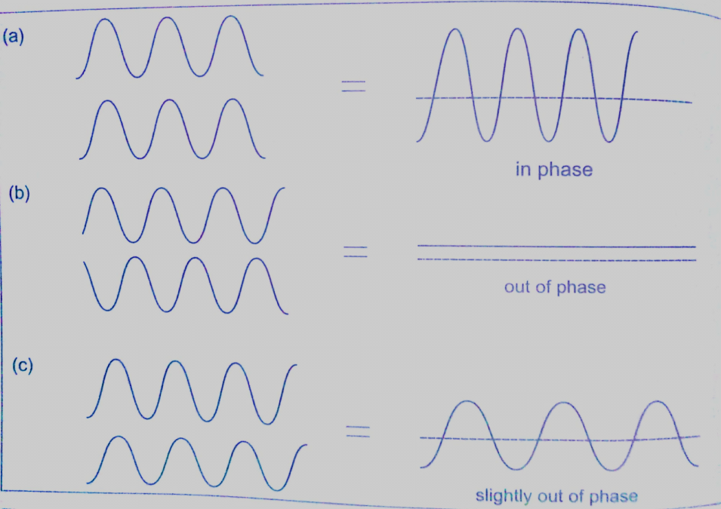

A ripple tank can be used to produce both constructive and destructive waves as shown below in the following diagram.

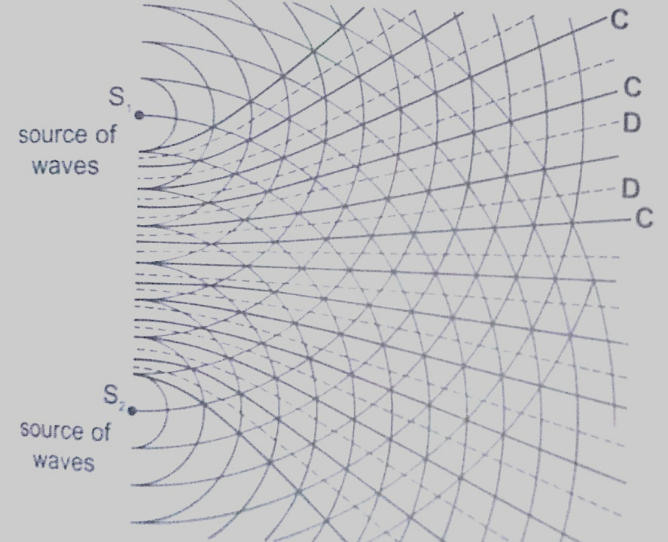

Interference in sound

Two loud speakers L1 and L2 are connected to the same signal generator so that sound waves from each of them are in phase. The two speakers are separated by a distance of the order of wavelengths i.e. 0.5 m apart for sound frequency of 1,000 Hz.

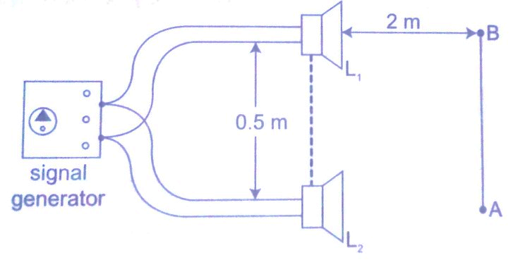

If you walk along line AB about 2m away from the speakers, the intensity of sound rises and falls alternately hence both destructive and constructive interference will be experienced.

Stationary waves

***They are also known as standing waves and are formed when two equal progressive waves travelling in opposite direction are superposed on each other***. When the two speakers are placed facing each other they produce standing waves. A rope tied at one end will still produce stationary waves.

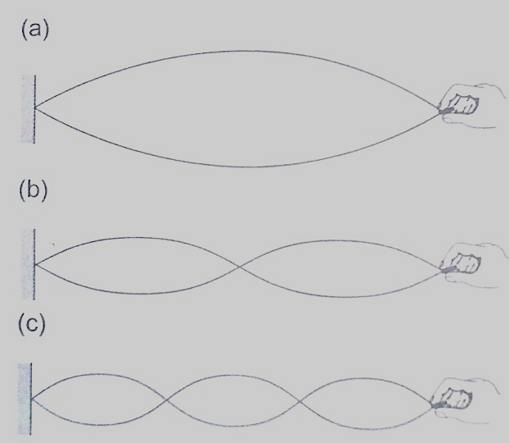

**CHAPTER SEVEN**

**ELECTROSTATICS II**

Electric fields

***An electric field is the space around a charged body where another charged body would be acted on by a force.*** These fields are represented by lines of force. This line of force also called an electric flux line points in the direction of the force.

Electric field patterns

Just like in magnetic fields, the closeness of the electric field-lines of force is the measure of the field strength. Their direction is always from the north or positive to the south or negative.

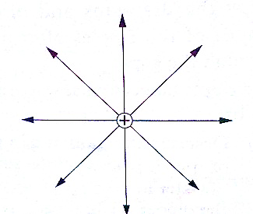

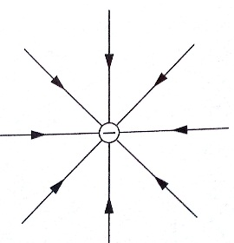

Electric field pattern for an isolated positive charge

Electric field pattern for an isolated negative charge

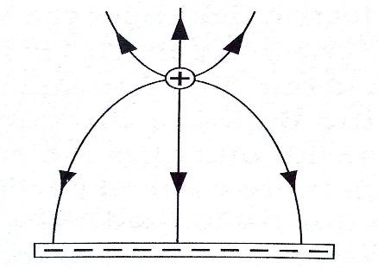

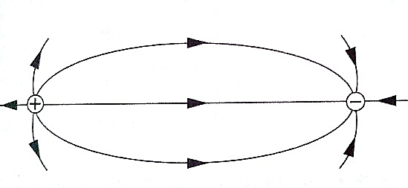

Electric field pattern for appositive charge and a line of charge

Electric field pattern for a dipole

Charge distribution on conductors’ surface

A proof plane is used to determine charge distribution on spherical or pear-shaped conductors. For an isolated sphere it is found that the effect is the same for all points on the surface meaning that the charge is evenly distributed on all points on the spherical surface. For appear-shaped conductor the charge is found to be denser in the regions of large curvature (small radius). The density of charge is greatest where curvature is greatest.

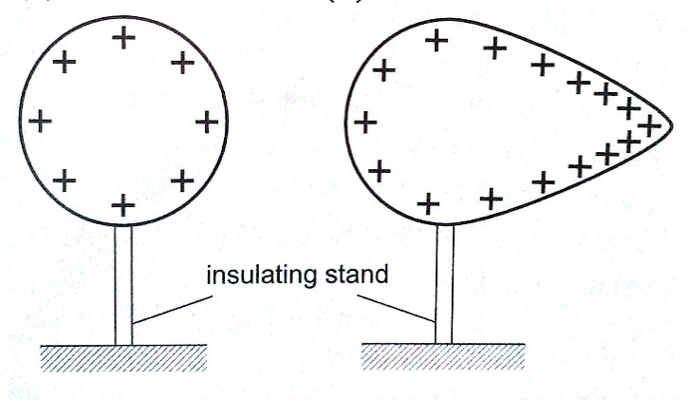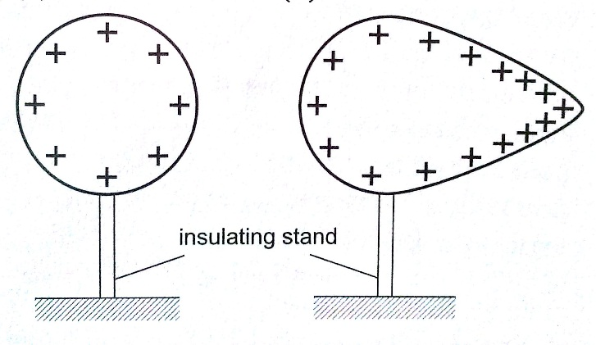

**stand**

Charge distribution for an isolated pear-shaped conductor

Charge distribution for an isolated spherical conductor

Charges on or action at sharp points

A moving mass of air forms a body with sharp points. The loss of electrons by molecules (ionization) makes the molecules positively charged ions. These ions tend to move in different directions and collide producing more charged particles and this makes the air highly ionized. When two positively charged bodies are placed close to each other, the air around them may cause a spark discharge which is a rush of electrons across the ionized gap, producing heat, light and sound in the process which lasts for a short time. Ionization at sharp projections of isolated charged bodies may sometimes be sufficient to cause a discharge. This discharge produces a glow called ***corona discharge*** observed at night on masts of ships moving on oceans. The same glow is observed on the trailing edges of aircrafts. This glow in aircrafts and ships is called **St. Elmo’s fire**. Aircrafts are fitted with **‘pig tails’** on the wings to discharge easily.

The lightning arrestors

***Lightning is a huge discharge where a large amount of charge rushes to meet the opposite charge***. It can occur between clouds or the cloud and the earth. Lightning may not be prevented but protection from its destruction may be done through arrestors. An arrestor consists of a thick copper strip fixed to the outside wall of a building with sharp spikes.

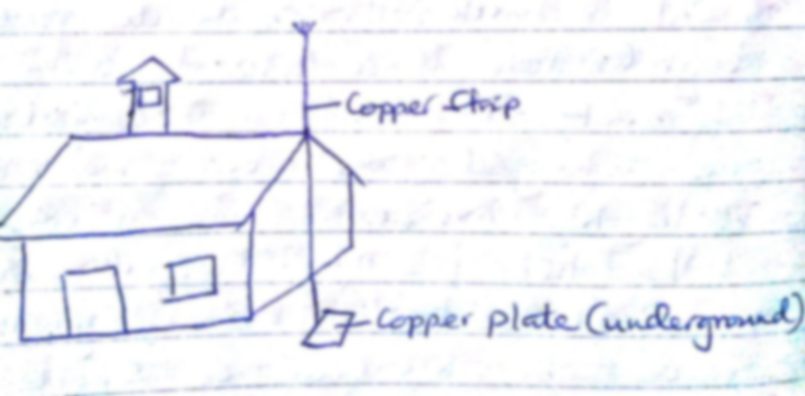

Capacitors and capacitance

***A capacitor is a device used for storing charge***. It consists of two or more plates separated by either a vacuum or air. The insulating material is called **‘dielectric’**. They are symbolized as shown below,

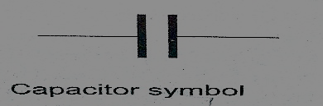

**Capacitance C = Q / V** where Q- charge and V – voltage.

The units for capacitance are coulombs per volt (Coul /volt) and are called farads.

**1 Coul/ volt = 1 farad (F)**

**1 µF = 10-6 F and 1pF = 10-12**

Types of capacitors are;

1. *Paper capacitors*
2. *Electrolyte capacitors*
3. *Variable capacitors*
4. *Plastic capacitors*
5. *Ceramic capacitors*
6. *Mica capacitors*

Factors affecting the capacitance of a parallel-plate capacitor

1. *Distance between the plates*: - reducing separation increases capacitance but the plates should not be very close to avoid ionization which may lead to discharge.
2. *Area of plate*: - reduction of the effective area leads to reduction in capacitance.
3. *Dielectric material between plates*: - different materials will produce different capacitance effects.

Charging and discharging a capacitor

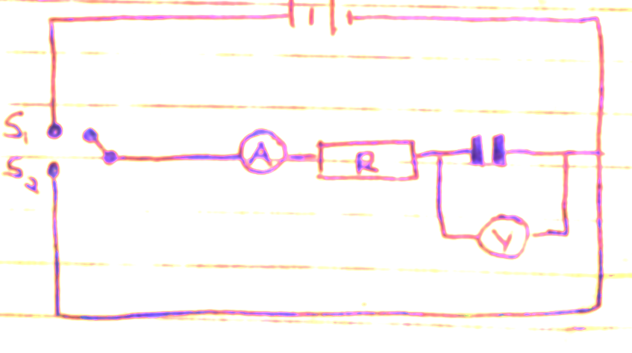

When the switch S1 is closed the capacitor charges through resistor R and discharges through the same resistor when switch S2 is closed.

Applications of capacitors

1. Variable capacitor: - used in tuning radios to enable it transmit in different frequencies.
2. Paper capacitors: - used in mains supply and high voltage installations.
3. Electrolytic capacitors: - used in transistor circuits where large capacitance values are required.

Other capacitors are used in reducing sparking as a car is ignited, smoothing rectified current and increasing efficiency in a. c. power transmission.

*Example*

*A capacitor of two parallel plates separated by air has a capacitance of 15pF. A potential difference of 24 volts is applied across the plates,*

1. *Determine the charge on the capacitors.*
2. *When the space is filled with mica, the capacitance increases to 250pF. How much more charge can be put on the capacitor using a 24 V supply?*

*Solution*

1. C= Q / V then Q = VC, hence Q = (1.5 × 10-12) × 24 = 3.6 × 10-10Coul.
2. Mica C = 250pF, Q = (250 × 10-12) × 24 = 6 × 10-9Coul.

Additional charge = (6 × 10-9) – (3.6 × 10-10) = 5.64 × 10-9Coul.

Capacitor combination

1. *Parallel combination – for capacitors in parallel the total capacitance is the sum of all the separate capacitances.*

**CT = C1 + C2 + C3 + ………..**

1. *Series combination – for capacitors in series, the reciprocal of the total capacitance is equal to the sum of the reciprocals of all the separate capacitances.*

**1/ CT = 1 / C1 + 1 / C2 + 1 / C3**

For two capacitors in series then total capacitance becomes,

**CT = (C1 C2) / (C1 + C2)**

*Examples*

1. *Three capacitors of capacitance 1.5µF, 2µF and 3µF are connected to a potential difference of 12 V as shown.*

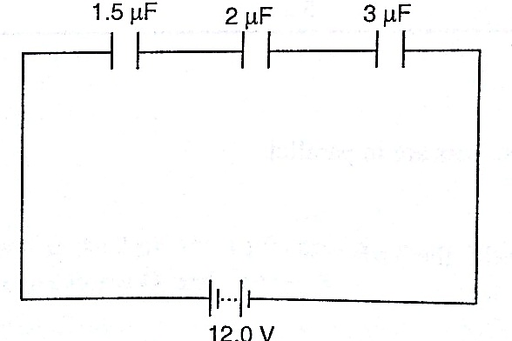

*Find;*

1. *The combined capacitance*
2. *The charge on each capacitor*
3. *The voltage across the 2 µF capacitor*

*Solution*

1. 1 /CT = 1/ 1.5 + 1 / 3.0 + 1 /20 = 3/2 hence CT = 0.67 µF
2. Total charge, Q = V C , (2/3 × 10-6) × 12.0 V = 8 × 10-6 = 8 µC.
3. The charge is the same for each capacitor because they’re in series hence = 8 µC.
4. V = Q / C, then V = 8 µC / 2 µF = 4 V.
5. *Three capacitors of capacitance* 3 *µF, 4 µF and 5 µF are arranged as shown. Find the effective capacitance.*

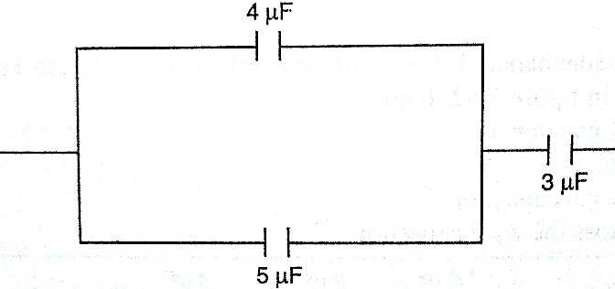

*Solution*

Since 4 µF and 5 µF are in parallel then, CT = 9 µF, then the 9 µF is in series with 3 µF,

Hence CT = 27/ 12 = 2.25 µF

1. *Calculate the charges on the capacitors shown below.*

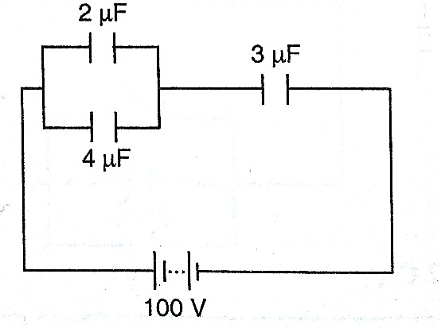

*Solution*

The 2 µF and 4 µF are in parallel then combined capacitance = 6 µF

The 6 µF is in series with the 3 µF capacitor hence combined capacitance = 18 / 9 = 2 µF

Total charge Q = CV then Q = (2.0 × 10-6) × 100 = 2.0 × 10-4 C

The charge on the 3 µF capacitor is also equal to 2.0 × 10-4 C

The p.d across the 3 µF capacitor => V = Q / C => (2.0 × 10-4)/ 3.0 × 10_6

= 2/3 × 102 = 66.7 V

The p.d across the 2 µF and 4 µF is equal to 100 V – 66.7 V = 33.3 V,

Hence Q1 = CV = 2.0 × 10-6 × 33.3 = 6.66 × 10-5 C

Q2 = CV = 4.0 × 10-6 × 33.3 = 1.332 × 10-4 C

**N.B**

Energy stored in a capacitor is calculated as;

**Work done (W) = average charge × potential difference**

**W = ½ QV or ½ CV2**

*Example*

A 2 µF capacitor is charged to a potential difference of 120 V. Find the energy stored in it.

Solution

W = ½ CV2 = ½ × 2 × 10-6 × 1202 = 1.44 × 10-2 J

**CHAPTER EIGHT**

**HEATING EFFECT OF AN ELECTRIC CURRENT**

When current flows, electrical energy is transformed into other forms of energy i.e. light, mechanical and chemical changes.

Factors affecting electrical heating

Energy dissipated by current or work done as current flows depends on,

1. ***Current***
2. ***Resistance***
3. ***Time***

This formula summarizes these factors as, ***E = I2 R t, E = I V t or E = V2 t / R***

*Examples*

1. *An iron box has a resistance coil of 30 Ω and takes a current of 10 A. Calculate the heat in kJ developed in 1 minute.*

*Solution*

E = I2 R t = 102 × 30 × 60 = 18 × 104 = 180 kJ

1. *A heating coil providing 3,600 J/min is required when the p.d across it is 24 V. Calculate the length of the wire making the coil given that its cross-sectional area is 1 × 10-7 m2 and resistivity 1 × 10-6 Ω m.*

*Solution*

E = P t hence P = E / t = 3,600 / 60 = 60 W

P = V2 / R therefore R = (24 × 24)/ 60 = 9.6 Ω

R = ρ *l/* A*, l* = (RA) / ρ = (9.6 × 1 × 10-7) / 1 × 10-6 = 0.96 m

Electrical energy and power

In summary, electrical power consumed by an electrical appliance is given by;

**P = V I**

**P = I2 R**

**P = V2 / R**

The SI unit for power is the watt **(W)**

***1 W = 1 J/s and 1kW = 1,000 W***.

*Examples*

1. *What is the maximum number of 100 W bulbs which can be safely run from a 240 V source supplying a current of 5 A?*

*Solution*

Let the maximum number of bulbs be ‘n’. Then 240 × 5 = 100 n

So ‘n’ = (240 × 5)/ 100 = 12 bulbs.

1. *An electric light bulb has a filament of resistance 470 Ω. The leads connecting the bulb to the 240 V mains have a total resistance of 10 Ω. Find the power dissipated in the bulb and in the leads.*

*Solution*

Req = 470 + 10 = 480 Ω, therefore I = 240 / 480 = 0.5 A.

Hence power dissipated = I2 R = (0.5)2 × 470 = 117.5 W (bulb alone)

For the leads alone, R = 10 Ω and I = 0.5 A

Therefore power dissipated = (0.5)2 × 10 = 2.5 W.

Applications of heating of electrical current

1. Filament lamp – the filament is made up of tungsten, a metal with high melting point (3.400 0C). It is enclosed in aglass bulb with air removed and argon or nitrogen injected to avoid oxidation. This extends the life of the filament.
2. Fluorescent lamps – when the lamp is switched on, the mercury vapour emits ultra violet radiation making the powder in the tube fluoresce i.e. emit light. Different powders emit different colours.

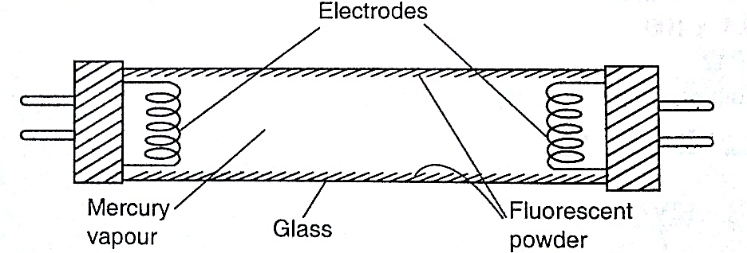

1. Electrical heating – electrical fires, cookers e.tc. their elements are made up nichrome ( alloy of nickel and chromium) which is not oxidized easily when it turns red hot.

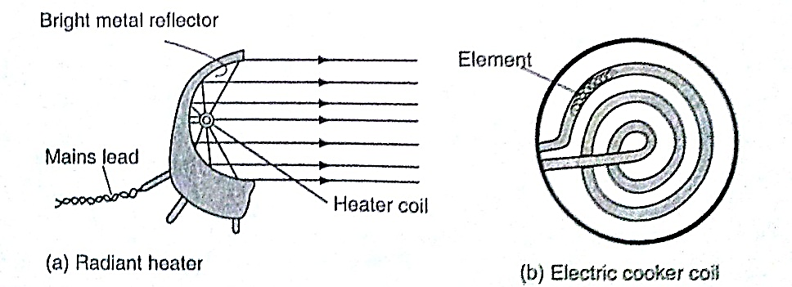

1. 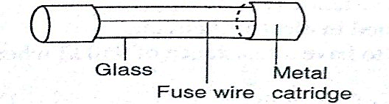Fuse – this is a short length of wire of a material with low melting point (often thinned copper) which melts when current through it exceeds a certain value. They are used to avoid overloading.

**CHAPTER NINE**

**QUANTITY OF HEAT**

***Heat is a form of energy that flows from one body to another due to temperature differences between them.***

Heat capacity

***Heat capacity is defined as the quantity of heat required to raise the temperature of a given mass of a substance by one degree Celsius or one Kelvin***. It is denoted by ‘**C**’.

***Heat capacity, C = heat absorbed, Q / temperature change* θ*.***

The units of heat capacity are **J / 0C or J / K.**

Specific heat capacity.

***S.H.C of a substance is the quantity of heat required to raise the temperature of 1 kg of a substance by 1 0C or 1 K***. It is denoted by ‘**c**’, hence,

**c = Q / m θ** where ***Q*** *– quantity of heat,* ***m*** *– mass and***θ** *– change in temperature.*

The units for ‘***c****’* are ***J kg-1 K-1***. Also **Q = m c θ.**

*Examples*

1. *A block of metal of mass 1.5 kg which is suitably insulated is heated from 30 0C to 50 0C in 8 minutes and 20 seconds by an electric heater coil rated54 watts. Find;*
2. *The quantity of heat supplied by the heater*
3. *The heat capacity of the block*
4. *Its specific heat capacity*

*Solution*

1. Quantity of heat = power × time = P t

= 54 × 500 = 27,000 J

1. Heat capacity, C = Q / θ = 27,000 / (50 – 30) = 1,350 J Kg-1 K-1
2. Specific heat capacity, c = C / m = 1,350 / 1.5 = 900 J Kg-1 K-1
3. *If 300 g of paraffin is heated with an immersion heater rated 40 W, what is the temperature after 3 minutes if the initial temperature was 20 0C? (S.H.C for paraffin = 2,200 J Kg-1 K-1).*

*Solution*

Energy = P t = m c θ = Q = quantity of heat.

P t = 40 × 180 = 7,200 J

m = 0.30 kg c = 2,200, θ = ..?

Q = m c θ, θ = Q / m c = 7,200 / (0.3 × 2,200) = 10.9 0C

1. *A piece of copper of mass 60 g and specific heat capacity 390 J Kg-1 K-1 cools from 90 0C to 40 0C. Find the quantity of heat given out.*

*Solution*

Q = m c θ, = 60 × 10-3 × 390 × 50 = 1,170 J.

Determination of specific heat capacity

***A calorimeter is used to determine the specific heat capacity of a substance***. This uses the principle of heat gained by a substance is equal to the heat lost by another substance in contact with each other until equilibrium is achieved. Heat losses in calorimeter are controlled such that no losses occur or they are very minimal.

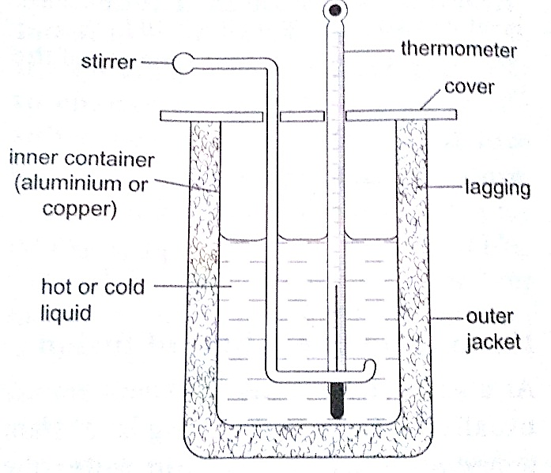

*Examples*

1. *A 50 W heating coil is immersed in a liquid contained in an insulated flask of negligible heat capacity. If the mass of the liquid is 10 g and its temperature increases by 10 0C in 2 minutes, find the specific heat capacity of the liquid.*

*Solution*

Heat delivered (P t) = 50 × 2 × 60 = 2,400 J

Heat gained = 0.1 × c × 10 J

Therefore ‘c’ = 2,400 / 0.1 × 10 = 2,400 J Kg-1 K-1

1. *A metal cylindermass 0.5 kg is heated electrically. If the voltmeter reads 15V, the ammeter 0.3A and the temperatures of the block rises from 20 0C to 85 0C in ten minutes. Calculate the specific heat capacity of the metal cylinder.*

*Solution*

Heat gained = heat lost, V I t = m c θ

15 × 3 × 10 × 60 = 0.5 × c × 65

c = (15 × 3 × 600)/ 0.5 × 65 = 831 J Kg-1 K-1

Fusion and latent heat of fusion

***Fusion is the change of state from solid to liquid***. Change of state from liquid to solid is called solidification. **Latent heat of fusion is the heat energy absorbed or given out during fusion**. ***Specific latent heat of fusion of a substance is the quantity of heat energy required to change completely 1 kg of a substance at its melting point into liquid without change in temperature.*** It is represented by the symbol **(L),** we use the following formula,

***Q = m Lf***

Different substances have different latent heat of fusion.

*Factors affecting the melting point*

1. *Pressure*
2. *Dissolved substances*

***Specific latent heat of vaporization is the quantity of heat required to change completely 1 kg of a liquid at its normal boiling point to vapour without changing its temperature.*** Hence

***Q = m L v***

The SI unit for specific latent heat of vaporization is ***J / Kg.***

*Example*

*An immersion heater rated 600 W is placed in water. After the water starts to boil, the heater is left on for 6 minutes. It is found that the mass of the water had reduced by 0.10 kg in that time. Estimate the specific heat of vaporization of steam.*

*Solution*

Heat given out by the heater = P t = 600 × 6 × 60

Heat absorbed by steam = 0.10 × L v

Heat gained = heat lost, therefore, 600 × 6 × 60 = 0.10 × L v = 2.16 × 106 J / Kg

*Evaporation*

Factors affecting the rate of evaporation

1. Temperature
2. Surface area
3. Draught (hot and dry surrounding)
4. Humidity

*Comparison between boiling and evaporation*

***Evaporation Boiling***

1. Takes place at all temperature - takes place at a specific temperature
2. Takes place on the surface (no bubbles formed)- takes place throughout the liquid ( bubbles formed)
3. Decrease in atmospheric pressure increases the rate –decreases as atmospheric pressure lowers

*Applications of cooling by evaporation*

1. Sweating
2. Cooling of water in a porous pot
3. The refrigerator

**CHAPTER TEN**

**THE GAS LAWS**

Pressure law

This law states that “***the pressure of a fixed mass of a gas is directly proportional to the absolute temperature if the volume is kept constant***”. The comparison between Kelvin scale and degrees Celsius is given by; **θ0 = (273 + θ) K, and T (K) = (T – 273) 0C**.

*Examples*

1. *A gas in a fixed volume container has a pressure of 1.6 × 105 Pa at a temperature of 27 0C. What will be the pressure of the gas if the container is heated to a temperature of 2770C?*

*Solution*

Since law applies for Kelvin scale, convert the temperature to kelvin

T1 = 270C = (273 + 27) K = 300 K

T2 = 2270C = (273 + 277) = 550 K

P1 / T1 = P2 / T2, therefore P2 = (1.6 × 105) × 550 / 300 = 2.93 × 105 Pa.

1. *At 200C, the pressure of a gas is 50 cm of mercury. At what temperature would the pressure of the gas fall to 10 cm of mercury?*

*Solution*

P / T = constant, P1 / T1 = P2 / T2, therefore T2 = (293 × 10) / 50 = 58.6 K or (– 214.4 0C)

Charles law

Charles law states that “***the volume of a fixed mass of a gas is directly proportional to its absolute temperature (Kelvin) provided the pressure is kept constant***”. Mathematically expressed as follows,

**V1 / T1 = V2 / T2**

*Examples*

1. *A gas has a volume of 20 cm3 at 270C and normal atmospheric pressure. Calculate the new volume of the gas if it is heated to 540C at the same pressure.*

*Solution*

Using, V1 / T1 = V2 / T2, then V2 = (20 × 327) / 300 = 21.8 cm3.

1. *0.02m3 of a gas is at 27 0C is heated at a constant pressure until the volume is 0.03 m3. Calculate the final temperature of the gas in 0C.*

*Solution*

Since V1 / T1 = V2 / T2, T2 = (300 × 0.03) / 0.02 = 450 K 0r 1770C

Boyle’s law

Boyle’s law states that “***the pressure of a fixed mass of a gas is inversely proportional to its volume provided the temperature of the gas is kept constant***”. Mathematically expressed as,

**P1 V1 = P2 V2**

*Examples*

1. *A gas in a cylinder occupies a volume of 465 ml when at a pressure equivalent to 725 mm of mercury. If the temperature is held constant, what will be the volume of the gas when the pressure on it is raised to 825 mm of mercury?*

*Solution*

Using, P1 V1 = P2 V2, then V2 = (725 × 465) / 825 = 409 ml.

1. *The volume of air 26 cm long is trapped by a mercury thread 5 cm long as shown below. When the tube is inverted, the air column becomes 30 cm long. What is the value of atmospheric pressure?*

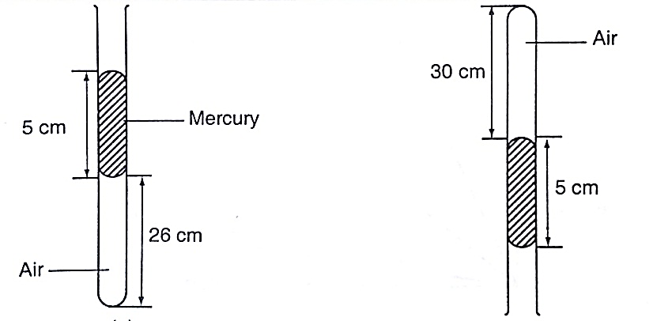

*Solution*

Before inversion, gas pressure = atm. Pressure + *h p g*

After inversion, gas pressure = atm. Pressure - *h p g*

From Boyle’s law, P1 V1 = P2 V2, then let the atm. Pressure be ‘x’,

So (x + 5) 0.26 = (x – 5) 0.30

0.26x + 1.30 = 0.3x - 1.5, x = 2.8/ 0.04 = 70 cm.

A general gas law

Any two of the three gas laws can be used derive a general gas law as follows,

**P1 V1 / T1 = P2 V2 / T2***or*

***P V / T = constant*** – *equation of state for an ideal gas.*

*Examples*

1. *A fixed mass of gas occupies 1.0 × 10-3 m3 at a pressure of 75 cmHg. What volume does the gas occupy at 17.0 0C if its pressure is 72 cm of mercury?*

*Solution*

P V / T = constant so V1 = (76 × 1.0 × 10-3 × 290) / 273 ×72 = 1.12 × 10-3 m3.

1. *A mass of 1,200 cm3 of oxygen at 270C and a pressure 1.2 atmosphere is compressed until its volume is 600 cm3 and its pressure is 3.0 atmosphere. What is the Celsius temperature of the gas after compression?*

*Solution*

Since P1 V1 / T1 = P2 V2 / T2, then T2 = (3 × 600 × 300) / 1.2 × 1,200 = 375 K or 102 0C.

**===== THE END =====**